

**Clinical Decision Support for Immunization (CDSi):**

**Logic Specification for ACIP Recommendations**

National Center for Immunization and Respiratory Disease (NCIRD)

Immunization Information Systems Support Branch (IISSB)

Version 2*.1*

*January 4, 2016*

**Table of Contents**

1 Executive Summary 8

1.1 Background and Goals 8

1.2 Approach 9

1.3 Scope 9

1.4 Products 10

2 Logic Specification Overview 14

2.1 Chapter Overview 14

2.2 Logic Specification Design Principles 15

2.3 Design and Documentation Strategy 16

2.4 Supporting Data 17

2.5 Logic Definition - Purpose 18

2.6 Logic Definition – Evaluation 18

2.7 Logic Definition – Forecasting 19

2.8 Logic Definition – Select Best Patient Series 21

2.9 Logic Definition – Identify and Evaluate Vaccine Group 21

2.10 Processing Model 22

3 Logic Specification Concepts 24

3.1 Target Dose 24

3.2 Statuses 25

3.3 Supporting Data 26

3.4 Date Calculations 26

3.5 Decision Table Overview 29

4 Evaluate Vaccine Dose Administered 31

4.1 Evaluate Dose Administered Condition 33

4.2 Evaluate Conditional Skip 34

4.3 Evaluate Age 37

4.4 Evaluate Interval 39

4.5 Evaluate Allowable Interval 42

4.6 Evaluate Live Virus Conflict 45

4.7 Evaluate for Preferable Vaccine 48

4.8 Evaluate for Allowable Vaccine 50

4.9 Evaluate Gender 53

4.10 Satisfy Target Dose 53

5 Forecast Dates and Reasons 55

5.1 Evaluate Conditional Skip 56

5.2 Determine Evidence of Immunity 57

5.3 Determine Forecast Need 58

5.4 Generate Forecast Dates and Recommended Vaccines 59

6 Select Best Patient Series 62

6.1 Select best patient series vocabulary 64

6.2 One Best Patient Series 65

6.3 Classify Patient Series 65

6.4 Complete Patient Series 66

6.5 In-process Patient Series 66

6.6 No valid doses 67

6.7 Select Best Candidate Patient Series 68

7 Identify and Evaluate Vaccine Group 69

7.1 Classify Vaccine Group 70

7.2 Single Antigen Vaccine Group 70

7.3 Multiple Antigen Vaccine Group 71

8 Processing Model 73

8.1 Gather Necessary Data 74

8.2 Create Patient Series 75

8.3 Organize Immunization History 75

8.4 Evaluate and Forecast all Patient Series 78

8.5 Select Best Patient Series 80

8.6 Identify and Evaluate Vaccine Group 81

Appendix A: Domain Model and Glossary 83

Appendix B: Acronyms and Abbreviations 94

Appendix C: Acknowledgements 96

Appendix D: References 113

Appendix E: Supplemental Material 116

Appendix F: Document Management 117

List of Figures and Tables

Table 1 - 1 Vaccine groups in scope 9

Figure 1 - 1 Mechanisms used in Logic Specification 11

Table 1 - 2 Components of Logic Specification 11

Table 1 - 3 Components of Testing Methodology 12

Table 1 - 4 Components of Sustainability Plan 12

Table 2 - 1 List of Chapters 14

Table 2 - 2 Descriptions of components 16

Table 2 - 3 Supporting data Suggested Audience 17

Table 2 - 4 Supporting data example 18

Table 2 - 5 Evaluation Suggested audience 18

Table 2 - 6 Forecasting suggested audience 19

Table 2 - 7 Select best patient series suggested audience 21

Table 2 - 8 Identify and evaluate vaccine group suggested audience 22

Table 2 - 9 Processing model suggested audience 22

Figure 3 - 1 How a Vaccine Dose Administered Satisfies a Target Dose 25

Table 3 - 1 Evaluation Statuses 25

Table 3 - 2 Target Dose Statuses 26

Table 3 - 3 Patient Series Statuses 26

Table 3 - 4 General Date Rules 27

Table 3 - 5 Logical Component Date Rules 27

Table 3 - 6 Should I get my car washed? 29

Table 3 - 7 Explanations of Outcomes 30

Table 3 - 8 What Exercise Should I do Today? 30

Table 4 - 1 Evaluation Process Steps 31

Figure 4 - 1 Evaluation Process Model 32

Figure 4 - 2 Vaccine Dose Administered Condition Process Model 33

Table 4 - 2 Dose Administered Condition Attributes 33

Table 4 - 3 Can the Vaccine Dose Administered Be Evaluated? 33

Figure 4 - 3 Conditional Skip Process Model 35

Table 4 - 4 Conditional skip Attributes 35

Table 4 - 5 CONDITIONAL SKIP BUSINESS RULES 36

Table 4 - 6 CONDITIONAL Type of Age – Is the Condition Met? 36

Table 4 - 7 CONDITIONAL Type of Interval – Is the Condition Met? 36

Table 4 - 8 CONDITIONAL Type of Vaccine Count By Age or Date – Is the Condition Met? 37

Table 4 - 9 Is the Conditional Skip Set Met? 37

Table 4 - 10 Can The Target Dose Be Skipped? 37

Figure 4 - 4 Evaluate Age Timeline 38

Figure 4 - 5 Evaluate Age Process Model 38

Table 4 - 11 Age Attributes 38

Table 4 - 12 Was the Vaccine Dose Administered at a Valid Age? 38

Figure 4 - 6 Evaluate Interval 'From Immediate Previous Dose' Timeline 40

Figure 4 - 7 Evaluate Interval 'From Target Dose Number In Series' Timeline 40

Figure 4 - 8 Evaluate Interval ‘From MOST RECENT Dose of Specified Vaccine type’ Timeline 41

Figure 4 - 9 Evaluate Interval Process Model 41

Table 4 - 13 Interval Attributes 41

Table 4 - 14 Did the vaccine dose administered satisfy the defined interval? 42

Table 4 - 15 Evaluate Interval business Rules 42

Figure 4 - 10 Evaluate Allowable Interval 'From Immediate Previous Dose' Timeline 43

Figure 4 - 11 Evaluate Allowable Interval 'From Target Dose Number In Series' Timeline 43

Figure 4 - 12 Evaluate Allowable Interval Process Model 44

Table 4 - 16 Interval Attributes 44

Table 4 - 17 Did the vaccine dose administered satisfy the defined Allowable interval? 44

Table 4 - 18 Evaluate Interval business Rules 45

Figure 4 - 13 Evaluate Live Virus Conflict Timeline 45

Figure 4 - 14 Evaluate Live Virus Conflict Process Model 46

Table 4 - 19 Live Virus Conflict Attributes 46

Table 4 - 20 Should the Current vaccine dose administered be evaluated for a live virus conflict? 47

Table 4 - 21 Could the two vaccine doses adminsitered be in conflict? 47

Table 4 - 22 Is the current vaccine Dose Administered in Conflict with a Previous Vaccine Dose Administered? 47

Table 4 - 23 Live Virus Conflict business Rules 48

Figure 4 - 15 Patient Received a Preferable Vaccine 48

Figure 4 - 16 Patient DID Not Receive a Preferable Vaccine 49

Figure 4 - 17 EvaluatE For a Preferable Vaccine Process Model 49

Table 4 - 24 Preferable Vaccine Administered Attributes 50

Table 4 - 25 Was the supporting data defined preferable vaccine administered? 50

Table 4 - 26 Preferable Vaccine business Rules 50

Figure 4 - 18 Patient Received an Allowable Vaccine 51

Figure 4 - 19 Patient DID Not Receive an Allowable Vaccine 51

Figure 4 - 20 Evaluate For an Allowable Vaccine Process Model 52

Table 4 - 27 Allowable Vaccine Attributes 52

Table 4 - 28 Was the supporting data defined Allowable vaccine administered? 52

Table 4 - 29 Allowable Vaccine business Rules 53

Figure 4 - 21 Gender Process Model 53

Table 4 - 30 Gender Attributes 53

Table 4 - 31 Is the Patient's Gender One of the Required Genders? 53

Figure 4 - 22 Satisfy Target Dose Process Model 54

Table 4 - 32 Was the Target Dose Satisfied? 54

Table 5 - 1 Forecast Dates and Reasons Process Steps 55

Figure 5 - 1 Forecast Dates and Reason Process Model 56

Figure 5 - 2 Evidence of Immunity Process Model 57

Table 5 - 2 Immunity Attributes 57

Table 5 - 3 Does the patient have Evidence of Immunity? 57

Figure 5 - 3 Determine Forecast Need Process Model 58

Table 5 - 4 Determine forecast need attributes 58

Table 5 - 5 Should the patient receive another target dose? 58

Figure 5 - 4 Forecast Dates Timeline 60

Figure 5 - 5 Generate Forecast Dates and Recommended Vaccine Process Model 60

Table 5 - 6 Generate forecast Dates and Recommended Vaccine attributes 60

Table 5 - 7 Generate forecast date and Recommended Vaccine Business rules 61

Table 6 - 1 Select Best Patient Series Process Steps 62

Figure 6 - 1 Select Best Patient Series Process Model 63

Table 6 - 2 Select Best Patient Series Vocabulary 64

Table 6 - 3 Is there one best patient series? 65

Table 6 - 4 Which patient series should be scored? 66

Table 6 - 5 How many points are awarded to a complete patient series when 2 or more candidate patient series are complete? 66

Table 6 - 6 How many points are awarded to an in-process patient series when 2 or more candidate patient series are in-process and no candidate patient series are complete? 67

Table 6 - 7 How many points are awarded to a candidate patient series when all patient series have 0 valid doses and no default patient series is specified? 67

Table 6 - 8 Select Best Patient Series Business Rules 68

Table 7 - 1 Identify and evaluate vaccine group process steps 69

Figure 7 - 1 Identify and evaluate vaccine group process model 70

Table 7 - 2 What is the vaccine group type? 70

Table 7 - 3 Single antigen vaccine group rules 71

Table 7 - 4 What is the vaccine group status of a Multiple Antigen Vaccine Group? 71

Table 7 - 5 Multiple antigen vaccine group rules 72

Table 8 - 1 Logic Specification Processing Steps 73

Figure 8 - 1 Logic Specification Processing Model 74

Table 8 - 2 Prior to Organize Immunization History Example 75

Table 8 - 3 After Organize Immunization History Example 76

Figure 8 - 2 Organize Immunization History Process Model 77

Figure 8 - 3 Evaluate and Forecast Process Model 78

Figure 8 - 4 Evaluate Immunization History Process Model 79

Figure 8 - 5 Select Best Series Process Model 81

Figure 8 - 6 Identify and Evaluate Vaccine Group Process Model 82

Figure A - 1 CDSi domain diagram: Patient neighborhood 85

Figure A - 2 CDSi domain diagram: Vaccine and schedule neighborhood 86

Figure A - 3 CDSi domain diagram: Evaluation and forecasting neighborhood 87

Table A - 1 Glossary 88

Table B - 1 Acronyms and abbreviations 94

PAGE LEFT BLANK

# Executive Summary

## Background and Goals

In 2010, approximately 82% (18.8 million) of U.S. children under the age of six participated[1] in an Immunization Information System (IIS), an increase from 78% (18.0 million) in 2009. Further, a total of 11,536 public and 36,512 private provider sites also participated[2] in an IIS.[3] Given this widespread IIS participation, it is important that each patient’s immunization record is consistent and up-to-date within an IIS.

Currently, Health Information Systems (HIS) – which can include Health Information Exchanges (HIEs), IIS and Electronic Health Records (EHRs) – provide healthcare providers with immunization evaluation and forecasting tools designed to automatically determine the recommended immunizations needed when a patient presents for vaccination. These recommendations are developed by the Advisory Committee on Immunization Practices (ACIP). ACIP is a federal advisory committee responsible for providing expert external advice and guidance to the Director of the Centers for Disease Control and Prevention (CDC) and the Secretary of the U.S. Department of Health and Human Services (DHHS) on use of vaccines and related agents for control of vaccine-preventable disease in the United States. Recommendations include age for vaccine administration, number of doses, dosing interval, and precautions and contraindications.

After ACIP recommendations are published, technical and clinical subject matter experts (SMEs) work to interpret and integrate them into their evaluation and forecasting engines. An example of an evaluation and forecasting engine is a tool an IIS might use to alert a physician that a presenting child is overdue for a Measles, Mumps, and Rubella (MMR) vaccination. New ACIP schedule changes are currently communicated only through clinical language, in publications like the Morbidity and Mortality Weekly Report (MMWR) and the Epidemiology and Prevention of Vaccine-Preventable Diseases ("The Pink Book"). The translation of that clinical language into technical logic that is processed within evaluation and forecasting engines is a time-consuming and complex process that happens mostly independently within the different HIS. Due to the challenge of interpreting clinically-written ACIP recommendations, clinical decision support (CDS) engine outputs often vary and do not always match the expectations of clinical SMEs.

In an effort to harmonize the outcomes of existing HIS CDS tools, the Immunization Information System Support Branch (IISSB) at the CDC funded the Clinical Decision Support for Immunization (CDSi) Project to develop new clinical decision aids[4] for each vaccine preventable disease in accordance with ACIP recommendations:

* Make it easier to develop and maintain immunization evaluation and forecasting products
* Ensure a patient’s immunization status is current, accurate, consistent, and readily available
* Increase the accuracy and consistency of immunization evaluation and forecasting
* Improve the timeliness of accommodating new and changed ACIP recommendations

The ultimate goal of the project is to ensure that patients receive proper immunizations, i.e., “the right immunization at the right time.”

## Approach

As part of this project, an expert panel was formed in April 2011, consisting of SMEs and expert reviewers from:

* CDC Public Health Informatics and Technology Program Office (PHITPO)
* American Immunization Registry Association (AIRA)
* Indian Health Service (IHS)
* EHR vendors
* IIS programs and vendors
* Academic institutions

This panel was divided into three workgroups which met regularly to develop resources in support of the project’s goals:

* **Logic Specification Panel (LSP)** – Developed the **Logic Specification for ACIP Recommendations** (Logic Specification) which captures ACIP recommendations in an unambiguous manner and improves both the uniform representation of vaccine decision guidelines as well as the ability to automate vaccine evaluation and forecasting
* **Validation and Testing Panel (VTP)** – Created the **Testing Methodology** to extensively test the compliance of CDS logic representation within CDS engines with ACIP recommendations
* **Process, Communication and Sustainability Panel (PCSP)** – Produced a **Sustainability Plan** to ensure the long-term viability of the clinical decision support for immunization (CDSi) resources

Please refer to Appendix C for more information regarding the expert panelists.

## Scope

The vaccine groups in scope for the current phase of the project are those routinely recommended by ACIP for healthy individuals from birth through age 65 + years, including:

Table 1 - 1 Vaccine groups in scope

| **Vaccine Groups** |  |  | |  |
| --- | --- | --- | --- | --- |
| * Diphtheria, Tetanus, and Pertussis/Tetanus-diphtheria (DTaP, Tdap, Td) | * Haemophilus influenzae type B (Hib) | * Meningococcal conjugate vaccine (MCV) | * Poliomyelitis | |
| * Hepatitis A | * Human papillomavirus (HPV) | * Measles, Mumps, Rubella (MMR) | * Rotavirus | |
| * Hepatitis B | * Influenza (Flu) | * Pneumococcal | * Varicella | |
| * Zoster |  |  |  | |

Additional items in scope include:

* Current ACIP recommendations with clarifications
* Compromised/sub-potent/expired doses
* Vaccine recalls
* Wrong vaccine formulations
* Underlying conditions related to contraindications listed in the General Recommendations
* The 4-day grace period
* Catch-up schedule
* Aged-Based Adult Recommendations

While not addressed specifically, the Logic Specification was developed to accommodate non-ACIP published rules (i.e., state law variations, local school schedules, rules published by other organizations, rules published in other countries). Supporting data in the specification can be adjusted by implementers to cover these variations from the ACIP recommendations.

Items currently out of scope but candidates for future project phases include the following:

* Underlying conditions related to precautions and special indications
* High/increased/special risk series (e.g. Hib past 5 years, MCV HIV series)
* Outbreak recommendations
* Immune Globulin (IG)
* Route and body site of administration
* Travel vaccines
* Non-FDA approved vaccines (i.e., those used in clinical trials)

## Products

### Logic Specification

The panel developed the Logic Specification which captures ACIP recommendations in an unambiguous manner and improves both the uniform representation of vaccine decision guidelines as well as the ability to automate vaccine evaluation and forecasting. The Logic Specification provides a single, authoritative, implementation-neutral foundation for development and maintenance of clinical decision support engines. It increases the accuracy and consistency of forecasting and evaluation across the HIS community and improves the timeliness of HIS accommodation of new and changed rules.

The objectives of the Logic Specification are to:

* Create a standardized CDS logic representation for ACIP recommendations that allows for broad implementation and effective usage across IIS and other HIS
* Document the logic for applying ACIP business rules in CDS engines in order to improve the clarity, consistency, and computability of on-going childhood, adolescent, and adult immunization evaluation and forecasting

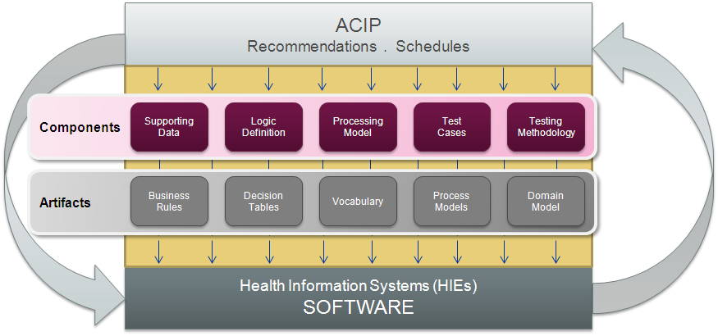

Figure 1 - 1 Mechanisms used in Logic Specification

As illustrated above, a variety of mechanisms (e.g., business rules, models, and logic diagrams) are used as part of the specification.

The table below describes the three major components of the Logic Specification.

Table 1 - 2 Components of Logic Specification

| **Logic Specification** | **Supporting Data** | Describes, by antigen, various factors and their accompanying sets of values to be considered when implementing ACIP recommendations |
| --- | --- | --- |
| **Logic Definition** | Describes the functionality required to evaluate and forecast based on a patient’s immunization history and the supporting data |
| **Processing Model** | Describes the technical structure necessary to pull the details of the logic definition and supporting data together |

The intended audience of the Logic Specification includes business and technical implementers of immunization CDS engines. These implementers may support any system with an immunization evaluation and forecasting engine, including but not limited to an IIS.

The Logic Specification was developed to be as implementation-neutral as possible to support those currently with or without complete evaluation and forecasting engines as they:

* Refine, extend, or develop their implementation
* Clarify their understanding of immunization rules
* Troubleshoot and verify correct implementation of immunization rules

### Testing Methodology

The panel developed a Testing Methodology to extensively test the compliance of CDS logic representation within CDS engines with the ACIP recommendations. The panel created test cases and expected results which can be processed against an immunization evaluation and forecasting engine to validate or test its algorithm against the Logic Specification.

The table below describes the two components of the Testing Methodology.

Table 1 - 3 Components of Testing Methodology

| **Testing Methodology** | **Test Cases** | Provides a representative set of scenarios and their expected outcomes as dictated by the Logic Specification |
| --- | --- | --- |
| **Testing Document** | Details the process used to develop the test cases and how to maintain them |

The intended audience of the Testing Methodology is implementers of immunization evaluation and forecasting products and services with a sound understanding of immunization evaluation and forecasting testing. Both business analysts and software developers will find value in the testing components.

### Sustainability Plan

The panel produced a Sustainability Plan to ensure the long-term viability of the CDSi resources. It provides recommendations and tools for both publicizing the project outputs to potential users and ensuring the long-term viability of the resources through training and support materials, recommended maintenance and support processes, and communications.

The table below describes the four components of the Sustainability Plan.

Table 1 - 4 Components of Sustainability Plan

| **Sustainability Plan** | **Training Plan** | Details the CDSi intended short-term and long-term training and learning support activities |
| --- | --- | --- |
| **Process Recommendations** | Provides recommended processes for maintaining the CDSi resources as ACIP recommendations change, communicating these changes, and supporting users of the CDSi resources |
| **Communication Plan** | Details the CDSi intended short-term and long-term communication activities and provides a structure for managing them |
| **Supplemental Recommendations** | Provides additional recommendations towards the successful longevity of the CDSi resources |

The intended audiences of the Sustainability Plan include members of the CDC IISSB who will be responsible for the sustainability and continued usability of the CDSi resources, namely the Logic Specification and Testing Methodology.

# Logic Specification Overview

## Chapter Overview

The Logic Specification provides the rules to determine if the immunizations received meet the requirements stated by the ACIP. A description of each chapter is presented below:

Table 2 - 1 List of Chapters

| Chapter | Title | Description | Emphasized Audience | | |
| --- | --- | --- | --- | --- | --- |
|  |  |  | Program Managers | Business Analysts | Technical Developers |
| Chapter 1 | Executive Summary | Introduces the context, goals, and primary deliverable of the CDSi project. | ✓ | ✓ | ✓ |
| Chapter 2 | Logic Specification Overview | Provides a high-level overview of the key components of the Logic Specification. The purpose and function are described for each component. In addition, the instruments used to document each component are also introduced. | ✓ | ✓ | ✓ |
| Chapter 3 | Logic Specification Concepts | Provides an explanation of target dose, the meanings of statuses used in evaluation and forecasting, an introduction to supporting data, the business rules for calculating dates, and an explanation of the use of decision tables within the document. |  | ✓ | ✓ |
| Chapter 4 | Logic Definition – Evaluation | Provides the rules for evaluating a vaccine dose administered. The approach is documented using a process model, decision tables, and business rules. |  | ✓ | ✓ |
| Chapter 5 | Logic Definition – Forecasting | Provides the rules for determining forecast dates. The approach is documented using a process model, decision tables, and business rules. |  | ✓ | ✓ |
| Chapter 6 | Logic Definition – Select Best Patient Series | Provides the rules for selecting the patient series which best fits based on various important factors. The approach is documented using a process model, decision tables, and business rules. |  | ✓ | ✓ |
| Chapter 7 | Logic Definition – Identify & Evaluate Vaccine Group | Provides the rules for combining selected patient series from an antigen-based forecast into a vaccine group-based forecast. The approach is documented using a process model, decision tables, and business rules. |  | ✓ | ✓ |
| Chapter 8 | Processing Model | Provides the major logical steps involved in the immunization evaluation and forecasting engine of the CDS process. |  |  | ✓ |
| Appendix A | Domain Model and Glossary | Provides a domain model that includes diagrams and vocabulary that is pertinent to the Logic Specification. |  | ✓ | ✓ |
| Appendix B | Acronyms and Abbreviations | Provides the meanings of acronyms and abbreviations used in the document. |  | ✓ | ✓ |
| Appendix C | Acknowledgements | Provides biographies of subject matter experts who served as volunteer panelists for the CDSi project. |  |  |  |
| Appendix D | References | Provides citations of various reference materials that were used to document the business rules and supporting data tables. |  |  |  |
| Appendix E | Supplemental Material | Provides supplemental material to aid with concepts found in the Logic Specification |  |  |  |
| Appendix F | Document Management | Provides a table to track key changes and versions of the document. |  |  |  |

## Logic Specification Design Principles

The following guiding principles (GP) were central to the development and the design of the Logic Specification. Ultimately, the Logic Specification should:

1. Reduce complexity of understanding and implementing ACIP recommendations
2. Ensure consistency in interpretation of ACIP recommendations
3. Enhance maintainability in response to newly published ACIP recommendations

* Improved timeliness (i.e., turnaround time)
* Reduction in rework
* Minimal impact of changes

1. Inform a variety of implementations

## Design and Documentation Strategy

Giving the complexity of implementing ACIP recommendations and considering the guiding principles, the design strategy included two key elements:

* Focusing on three components by setting apart the configuration data, the business rules, and the processing model that pulls the business rules together
* Emphasizing “universal” functionality applicable across HIS instead of implementation-specific engineering requirements

In addition, a variety of mechanisms were chosen to document the specification in order to provide a concise, unambiguous, and computable description of the functionality required. Thus, the design of the Logic Specification is divided into three components. The graphic below lists each component, the description, and the documentation method.

Table 2 - 2 Descriptions of components

| **Component** | **Description** | **Documentation Method** |
| --- | --- | --- |
| The pictures in the table represent Supporting Data, Logic Definition, and Processing Model. | Describes, by antigen, various factors and their accompanying sets of values to be considered when implementing ACIP recommendations | **Chapter 3:**   * Introduction to supporting data * Link to view supporting data spreadsheets |
| The pictures in the table represent Supporting Data, Logic Definition, and Processing Model. | Describes the functionality required to evaluate and forecast based on a patient’s immunization history and the supporting data.  Logic definitions include:   * Evaluation Logic * Forecasting Logic * Select Best Patient Series Logic * Identify and Evaluate Vaccine Group Logic | **Chapters 4, 5, 6 & 7:**   * Thin process models * Decision tables * Business rules |
| The pictures in the table represent Supporting Data, Logic Definition, and Processing Model. | Describes the technical structure necessary to pull the details of the Logic Definition, Supporting Data, and Patient Related Data together | **Chapter 8:**   * Activity diagrams |

Together these components describe the functionality to evaluate and forecast based on ACIP recommendations using a patient’s immunization history.

## The picture highlights the Supporting Data component.Supporting Data

### Purpose

The **supporting data** component describes the attributes (e.g., minimum age, earliest recommended age, and preferable vaccine type) necessary and specific values (e.g., schedule-specific, antigen series-specific, and dose-specific) required to support evaluation and forecasting as described by the logic definition.

To reduce complexity, the supporting data elements are divided into logical components. Each focuses on one aspect of the more complex processes of evaluation and forecasting.

Simply put, supporting data is akin to configuration data which feeds the system. It is representative of the ACIP recommendations and completed either at dose level (one per dose per series) or schedule level (one for entire ACIP schedule - e.g., live virus supporting data and contraindications supporting data). The supporting data is able to be modified separately from the logic.

### What problem does it help solve

The supporting data was separated from the logic definition in order to reduce and ease the maintenance of the logic as new and updated ACIP recommendations are released. The supporting data values are expected to change on a regular basis in conjunction with new and updated ACIP recommendations. It is not expected that the logic definition will change as rapidly. If supporting data are ultimately implemented as some form of a data store (e.g., database), new and updated recommendations can be reflected through simple supporting data changes. In essence, supporting data can be thought of as configuration parameters and values.

Although out of scope for the Logic Specification, separating the supporting data makes it easier to support local differences (e.g., state laws) with minimal impact on the implemented logic (i.e., code).

Table 2 - 3 Supporting data Suggested Audience

| Role | Perspective |
| --- | --- |
| Business Analyst | Understanding and documenting the specific values that describe the relevant information about antigens, series, doses, etc. |
| Technical Developer | Implementing the data structures to support storage and access of the supporting data. Understanding the integration of the supporting data, logic definition, and processing model. |

### How and where it is documented

The vocabulary in Appendix A provides definitions of the data elements used within the logical components of the Logic Specification. Additional understanding can be obtained by reviewing the actual supporting data. Chapter 3 provides the link to access all supporting data spreadsheets.

For instance, a dose for a series is divided into the logical components of **age**, **interval**, **preferable vaccine type**, **allowable vaccine type**, **conditional skip**, **recurring dose**, **seasonal recommendation**, and **gender**. The appropriateness of each logical component and the appropriate value for each data element could (and in most cases, will) vary based on the specific antigen, series, or dose being described. The example below reflects different values for data elements associated with the logical component age.

Table 2 - 4 Supporting data example

| Series | Target  Dose | Absolute Minimum Age | Minimum Age | Earliest Recommended Age | Latest Recommended Age  (less than) | Maximum Age  (less than) |
| --- | --- | --- | --- | --- | --- | --- |
| HepA Standard 2 Dose Series | 1 | 12m – 4d | 12m | 12m | 24m +4w | n/a |
| Varicella 2 Dose Child Series | 2 | 12m + 4w | 15m | 4y | 7y + 4w | n/a |
| Rotavirus Standard Series | 2 | 10w – 4d | 10w | 4m | 5m + 4w | 8m + 1d |

The current standard set of supporting data definitions with appropriate values, based on the ACIP recommendations without modification for any local differences can be found at <http://www.cdc.gov/vaccines/programs/iis/interop-proj/cds.html> .

## The picture highlights the Logic Definition component.Logic Definition - Purpose

The logic definition describes, in a technology-neutral fashion, the functional steps necessary to process the patient’s medical history using the supporting data.

The logic definition is composed of four separate, but related functions:

* Evaluation
* Forecasting
* Select Best Patient Series
* Identify and Evaluate Vaccine Group

To further reduce complexity, the four logic definitions are divided into logical sub-steps, each of which focuses on one aspect of the more complex processes of evaluation and forecasting. In addition, the vaccine-specific values have been abstracted out of the logic and reside in the supporting data.

## The picture highlights the Logic Definition - Evaluation.Logic Definition – Evaluation

### Purpose

The logic definition **evaluation** describes the process of evaluating a single vaccine dose administered against a defined target dose to determine if the vaccine dose administered is **valid** or **not valid** for that specific target dose.

### What problem it helps solve

Focusing only on evaluation of a patient’s immunization history greatly simplifies the complexity of interpreting ACIP recommendations. It also reduces the breadth of the impact on the logic of future ACIP recommendation changes.

Table 2 - 5 Evaluation Suggested audience

| Role | Perspective |
| --- | --- |
| Business Analyst | Understanding and documenting the logical steps of **evaluation** and the impact of supporting data elements. |
| Technical Developer | Coding the system to implement the functional processes described in the logic definition. Understanding the integration of the supporting data, logic definition and processing model. |

### How and where it is documented

Chapter 4 of the Logic Specification describes the process of evaluation. It is documented using the following:

* A thin process model that represents the high-level steps to evaluate each of the logical sub-components which ultimately affect the validity of a vaccine dose administered.
* Timelines that graphically represent dates and/or time intervals used in evaluation.
* Attribute tables that provide the attribute type, name, and assumed value if empty.
* Decision tables that state the conditions and rules which must be assessed for a specific logical sub-component and the resulting outcomes.

## The picture highlights the Logic Definition – Forecasting.Logic Definition – Forecasting

### Purpose

The logic definition **forecasting** describes the process of using a patient’s medical and immunization history to determine immunization due dates.

### What problem it helps solve

Focusing only on forecasting immunization due dates, separate from determining which possible paths to immunity a patient is on, greatly simplifies the complexity of interpreting ACIP recommendations. It also reduces the breadth of the impact on the logic of future ACIP recommendation changes. Even though the logic for evaluation and forecasting is separate, sound evaluation simplifies the work of forecasting; i.e., understanding which target dose has been satisfied simplifies forecasting the next target dose in the patient series.

Table 2 - 6 Forecasting suggested audience

| Role | Perspective |
| --- | --- |
| Business Analyst | Understanding and documenting the logical steps of **forecasting** and the impact of supporting data elements. |
| Technical Developer | Coding the system to implement the functional processes described in the logic definition. Understanding the integration of the supporting data, logic definition and processing model. |

### How and where it is documented

Chapter 5 of the Logic Specification describes the process of forecasting. It is documented using the following:

* A thin process model that represents the high-level steps to forecast immunization due dates.
* Attribute tables that provide the attribute type, name, and assumed value if empty.
* Timelines that graphically represent dates and/or time intervals used to generate or result from the generated forecasted dates.
* Decision tables that represent the combination of conditions and the resulting impact on the need to generate forecasted dates.

## The picture highlights the Logic Definition - Select Patient Series. Logic Definition – Select Best Patient Series

### Purpose

The logic definition **select best patient series** describes the process of selecting the patient series, out of the possible series, which puts the patient on the best path to immunity based on various important factors.

### What problem it helps solve

There is more than one path which can lead a patient to immunity. See Appendix E for representations of multiple patient series (paths to immunity) for an antigen. Select best patient series helps to put a specific patient on the best path for them through the application of ACIP recommendations given the outcomes of evaluation and forecasting.

Table 2 - 7 Select best patient series suggested audience

| Role | Perspective |
| --- | --- |
| Business Analyst | Understanding and documenting the logical steps of Select Best Patient Series and the factors used when scoring Candidate Patient Series. |
| Technical Developer | Coding the system to implement the functional processes described in the logic definition. Understanding the integration of the supporting data, logic definition, and processing model. |

### How and where it is documented

Chapter 6 of the Logic Specification describes the process of selecting best patient series. It is documented using the following:

* A thin process model that represents the high-level steps to select best patient series.
* A vocabulary table that provides meanings to terms used strictly in the select best patient series logic definition.
* Decision tables that represent the combination of conditions and the resulting impact on classifying and scoring patient series.
* Business rules used to concisely, unambiguously describe what and how various factors affect the score given to competing patient series.

## The picture highlights the Logic Definition - Identify and Evaluate Vaccine Group.Logic Definition – Identify and Evaluate Vaccine Group

### Purpose

The logic definition **identify and evaluate vaccine group** describes the process of combining patient series, described in terms of antigens, into vaccine group-based forecasts.

### What problem it helps solve

Performing evaluation and forecasting at the antigen-level provides for an extremely effective and comprehensive approach. However, clinicians and physicians look at vaccines in a broader grouping known as vaccine groups. Identify and evaluate vaccine group pulls this notion together to provide a clinical-centric forecast based on vaccine groups.

Table 2 - 8 Identify and evaluate vaccine group suggested audience

| Role | Perspective |
| --- | --- |
| Business Analyst | Understanding and documenting the logical steps of **identifying and evaluating vaccine groups**. |
| Technical Developer | Coding the system to implement the functional processes described in the logic definition. Understanding the integration of the supporting data, logic definition, and processing model. |

### How and where it is documented

Chapter 7 of the Logic Specification describes the process of identifying and evaluating vaccine groups. It is documented using the following:

* A thin process model that represents the high-level steps to identify and evaluate vaccine groups.
* Decision tables that represent the combination of conditions which dictate which set of vaccine group forecasting rules apply.
* Business rules used to concisely, unambiguously describe how to apply the proper vaccine group forecasting rules to determine the appropriate vaccine group-based forecast.

## The picture highlights the Processing Model. Processing Model

### Purpose

The logic definitions focus on the functionality necessary to evaluate and forecast based on one specific target dose and one specific vaccine dose administered. This simplifies the entire process by only focusing on one item at a time. However, there are many possible paths to immunity which result in many potential target doses. In addition, a patient’s history often contains multiple vaccine doses administered. Thus, the **processing model** describes, in a technology-neutral fashion, the algorithms necessary to merge multiple executions and results of the logic definitions for evaluation and forecasting.

### What problem it helps solve

Separating the functionality of evaluation from forecasting and the algorithmic details of handling multiple iterations of evaluation and forecasting greatly simplifies the complexity of implementing ACIP recommendations. It also reduces the breadth of the impact on the logic of future ACIP recommendation changes

Table 2 - 9 Processing model suggested audience

| Role | Perspective |
| --- | --- |
| Technical Developer | Coding the system to implement the functional processes described in the logic definition. Understanding the integration of the patient related data, supporting data, and logic definition. |

### How and where it is documented

Chapter 8 of the Logic Specification describes the more detailed algorithms represented in the Logic Specification Processing Model. These algorithms are documented using activity diagrams, which represent the detailed looping necessary to evaluate a patient’s full immunization history against multiple potential vaccination series resulting in multiple candidate forecasted immunization due dates. Since this chapter provides illustrations of the major logical steps involved in the immunization evaluation and forecasting engine, a technical developer may benefit by reading Chapter 8 prior to other chapters.

# Logic Specification Concepts

The information contained in this chapter will be useful in understanding the business rules, decision tables, and process models that are used in the Logic Specification. The first section provides a basic understanding of target dose and how it is used throughout the document. Next, relevant meanings of statuses used during evaluation and forecasting are provided for clarity. Then, the link to review actual supporting data spreadsheets is provided as an easy way to view the data. Business rules used when calculating dates for evaluation and forecasting are provided next. The final section provides an example of how decision tables are used in the document to interpret the business rules used in evaluation and forecasting processes.

## Target Dose

**Target dose** is a term used often in the Logic Specification document. A target dose is a patient-specific dose required to satisfy the recommendations of ACIP. Until a target dose is satisfied, the patient is not allowed to move to the next target dose in the patient series. The patient remains on the “unsatisfied” target dose until the patient has a “valid” vaccine dose administered that satisfies the target dose. A target dose is also allowed to be skipped however this situation isn’t the common path and not immediately discussed here. Details on skipping target doses can be found in chapters 4 and 5.

This concept can be seen graphically below in figure 3-1. For simplicity in this hypothetical patient series, the target doses are defined only by the minimum age. The target doses have minimum ages of 0 days, 2 months, and 6 months. These are the minimum ages allowed by this patient series. The patient must have vaccine doses administered on or after these minimum ages to be considered valid. A valid vaccine dose administered will satisfy a target dose and allow movement to the next target dose. A vaccine dose administered which is anything but valid does not satisfy a target dose and does not allow movement to the next target dose.

This can be seen in figure 3-1 by looking at *target dose 2* and vaccine doses administered *dose 2* and *dose 3*. Dose 2 was administered too early and resulted in the evaluation status “not valid.” A not valid vaccine dose administered means the target dose was not satisfied and must be repeated. Dose 3 was given at an appropriate age which resulted in the evaluation status “valid” and satisfied the goals of target dose 2. This allows movement to target dose 3 which is subsequently satisfied by vaccine dose administered *dose 4*.

While not shown on this graphic, there is also a status which tracks the patient’s progress towards completion of a patient series. In this example, the patient series status is “not complete” for the first three vaccine doses administered. The patient series status is changed to “complete” once the fourth vaccine dose administered satisfies the third target dose which completes the patient series.

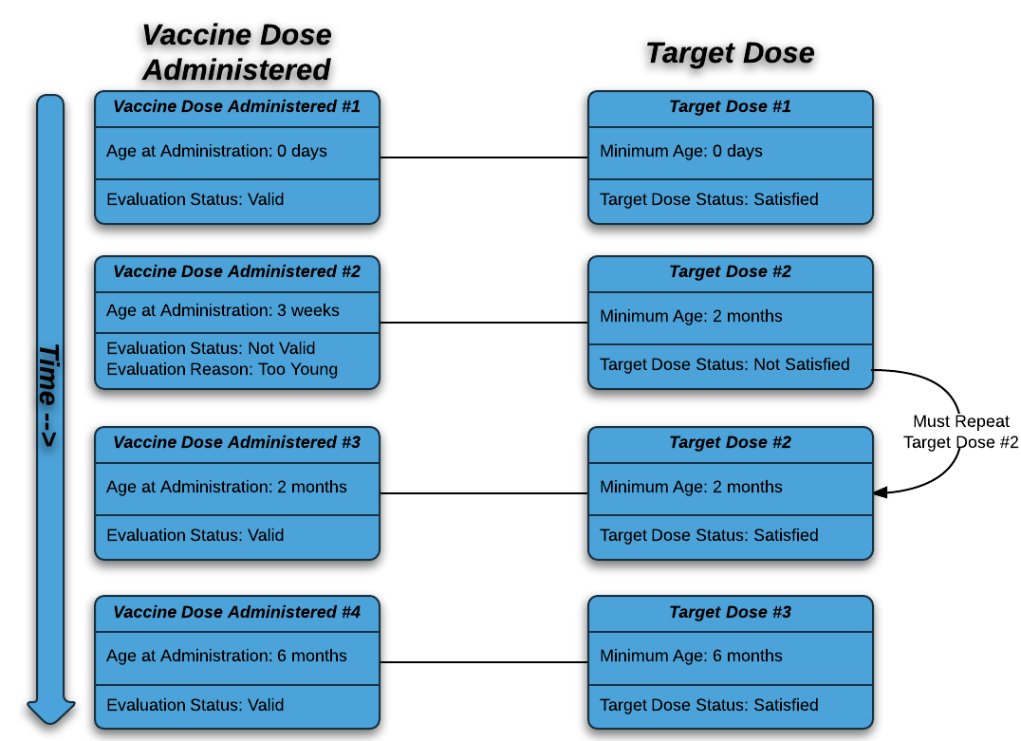

Figure 3 - 1 How a Vaccine Dose Administered Satisfies a Target Dose

## Statuses

The Logic Specification uses different statuses to denote the state of evaluation, target dose, and patient series. The following tables provide the meanings of statuses used in Logic Specification business rules and decision tables.

Table 3 - 1 Evaluation Statuses

| Evaluation Status | Relevant Meaning |
| --- | --- |
| Extraneous | An *extraneous* evaluation status means the vaccine dose administered was not administered according to ACIP recommendations, but the dose does not need to be repeated (including maximum age and extra doses.) |
| Not Valid | A *not valid* evaluation status means the vaccine dose administered was not administered according to ACIP recommendations and must be repeated at an appropriate time in the future. |
| Valid | A *valid* evaluation status means the vaccine dose administered was administered according to ACIP recommendations. |
| Sub-standard | A *sub-standard* evaluation status means the vaccine dose administered has a known dose condition (e.g., expired, sub-potent, and recall) which requires the dose to be repeated at an appropriate time in the future. |

Table 3 - 2 Target Dose Statuses

| Target Dose Status | Relevant Meaning |
| --- | --- |
| Not Satisfied | A *not satisfied* target dose status means no vaccine dose administered has met the goals of the target dose. |
| Satisfied | A *satisfied* target dose status means a vaccine dose administered has met the goals of the target dose. |
| Skipped | A *skipped* target dose status means no vaccine dose administered has met the goals of the target dose. Due to the patient’s age and/or interval from a previous dose, the target dose does not need to be satisfied. |
| Unnecessary | An *unnecessary* target dose status means the target dose is not needed and the target dose does not need to be satisfied. |

Table 3 - 3 Patient Series Statuses

| Patient Series Status | Relevant Meaning |
| --- | --- |
| Complete | A *complete* patient series status means the patient has met all of the ACIP recommendations for the patient series. |
| Contraindicated | A *contraindicated* patient series status means the patient’s medical history indicates no further immunizations should be administered for the patient series. |
| Immune | An *immune* patient series status means the patient has evidence of immunity indicating no further immunizations are needed for the patient series. |
| Not Complete | A *not complete* patient series status means the patient has not yet met all of the ACIP recommendations for the patient series. |
| Aged Out | An *Aged Out* patient series status means the patient exceeded the maximum age prior to completing the patient series. |
| Not Recommended | A *not recommended* patient series status means the patient’s immunization history provides sufficient protection against a disease and there’s no recommended action at this time. |

## Supporting Data

The purpose of supporting data is to provide the implementer with the necessary information needed for evaluation and forecasting. The Logic Specificationdefines supporting data by logical components. The logical components are: (1) Age, (2) Interval, (3) Preferable Vaccine, (4) Allowable Vaccine, (5) Conditional Skip, (6) Recurring Dose, (7) Seasonal Recommendation, and (8) Gender.

Click here to view all supporting data spreadsheets:

[http://www.cdc.gov/vaccines/programs/iis/interop-proj/cds.html.](http://www.cdc.gov/vaccines/programs/iis/interop-proj/cds.html." \o "CDSi Project website)

## Date Calculations

Business rules that are specific to calculating dates are provided in this section. A **calculated date** is a date that is mathematically derived from one or more terms. The first table provides rules for calculating dates in general. The second table provides rules for calculating dates by logical component.

Table 3 - 4 General Date Rules

| Business Rule ID | Business Rule | Example |
| --- | --- | --- |
| CALCDT-1 | The computed date of adding any number of years to an existing date must be calculated by incrementing the date-year while holding the date-month and date-day constant. | * 01/01/2000 + 3 years = 01/01/2003 |
| CALCDT-2 | The computed date of adding any number of months to an existing date must be calculated by incrementing the date-month (and date-year, if necessary) while holding the date-day constant. | * 01/01/2000 + 3 months = 04/01/2000 * 11/01/2000 + 3 months = 02/01/2001 |
| CALCDT-3 | The computed date of adding any number of weeks or days to an existing date must be calculated by adding the total days to the existing date. | * 01/01/2000 + 3 weeks = 01/22/2000 * 01/01/2000 + 3 days = 01/04/2000 * 02/01/2000 + 5 weeks = 03/07/2000 (leap year) * 02/01/2001 + 5 weeks = 03/08/2001 (not a leap year) |
| CALCDT-4 | The computed date of subtracting any number of days from an existing date must be calculated by subtracting the total days from the existing date. | * 01/15/2000 – 4 days = 01/11/2000 |
| CALCDT-5 | A computed date which is not a real date must be moved forward to first day of the next month. | * 07/31/2000 + 2 months = 10/01/2000 * 01/31/2001 + 1 month = 03/01/2001 |
| CALCDT-6 | A computed date must be calculated by first adjusting the years, followed by the months, and finally the weeks and/or days. | * 01/31/2000 + 1 month – 4 days = 02/25/2000 |

Table 3 - 5 Logical Component Date Rules

| Business Rule ID | Business Rule | Logical Component |
| --- | --- | --- |
| CALCDTSKIP-1 | **Retired in version 2.1 – No Longer Used.**  A patient's trigger age date must be calculated as the patient’s date of birth plus the skip dose trigger age. | n/a |
| CALCDTSKIP-2 | **Retired in version 2.1 – No Longer Used.**  A patient's trigger interval date must be calculated as the vaccine date administered which satisfied the previous target dose plus the skip dose trigger interval. | n/a |
| CALCDTSKIP-3 | A patient’s conditional skip begin age date must be calculated as the patient’s date of birth plus the Begin Age of the conditional skip condition. | Conditional Skip |
| CALCDTSKIP-4 | A patient’s conditional skip end age date must be calculated as the patient’s date of birth plus the End Age of the conditional skip condition. | Conditional Skip |
| CALCDTSKIP-5 | A patient’s conditional skip interval date must be calculated as the vaccine date administered which satisfied the previous target dose plus the Interval of the conditional skip condition. | Conditional Skip |
| CALCDTAGE-1 | A patient's maximum age date must be calculated as the patient’s date of birth plus the maximum age. | Age |
| CALCDTAGE-2 | A patient's latest recommended age date must be calculated as the patient’s date of birth plus the latest recommended age. | Age |
| CALCDTAGE-3 | A patient's earliest recommended age date must be calculated as the patient’s date of birth plus the earliest recommended age. | Age |
| CALCDTAGE-4 | A patient's minimum age date must be calculated as the patient’s date of birth plus the minimum age. | Age |
| CALCDTAGE-5 | A patient's absolute minimum age date must be calculated as the patient’s date of birth plus the absolute minimum age. | Age |
| CALCDTINT-1 | A patient's reference dose date must be calculated as the date administered of the most immediate previous vaccine dose administered which has evaluation status “Valid” or “Not Valid” if from immediate previous dose administered is “Y”. | Interval, Allowable Interval |
| CALCDTINT-2 | A patient's reference dose date must be calculated as the date administered of the vaccine dose administered which satisfies the target dose defined in the interval from target dose number in series if from immediate previous dose administered is “N” and from target dose number in series is not “n/a”. | Interval, Allowable Interval |
| CALCDTINT-3 | A patient's absolute minimum interval date must be calculated as the patient's reference dose date plus the absolute minimum interval. | Interval, Allowable Interval |
| CALCDTINT-4 | A patient's minimum interval date must be calculated as the patient's reference dose date plus the minimum interval. | Interval |
| CALCDTINT-5 | A patient's earliest recommended interval date must be calculated as the patient’s reference dose date plus the earliest recommended interval. | Interval |
| CALCDTINT-6 | A patient's latest recommended interval date must be calculated as the patient’s reference dose date plus the latest recommended interval. | Interval |
| CALCDTINT-7 | A patient's latest minimum interval date must be the latest date of all calculated minimum interval dates for a given target dose. | Interval |
| CALCDTINT-8 | A patient's reference dose date must be calculated as the most recent vaccine dose administered which is of the same vaccine type as the supporting data defined from most recent vaccine type if from immediate previous dose administered is “N” and from most recent is not “n/a”. | Interval |
| CALCDTLIVE-1 | A patient's conflict begin interval date must be calculated as the date administered of the *conflicting* vaccine dose administered plus the live virus conflict begin interval. | Live Virus Conflict |
| CALCDTLIVE-2 | A patient's conflict end interval date must be calculated as the date administered of the conflicting vaccine dose administered plus the live virus minimum conflict end interval if the conflicting vaccine dose administered has evaluation status “valid.” | Live Virus Conflict |
| CALCDTLIVE-3 | A patient's conflict end interval date must be calculated as the date administered of the conflicting vaccine dose administered plus the live virus conflict end interval if the conflicting vaccine dose administered does not have evaluation status “valid.” | Live Virus Conflict |
| CALCDTLIVE-4 | A patient's latest conflict end interval date must be the latest date of all calculated conflict end interval dates for a given target dose. | Live Virus Conflict |
| CALCDTPREF-1 | A patient's preferable vaccine type begin age date must be calculated as the patient’s date of birth plus the vaccine type begin age of a preferable vaccine. | Preferable Vaccine |
| CALCDTPREF-2 | A patient's preferable vaccine type end age date must be calculated as the patient’s date of birth plus the vaccine type end age of a preferable vaccine. | Preferable Vaccine |
| CALCDTALLOW-1 | A patient's allowable vaccine type begin age date must be calculated as the patient’s date of birth plus the vaccine type begin age of an allowable vaccine. | Allowable Vaccine |
| CALCDTALLOW-2 | A patient's allowable vaccine type end age date must be calculated as the patient’s date of birth plus the vaccine type end age of an allowable vaccine. | Allowable Vaccine |
| CALCDTCOND-1 | **Retired in version 2.1 – No Longer Used.**  The patient's conditional begin age date must be calculated as the patient's date of birth plus the conditional begin age. | n/a |
| CALCDTCOND-2 | **Retired in version 2.1 – No Longer Used.**  The patient's conditional end age date must be calculated as the patient's date of birth plus the conditional end age. | n/a |

## Decision Table Overview

A decision table documents the way that a system responds to various combinations of input conditions. It describes business rules where the required response depends on a number of factors that must all be considered at the same time. Decision tables are useful when trying to clearly define a set of conditions, how they work in combination, and what actions should be taken on encountering a given set of conditions.

There are various ways of documenting decision tables. The Logic Specificationuses two different styles. Both start with a simple business question as the title or subject of the decision table.

The majority of decision tables in the Logic Specification use a condition/outcome style formatting. In this approach, the top half lists conditions based on the business question. The bottom half of the decision table states the outcome after the rules have been applied to the condition.

In order to familiarize the reader with the use of decision tables in the Logic Specification, an example is provided below using a real-world scenario that is unrelated to immunizations.

Table 3 - 6 Should I get my car washed?

| **CONDITIONS** | **RULES** | | | |
| --- | --- | --- | --- | --- |
| Is the car wash open? | No | - | - | Yes |
| Is my car dirty? | - | No | - | Yes |
| Do I have enough money? | - | - | No | Yes |
|  |  |  |  |  |
| **OUTCOMES** | No.  The car wash is closed. | No.  My car is not dirty. | No.  I cannot afford it. | Yes.  I should get my car washed. |

The following table provides explanations of how the various outcomes were determined.

Table 3 - 7 Explanations of Outcomes

| Outcome | Explanations |
| --- | --- |
| No. The car wash is closed. | The answer “No” to the first condition means the car wash was not open. The other conditions (Is my car dirty? or Do I have enough money?) do not matter. |
| No. My car is not dirty. | The answer “No” to the second condition means my car is not dirty. The other conditions (Is the car wash open? Or Do I have enough money?) do not matter. |
| No. I cannot afford it. | The answer “No” to the third condition means I do not have enough money. The other conditions (Is the car wash open? Or Is my car dirty?) do not matter. |
| Yes. I should get my car washed. | The answer “Yes” to all of the conditions means the car wash is open, my car is dirty, and I have enough money. The outcome (Yes. I should get my car wash.) is based on answers to all conditions. |

In the second style, the outcome is the intersection of a row and column where the row and column heading are the conditions. The example below illustrates exercise based on the day of the week and the weather outside. For example, the exercise on Saturday when it is raining outside is a Yoga Class.

Table 3 - 8 What Exercise Should I do Today?

|  |  | **Weather** | | |
| --- | --- | --- | --- | --- |
|  |  | **Dry** | **Raining** | **Snowing** |
| **Day of Week** | **Monday** | Trail Run | Treadmill | Cross Country Ski |
| **Tuesday** | No Exercise | No Exercise | No Exercise |
| **Wednesday** | Trail Run | Treadmill | Cross Country Ski |
| **Thursday** | Trail Run | Treadmill | Cross Country Ski |
| **Friday** | No Exercise | No Exercise | No Exercise |
| **Saturday** | Golf | Yoga Class | Downhill Ski |
| **Sunday** | Golf | Yoga Class | Downhill Ski |

A decision table is helpful when decision-based rules have to be applied in combination. As illustrated above, the Logic Specification refers to key components of a decision table as (1) Conditions, (2) Rules, and (3) Outcomes. These components function together in the following manner: Conditions + Answers = Rules; Rules determine Outcomes.

Logical reasoning used to determine the outcome in the example decision tables above is similar to the decision tables used in the Logic Specification. The goal of a decision table is to answer a business question while providing the correct technical outcome.

# Evaluate Vaccine Dose Administered

The core of a CDS engine is the process of evaluating a single vaccine dose administered against a defined target dose to determine if the vaccine dose administered is “valid” or “not valid.” The results will ultimately determine if all conditions of the target dose are satisfied and the dose does not need to be repeated. This can be accomplished by breaking the evaluation process into simple and logical components. After processing each logical component, the results of those logical components are used to determine if the vaccine dose administered satisfies the goals of the target dose.

Each logical component has its own set of business rules that are used to determine if a target dose is “satisfied.” These business rules are documented using the decision table format. (See section 3.5 to review an example of a decision table using a real-world scenario.) The decision table describes the way that the CDS engine responds to various combinations of conditions. The implementer is able to clearly see the set of conditions, how they work in combination, and what actions should be taken on a given set of conditions.

Specific attributes and decision tables are provided for each step of the evaluation process.

Table 4 - 1 Evaluation Process Steps

| Section | Activity | Goal |
| --- | --- | --- |
| 4.1 | Evaluate Dose Administered Condition | The goal of this step is to determine if a vaccine dose administered can be evaluated. |
| 4.2 | Evaluate Conditional Skip | The goal of this step is to determine if the target dose can be skipped due to a patient’s age or immunization history. |
| 4.3 | Evaluate Age | The goal of this step is to determine if the vaccine dose administered was given at an appropriate age. |
| 4.4 | Evaluate Interval | The goal of this step is to determine if the vaccine dose administered was given at an appropriate interval. |
| 4.5 | Evaluate Allowable Interval | The goal of this step is to determine if the vaccine dose administered was given at an allowable interval. |
| 4.6 | Evaluate Live Virus Conflict | The goal of this step is to determine if the vaccine dose administered was in conflict with any live virus vaccines. |
| 4.7 | Evaluate Preferable Vaccine Administered | The goal of this step is to determine if the vaccine dose administered was one of the preferable vaccines. |
| 4.8 | Evaluate Allowable Vaccine Administered | The goal of this step is to determine if the vaccine dose administered was one of the allowable vaccines. |
| 4.9 | Evaluate Gender | The goal of this step is to determine if the vaccine dose administered was given to an appropriate gender. |
| 4.10 | Satisfy Target Dose | The goal of this step is to determine if the target dose is satisfied. |

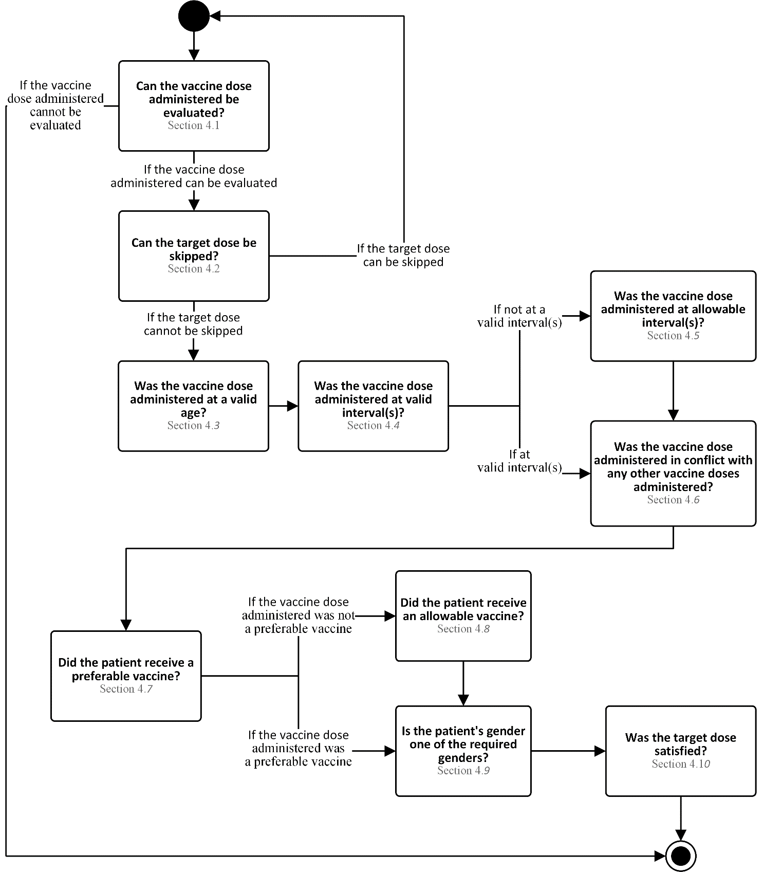

Figure 4 - 1 Evaluation Process Model

## Evaluate Dose Administered Condition

*Vaccine dose Evaluate Dose Administered Condition* checks the dose administered to see if the target dose must be repeated regardless of the other evaluation rules.

Relationship to ACIP recommendations:

* Doses which were administered after the lot expiration date or which contain a condition do not need to be evaluated.
* Examples of conditions which would prevent evaluation of a vaccine dose administered range from misadministration to recalls to cold chain breaks.

The following processing model, attribute table and decision table are used to determine if dose administered can be evaluated.

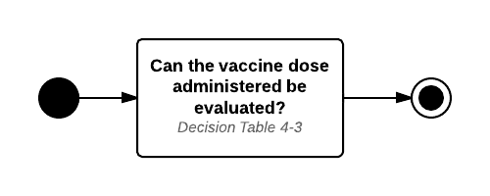

Figure 4 - 2 Vaccine Dose Administered Condition Process Model

Table 4 - 2 Dose Administered Condition Attributes

| Attribute Type | Attribute Name | Assumed Value if empty |
| --- | --- | --- |
| Vaccine dose administered | Date Administered | - |
| Vaccine dose administered | Lot Expiration Date | 12/31/2999 |
| Vaccine dose administered | Dose Condition | - |

Table 4 - 3 Can the Vaccine Dose Administered Be Evaluated?

| **CONDITIONS** | **RULES** | | |
| --- | --- | --- | --- |
| Date administered > lot expiration date? | Yes | No | No |
| Dose condition indicated? | - | Yes | No |
|  |  |  |  |
| **OUTCOMES** | No. The vaccine dose administered cannot be evaluated. Target dose status is “not satisfied.” Evaluation status is “sub-standard.” | No. The vaccine dose administered cannot be evaluated. Target dose status is “not satisfied.” Evaluation status is “sub-standard.” | Yes. The vaccine dose administered can be evaluated. |

## Evaluate Conditional Skip

*Evaluate Conditional Skip* addresses times when a target dose can be skipped. A dose should be considered necessary unless it is determined that it can be skipped. The most common scenarios for skipping a dose are:

* Catch-up doses where the patient is current with their administrations and does not need to catch-up
* The patient is behind schedule and the total number of doses needed to satisfy the patient series can be reduced
* The previously administered dose(s) negates the need for the current target dose

In cases where a target dose does not specify Conditional Skip attributes, the target dose cannot be skipped.

A dose may be skipped based on whether or not one or more conditions evaluates to true. Conditions are classified as one of a number of types, each with one or more parameters in the Supporting Data. Conditions are contained within sets. Each set contains one or more conditions to be evaluated. Within a set, one or more conditions must be met for the set to be met. In the case where a set contains multiple conditions, whether all conditions or just one condition must be met is specified by the Condition Logic (e.g., AND vs. OR). Similarly, a dose may contain multiple sets. In the case where a dose contains multiple sets, whether all sets or just one set must be met is specified by the Set Logic.

Finally, in an effort to reduce page size and eliminate duplicate logic which could result in typographical and consistency errors, this section of logic is defined here once, but used in both Evaluation and Forecasting. The forecasting chapter refers the reader back to this section for appropriate logic.

The following process model, attribute table, and decision table are used to determine if the target dose can be skipped.

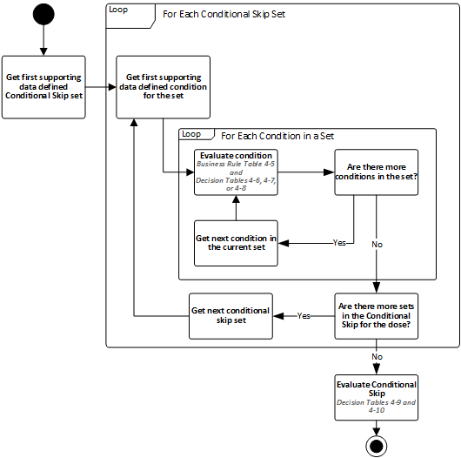

Figure 4 - 3 Conditional Skip Process Model

Table 4 - 4 Conditional skip Attributes

| Attribute Type | Attribute Name | Assumed Value if empty |
| --- | --- | --- |
| Vaccine dose administered | Date Administered | - |
| Processing data | Assessment Date | current date |
| Patient Immunization History | Administered Dose Count | - |
| Calculated date (CALCDTSKIP-3) | Conditional Skip Begin Age Date | - |
| Calculated date (CALCDTSKIP-4) | Conditional Skip End Age Date | - |
| Calculated date (CALCDTSKIP-5) | Conditional Skip Interval Date | - |
| Supporting Data (Conditional Skip) | Conditional Skip Start Date | - |
| Supporting Data (Conditional Skip) | Conditional Skip End Date | - |
| Supporting Data (Conditional Skip) | Conditional Skip Dose Type | - |
| Supporting Data (Conditional Skip) | Conditional Skip Dose Count Logic | - |
| Supporting Data (Conditional Skip) | Conditional Skip Dose Count | - |

Table 4 - 5 CONDITIONAL SKIP BUSINESS RULES

| Business Rule ID | Term | Business Rule |
| --- | --- | --- |
| CONDSKIP-1 | Number of Conditional Doses Administered | The Number of Conditional Doses Administered must be computed as the count of vaccine doses administered where all of the following are true:  Vaccine Type is one of the supporting data defined conditional skip vaccine types.  Date Administered is:   * + - on or after the conditional skip begin age date and before the conditional skip end age date OR     - on or after the conditional skip start date and before conditional skip end date   Evaluation Status is:   * + - “Valid” if the conditional skip dose type is “Valid” OR     - of any status if the conditional skip dose type is “Total” |
| CONDSKIP-2 | Conditional Skip Reference Date | The Conditional Skip Reference Date is one of the following:  The Date Administered of the vaccine dose administered when evaluating a vaccine dose administered.  The Assessment Date when determining a forecast. |

Table 4 - 6 CONDITIONAL Type of Age – Is the Condition Met?

| **CONDITIONS** | **RULES** | |
| --- | --- | --- |
| Is the Conditional Skip Reference Date ≥ Conditional Skip Begin Age Date? | Yes | No |
|  |  |  |
| **OUTCOMES** | Yes. The condition is met. | No. The condition is not met. |

Table 4 - 7 CONDITIONAL Type of Interval – Is the Condition Met?

| **CONDITIONS** | **RULES** | |
| --- | --- | --- |
| Is the Conditional Skip Reference Date ≥ Conditional Skip Interval Date? | Yes | No |
|  |  |  |
| **OUTCOMES** | Yes. The condition is met. | No. The condition is not met. |

Table 4 - 8 CONDITIONAL Type of Vaccine Count By Age or Date – Is the Condition Met?

|  |  | **Number of Conditional Doses Administered (BR: CONDSKIP-1)** | | |
| --- | --- | --- | --- | --- |
|  |  | **Greater than Conditional Skip Dose Count** | **Equal to Conditional Skip Dose Count** | **Less than Conditional Skip Dose Count** |
| **Dose Count Logic** | **Greater Than** | Yes. The condition is met. | No. The condition is not met. | No. The condition is not met. |
| **Equal** | No. The condition is not met. | Yes. The condition is met. | No. The condition is not met. |
| **Less Than** | No. The condition is not met. | No. The condition is not met. | Yes. The condition is met. |

Table 4 - 9 Is the Conditional Skip Set Met?

|  |  | **How many conditions were met?** | | |
| --- | --- | --- | --- | --- |
|  |  | **All** | **At least one, but not all** | **None** |
| **Condition Logic Type** | **AND** | Yes. The set is met. | No. The set is not met. | No. The set is not met. |
| **OR** | Yes. The set is met. | Yes. The set is met. | No. The set is not met. |

Table 4 - 10 Can The Target Dose Be Skipped?

|  |  | **How many sets were met?** | | |
| --- | --- | --- | --- | --- |
|  |  | **All** | **At least one, but not all** | **None** |
| **Set Logic Type** | **AND** | Yes. The target dose can be skipped. The target dose status is “skipped.” | No. The target dose cannot be skipped. | No. The target dose cannot be skipped. |
| **OR** | Yes. The target dose can be skipped. The target dose status is “skipped.” | Yes. The target dose can be skipped. The target dose status is “skipped.” | No. The target dose cannot be skipped. |

## Evaluate Age

*Evaluate age* validates the age at administration of a vaccine dose administered against a defined age range of a target dose. In cases where a target dose does not specify age attributes, the age at administration is considered “valid.”



Figure 4 - 4 Evaluate Age Timeline

The following process model, attribute table and decision table are used to evaluate age at administration.



Figure 4 - 5 Evaluate Age Process Model

Table 4 - 11 Age Attributes

| Attribute Type | Attribute Name | Assumed Value if empty |
| --- | --- | --- |
| Vaccine dose administered | Date Administered | - |
| Calculated date (CALCDTAGE-1) | Maximum Age Date | 12/31/2999 |
| Calculated date (CALCDTAGE-4) | Minimum Age Date | 01/01/1900 |
| Calculated date (CALCDTAGE-5) | Absolute Minimum Age Date | 01/01/1900 |

Table 4 - 12 Was the Vaccine Dose Administered at a Valid Age?

|  |  |  |  |  |  |  |
| --- | --- | --- | --- | --- | --- | --- |
| **CONDITIONS** | **RULES** | | | | | |
| Is the Date administered < absolute minimum age date? | Yes | No | No | No | No | No |
| Is the Absolute minimum age date ≤ date administered < minimum age date? | No | Yes | Yes | Yes | No | No |
| Is the Minimum age date ≤ date administered < maximum age date? | No | No | No | No | Yes | No |
| Is the Date administered > maximum age date? | No | No | No | No | No | Yes |
| Is this the first target dose? | - | No | No | Yes | - | - |
| Is the evaluation status of the previous vaccine dose administered “not valid” due to age or interval recommendations? | - | Yes | No | - | - | - |
|  |  |  |  |  |  |  |
| **OUTCOMES** | No. The vaccine dose administered was not administered at a valid age. Evaluation reason is “too young.” | No. The vaccine dose administered was not administered at a valid age. Evaluation reason is “too young.” | Yes. The vaccine dose administered was administered at a valid age. Evaluation reason is “grace period.” | Yes. The vaccine dose administered was administered at a valid age. Evaluation reason is “grace period.” | Yes. The vaccine dose administered was administered at a valid age. | No. The vaccine dose was administered after the maximum age and is extraneous. Evaluation reason is “too old.” |

## Evaluate Interval

*Evaluate interval* validates the date administered of a vaccine dose administered against defined interval(s) from previous vaccine dose(s) administered. In cases where a target dose does not specify interval attributes, the interval is considered “valid.”

Intervals can be measures in three different ways:

* “From Immediate Previous Dose Administered” requires the interval to be evaluated from the immediate previous vaccine dose administered and is used in the majority of cases.
* “From Target Dose # in Series” requires the interval to be evaluated from the date of the specified dose.
* “From Most Recent” requires the interval to be evaluated from the date of the most recently administered dose of a specific vaccine type (e.g., this is used in Pneumococcal to ensure proper spacing between the different intervals between PCV13 and PPSV23).

It is possible for a given dose to use multiple interval types. For example, dose 3 of HepB and dose 3 of HPV, each have two intervals. The first interval is from the immediate previous vaccine dose administered. The second interval is from satisfied target dose 1 in each respective series. Note that if multiple intervals are specified, then all intervals must be satisfied in order for the dose to satisfy the interval requirements.

Figure 4-6 provides the evaluation interval timeline used to define adjacent intervals by using *from immediate previous dose administered* as the reference point.



Figure 4 - 6 Evaluate Interval 'From Immediate Previous Dose' Timeline

Figure 4-7 illustrates the evaluation interval timeline used to define non-adjacent intervals by using *from target dose number in series* as the reference point. This timeline is used only when from immediate previous dose administered is “N.”



Figure 4 - 7 Evaluate Interval 'From Target Dose Number In Series' Timeline

Figure 4-8 illustrates the evaluation interval timeline used to define most recent vaccine intervals by using *from most recent dose of specified vaccine type* as the reference point.



Figure 4 - 8 Evaluate Interval ‘From MOST RECENT Dose of Specified Vaccine type’ Timeline

The following process model, attribute table, decision table, and business rule table are used to evaluate interval of a vaccine dose administered.

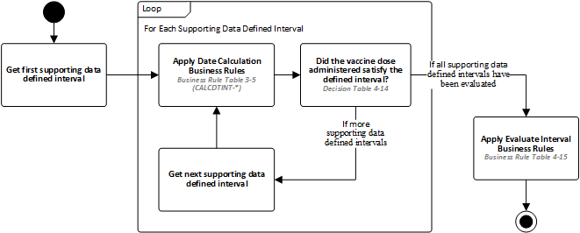

Figure 4 - 9 Evaluate Interval Process Model

Table 4 - 13 Interval Attributes

| Attribute Type | Attribute Name | Assumed Value if empty |
| --- | --- | --- |
| Vaccine dose administered | Date Administered | - |
| Supporting data (Interval) | From Immediate Previous Dose Administered | - |
| Supporting data (Interval) | From Target Dose Number In Series | - |
| Supporting data (Interval) | From Most Recent (CVX) | - |
| Calculated date (CALCDTINT-3) | Absolute Minimum Interval Date | 01/01/1900 |
| Calculated date (CALCDTINT-4) | Minimum Interval Date | 01/01/1900 |

Table 4 - 14 Did the vaccine dose administered satisfy the defined interval?

|  |  |  |  |  |  |
| --- | --- | --- | --- | --- | --- |
| **CONDITIONS** | **RULES** | | | | |
| Is the date administered < absolute minimum interval date? | Yes | No | No | No | No |
| Is the Absolute minimum interval date ≤ date administered < minimum interval date? | No | Yes | Yes | Yes | No |
| Is the Minimum interval date ≤ date administered? | No | No | No | No | Yes |
| Is this the first target dose? | - | No | No | Yes | - |
| Is the evaluation status of the previous vaccine dose administered “not valid” due to age or interval recommendations? | - | Yes | No | - | - |
|  |  |  |  |  |  |
| **OUTCOMES** | No. The vaccine dose administered did not satisfy the defined interval. Evaluation Reason is “too soon.” | No. The vaccine dose administered did not satisfy the defined interval. Evaluation Reason is “too soon.” | Yes. The vaccine dose administered satisfied the defined interval. Evaluation Reason is “grace period.” | Yes. The vaccine dose administered satisfied the defined interval. Evaluation Reason is “grace period.” | Yes. The vaccine dose administered did satisfy the defined interval. |

Table 4 - 15 Evaluate Interval business Rules

| Business Rule ID | Rule |
| --- | --- |
| EVALINT-1 | The vaccine dose administered was administered at a valid interval if all defined intervals were satisfied. |
| EVALINT-2 | The vaccine dose administered was not administered at a valid interval if any of the defined intervals were not satisfied. |

## Evaluate Allowable Interval

*Evaluate allowable interval* validates the date administered of a vaccine dose administered against defined allowable interval(s) from previous vaccine dose(s) administered. In rare cases, intervals can be applied which are either abnormally early – usually specified in ACIP footnotes or subsequent clarifications – or intervals which differ following a not valid administration.

In cases where a target dose does not specify allowable interval attributes, evaluate allowable interval cannot be used to validate a vaccine dose administered. To avoid a false validation, the allowable interval should be considered “not valid” in these cases.

The figure below provides evaluate allowable interval timeline used to define all adjacent intervals by using *from immediate previous dose administered* as the reference dose.



Figure 4 - 10 Evaluate Allowable Interval 'From Immediate Previous Dose' Timeline

The figure below illustrates evaluate allowable interval timeline used to define all non-adjacent intervals by using *from target dose number in series* as the reference dose.



Figure 4 - 11 Evaluate Allowable Interval 'From Target Dose Number In Series' Timeline

The following process model, attribute table, decision table, and business rule table are used to evaluate interval of a vaccine dose administered.



Figure 4 - 12 Evaluate Allowable Interval Process Model

Table 4 - 16 Interval Attributes

| Attribute Type | Attribute Name | Assumed Value if empty |
| --- | --- | --- |
| Vaccine dose administered | Date Administered | - |
| Supporting data (Allowable Interval) | From Immediate Previous Dose Administered | - |
| Supporting data (Allowable Interval) | From Target Dose Number In Series | - |
| Calculated date (CALCDTINT-3) | Absolute Minimum Interval Date | 01/01/1900 |

Table 4 - 17 Did the vaccine dose administered satisfy the defined Allowable interval?

|  |  |  |
| --- | --- | --- |
| **CONDITIONS** | **RULES** | |
| Is the date administered < absolute minimum interval date? | Yes | No |
|  |  |  |
| **OUTCOMES** | No. The vaccine dose administered did not satisfy the defined allowable interval. Evaluation Reason is “too soon.” | Yes. The vaccine dose administered did satisfy the defined allowable interval. |

Table 4 - 18 Evaluate Interval business Rules

| Business Rule ID | Rule |
| --- | --- |
| EVALINT-1 | The vaccine dose administered was administered at a valid interval if all defined intervals were satisfied. |
| EVALINT-2 | The vaccine dose administered was not administered at a valid interval if any of the defined intervals were not satisfied. |

## Evaluate Live Virus Conflict

*Evaluate live virus conflict* validates the date administered of a live virus vaccine dose administered against previous live virus administered vaccines to ensure proper spacing between administrations. For some live virus vaccines and for inactivated virus or recombinant vaccines, this condition does not exist. Therefore, if no live virus supporting data exists for the vaccine dose administered being evaluated, the vaccine dose administered is not in conflict with any other vaccine dose administered.

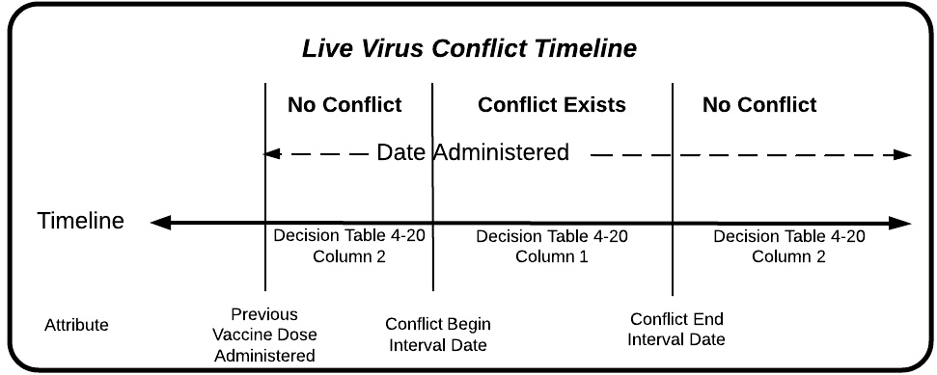

Figure 4 - 13 Evaluate Live Virus Conflict Timeline

The following process model, attribute table, decision tables, and business rule table are used to evaluate for a live virus conflict.



Figure 4 - 14 Evaluate Live Virus Conflict Process Model

Table 4 - 19 Live Virus Conflict Attributes

| Attribute Type | Attribute Name | Assumed Value if empty |
| --- | --- | --- |
| Vaccine dose administered | Date Administered | - |
| Calculated date (CALCDTLIVE-1) | Conflict Begin Interval Date | - |
| Calculated date (CALCDTLIVE-2 & CALCDTLIVE-3) | Conflict End Interval Date | - |
| Supporting Data (Live Virus Conflict) | Current Vaccine Type | - |
| Supporting Data (Live Virus Conflict) | Previous Vaccine Type | - |

Table 4 - 20 Should the Current vaccine dose administered be evaluated for a live virus conflict?

|  |  |  |  |
| --- | --- | --- | --- |
| **CONDITIONS** | **RULES** | | |
| Is the current vaccine type of the vaccine dose administered one of the supporting data defined live virus conflict current vaccine types? | Yes | No | - |
| Is there at least one vaccine dose administered on or before the current vaccine dose administered? | Yes | - | No |
|  |  |  |  |
| **OUTCOMES** | Yes. The vaccine dose administered should be evaluated for a live virus conflict | No. The vaccine dose administered should not be evaluated for a live virus conflict. | No. The vaccine dose administered should not be evaluated for a live virus conflict. |

Table 4 - 21 Could the two vaccine doses adminsitered be in conflict?

|  |  |  |
| --- | --- | --- |
| **CONDITIONS** | **RULES** | |
| Is the vaccine type of the previous vaccine dose administered the same as one of the supporting data defined live virus conflict previous vaccine types when the current vaccine dose administered type is same as the live virus conflict current vaccine type? | Yes | No |
|  |  |  |
| **OUTCOMES** | Yes. The two doses must be checked for a live virus conflict | No. The two doses need not be checked for a live virus conflict |

Table 4 - 22 Is the current vaccine Dose Administered in Conflict with a Previous Vaccine Dose Administered?

|  |  |  |
| --- | --- | --- |
| **CONDITIONS** | **RULES** | |
| Is the conflict begin interval date ≤ current date administered < conflict end interval date? | Yes | No |
|  |  |  |
| **OUTCOMES** | Yes. The vaccine dose administered is in conflict with a previous vaccine dose administered. | No. The vaccine dose administered is not in conflict with a previous vaccine dose administered. |

Table 4 - 23 Live Virus Conflict business Rules

| Business Rule ID | Rule |
| --- | --- |
| CONFLICT-1 | A current vaccine dose administered must be considered to be a conflicting vaccine dose administered if it is in conflict with any previous vaccine doses administered. |
| CONFLICT-2 | A current vaccine dose administered must not be considered to be a conflicting vaccine dose administered if it is not in conflict with any previous vaccine doses administered. |

## Evaluate for Preferable Vaccine

*Evaluate for preferable vaccine* validates the vaccine of a vaccine dose administered against the list of preferable vaccines.

Figures 4-15 depicts a patient who received a preferable vaccine while figure 4-16 depicts a patient who did not receive a preferable vaccine.

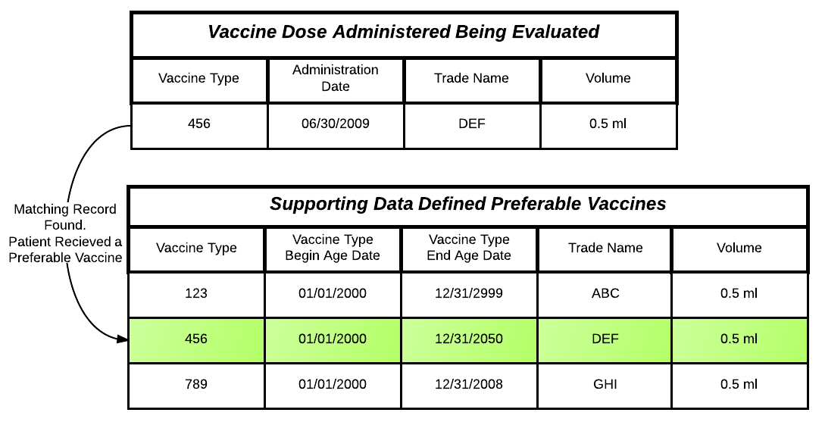

Figure 4 - 15 Patient Received a Preferable Vaccine

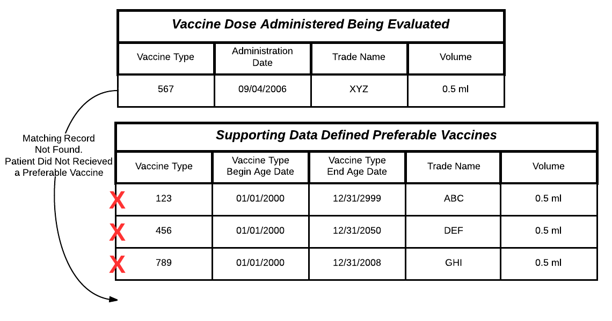

Figure 4 - 16 Patient DID Not Receive a Preferable Vaccine

It should be noted that volume is sparsely populated and tracked differently in most systems. Therefore, volume will not be used to evaluate the validity of a vaccine dose administered. However, it will be provided as an evaluation reason that less than sufficient volume was administered.

The following process model, attribute table, decision table, and business rule table are used to evaluate for a preferable vaccine.



Figure 4 - 17 EvaluatE For a Preferable Vaccine Process Model

Table 4 - 24 Preferable Vaccine Administered Attributes

| Attribute Type | Attribute Name | Assumed Value if empty |
| --- | --- | --- |
| Vaccine dose administered | Date Administered | - |
| Vaccine dose administered | Trade Name | - |
| Calculated date (CALCDTPREF-1) | Vaccine Type Begin Age Date | 01/01/1900 |
| Calculated date (CALCDTPREF-2) | Vaccine Type End Age Date | 12/31/2999 |
| Supporting data (Preferable Vaccine) | Preferable Vaccine Trade Name | Equal to the vaccine dose administered trade name. |
| Supporting data (Preferable Vaccine) | Preferable Vaccine Volume | Equal to the vaccine dose administered volume. |

Table 4 - 25 Was the supporting data defined preferable vaccine administered?

|  |  |  |  |  |  |
| --- | --- | --- | --- | --- | --- |
| **CONDITIONS** | **RULES** | | | | |
| Is the vaccine type of the vaccine dose administered the same as the vaccine type of the preferable vaccine? | Yes | Yes | No | Yes | Yes |
| Is the Preferable vaccine type begin age date ≤ date administered < preferable vaccine type end age date? | Yes | Yes | - | No | Yes |
| Is the vaccine dose administered trade name the same as the preferable vaccine trade name? | Yes | Yes | - | - | No |
| Is the Vaccine dose administered volume >= preferable vaccine volume? | Yes | No | - | - | - |
|  |  |  |  |  |  |
| **OUTCOMES** | Yes. A preferable vaccine was administered. | Yes. A preferable vaccine was administered. Evaluation Reason is volume administered is “less than recommended volume.” | No. This supporting data defined preferable vaccine was not administered. | No. This supporting data defined preferable vaccine was administered out of the preferred age range. | No. This supporting data defined preferable vaccine was of the wrong trade name. |

Table 4 - 26 Preferable Vaccine business Rules

| Business Rule ID | Rule |
| --- | --- |
| PREFERABLE-1 | The patient has received a preferable vaccine if one of the supporting data defined preferable vaccines were administered. |
| PREFERABLE-2 | The patient has not received a preferable vaccine if none of the supporting data defined preferable vaccines were administered. |

## Evaluate for Allowable Vaccine

*Evaluate for allowable vaccine* validates the vaccine of a vaccine dose administered against the list of allowable vaccines.

Figures 4-18 depicts a patient who received an allowable vaccine while figure 4-19 depicts a patient who did not receive an allowable vaccine.

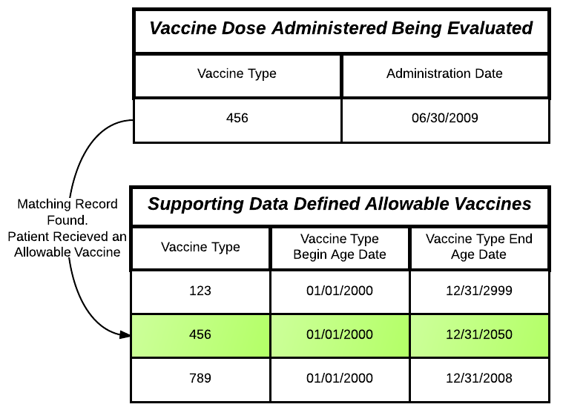

Figure 4 - 18 Patient Received an Allowable Vaccine

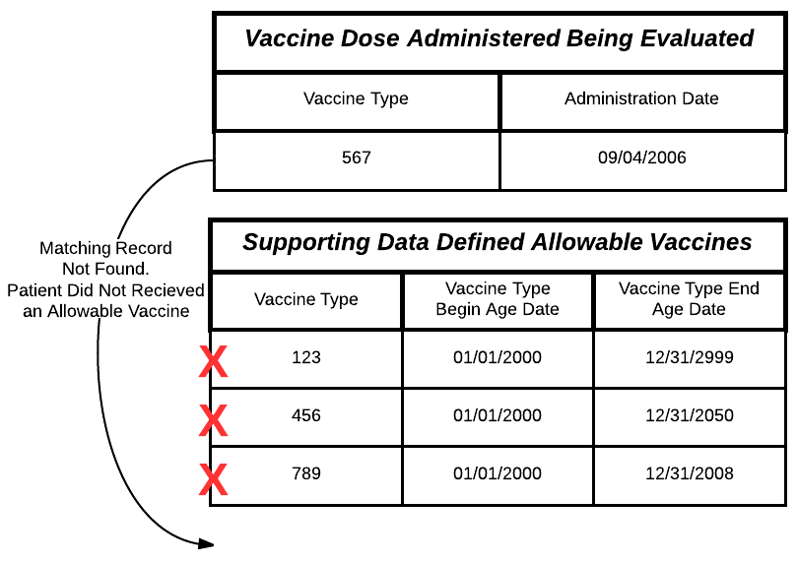

Figure 4 - 19 Patient DID Not Receive an Allowable Vaccine

The following process model, attribute table, decision table, and business rule table are used to evaluate for an allowable vaccine.



Figure 4 - 20 Evaluate For an Allowable Vaccine Process Model

Table 4 - 27 Allowable Vaccine Attributes

| Attribute Type | Attribute Name | Assumed Value if empty |
| --- | --- | --- |
| Vaccine dose administered | Date Administered | - |
| Vaccine dose administered | Vaccine Type | - |
| Supporting data (Allowable Vaccine) | Vaccine Type | - |
| Calculated date (CALCDTALLOW-1) | Allowable Vaccine Type Begin Age Date | 01/01/1900 |
| Calculated date (CALCDTALLOW-2) | Allowable Vaccine Type End Age Date | 12/31/2999 |

Table 4 - 28 Was the supporting data defined Allowable vaccine administered?

|  |  |  |  |
| --- | --- | --- | --- |
| **CONDITIONS** | **RULES** | | |
| Is the vaccine type of the vaccine dose administered the same as the vaccine type of the allowable vaccine? | Yes | No | Yes |
| Is the Allowable vaccine type begin age date ≤ date administered < allowable vaccine type end age date? | Yes | - | No |
|  |  |  |  |
| **OUTCOMES** | Yes. An allowable vaccine was administered. | No. This supporting data defined allowable vaccine was not administered. | No. This supporting data defined allowable vaccine was administered out of the allowable age range. |

Table 4 - 29 Allowable Vaccine business Rules

| Business Rule ID | Rule |
| --- | --- |
| ALLOWABLE-1 | The patient has received an allowable vaccine if one of the supporting data defined allowable vaccines were administered. |
| ALLOWABLE-2 | The patient has not received an allowable vaccine if none of the supporting data defined allowable vaccines were administered. |

## Evaluate Gender

*Evaluate gender* validates the *patient* gender against the *required* gender. In cases where a target dose does not specify gender attributes, the gender is valid.

The following process model, attribute table, and decision table are used to evaluate the gender.



Figure 4 - 21 Gender Process Model

Table 4 - 30 Gender Attributes

| Attribute Type | Attribute Name | Assumed Value if empty |
| --- | --- | --- |
| Patient | Gender | Unknown |
| Supporting data (Gender) | Required Gender | - |

Table 4 - 31 Is the Patient's Gender One of the Required Genders?

|  |  |  |
| --- | --- | --- |
| **CONDITIONS** | **RULES** | |
| Is the patient’s gender the same as one of the required genders? | Yes | No |
|  |  |  |
| **OUTCOMES** | Yes. Patient’s gender is one of the required genders. | No. Patient’s gender is not one of the required genders. Evaluation Reason is “incorrect gender.” |

## Satisfy Target Dose

*Satisfy target dose* uses the results from the previous evaluation sections as conditions to determine if the target dose is satisfied.

The following processing model and decision table are used to determine if the target dose was satisfied.



Figure 4 - 22 Satisfy Target Dose Process Model

Table 4 - 32 Was the Target Dose Satisfied?

|  |  |  |  |  |  |  |  |
| --- | --- | --- | --- | --- | --- | --- | --- |
| **CONDITIONS** | **RULES** | | | | | | |
| Was the vaccine dose administered at a valid age? | Yes | Extraneous | No | - | - | - | - |
| Was the vaccine dose administered at a valid or allowable interval? | Yes | - | - | No | - | - | - |
| Was the vaccine dose administered in conflict with any previous live virus vaccine doses administered? | No | - | - | - | Yes | - | - |
| Did the patient receive either a preferable or allowable vaccine? | Yes | - | - | - | - | No | - |
| Is the patient’s gender one of the required genders? | Yes | - | - | - | - | - | No |
|  |  |  |  |  |  |  |  |
| **OUTCOMES** | Yes. The target dose status is “satisfied.”  Evaluation status is “valid” with possible evaluation reason(s). | No. The target dose status is “not satisfied.”  Evaluation status is “extraneous” with possible evaluation reason(s). | No. The target dose status is “not satisfied.”  Evaluation status is “not valid” with evaluation reason(s). | No. The target dose status is “not satisfied.”  Evaluation status is “not valid” with evaluation reason(s). | No. The target dose status is “not satisfied.”  Evaluation status is “not valid” with evaluation reason(s). | No. The target dose status is “not satisfied.”  Evaluation status is “not valid” with evaluation reason(s). | No. The target dose status is “not satisfied.”  Evaluation status is “not valid” with evaluation reason(s). |

# Forecast Dates and Reasons

A CDS engine uses a patient’s medical and vaccine history to forecast immunization due dates. This chapter identifies specific business rules that are used by a CDS engine to forecast the next target dose. The major steps involved in this process are listed in the table below.

Table 5 - 1 Forecast Dates and Reasons Process Steps

| Section | Activity | Goal |
| --- | --- | --- |
| 5.1 | Evaluate Dose Conditional Skip | The goal of this step is to determine if the target dose can be skipped due to a patient’s age at assessment or immunization history. |
| 5.2 | Determine Evidence of Immunity | The goal of this step is to determine if the patient has evidence of immunity. |
| 5.3 | Determine Forecast Need | The goal of this step is to determine if the patient should receive another dose. |
| 5.4 | Generate Forecast Dates | The goal of this step is to generate forecast dates for the next target dose. |

The figure below provides an illustration of the *forecast dates and reasons* process.

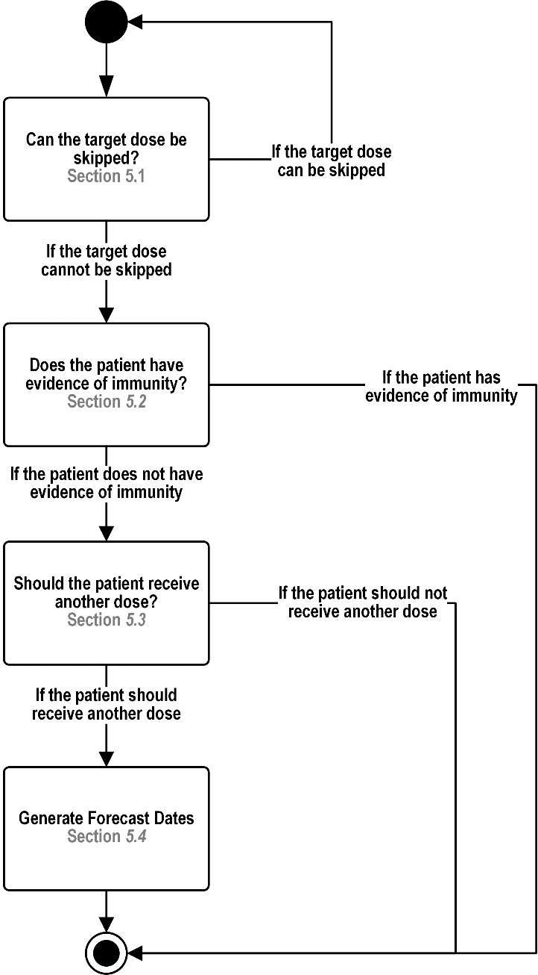

Figure 5 - 1 Forecast Dates and Reason Process Model

## Evaluate Conditional Skip

*Evaluate Conditional Skip* addresses times when a target dose can be skipped. A dose should be considered necessary unless it is determined that it can be skipped. The most common scenarios for skipping a dose are:

* Catch-up doses where the patient is current with their administrations and does not need to catch-up
* The patient is behind schedule and the total number of doses needed to satisfy the patient series can be reduced
* The previously administered dose(s) negates the need for the current target dose

In cases where a target dose does not specify Conditional Skip attributes, the target dose cannot be skipped.

The process model, attribute table, and decision table are used to determine if the target dose can be skipped is the same as described in Chapter 4.2.

## Determine Evidence of Immunity

*Determine evidence of immunity* assesses the patient’s profile to determine if the patient is already potentially immune to the target disease, negating the need for additional doses. A patient may be considered immune due to their clinical history or if they were born before a defined date for the given target disease. For example, for measles, a patient is considered immune if they have a clinical finding of “Measles immune” or if they were born before 01/01/1957. Additional patient attributes, such as occupation or pregnancy status, may supersede the birth date logic.



Figure 5 - 2 Evidence of Immunity Process Model

Table 5 - 2 Immunity Attributes

| Attribute Type | Attribute Name | Assumed Value if empty |
| --- | --- | --- |
| Patient Data | Date of Birth | - |
| Patient Data | Country of Birth | - |
| Calculated date (CALCDTAGE-1) | Maximum Age Date | 12/31/2999 |
| Supporting Data (Clinical History Immunity) | Immunity Guideline | - |
| Supporting Data (Birth Date Immunity) | Immunity Date | - |
| Supporting Data (Birth Date Immunity) | Exclusion Condition | - |
| Supporting Data (Birth Date Immunity) | Country of Birth | - |

Table 5 - 3 Does the patient have Evidence of Immunity?

|  |  |  |  |  |  |  |
| --- | --- | --- | --- | --- | --- | --- |
| **CONDITIONS** | **RULES** | | | | | |
| Does the patient's clinical history contain one of the supporting data defined immunity guidelines? | Yes | No | No | No | | No |
| Is the patient's date of birth < the supporting data defined immunity date? | - | Yes | Yes | Yes | | No |
| Does this patient have an exclusion condition to the immunity? | - | Yes | No | No | | - |
| Is the patient’s country of birth the same as the supporting data defined country of birth? | - | - | Yes | No | | - |
|  |  |  |  |  | |  |
| **OUTCOMES** | Yes. The patient has evidence of immunity.  Patient Series Status is “Immune.”.  Forecast reason is “patient has evidence of immunity.” | No. The patient does not have evidence of immunity. | Yes. The patient has evidence of immunity.  Patient Series Status is “Immune”.  Forecast reason is “patient has evidence of immunity.” | No. The patient does not have evidence of immunity. | No. The patient does not have evidence of immunity. | |

## Determine Forecast Need

*Determine forecast need* determines if there is a need to forecast dates. This involves reviewing patient data, antigen administered records, and patient series. This is a prerequisite before a CDS engine can produce forecast dates and reasons.

The following process model, attribute table, and decision table are used to determine the need to generate forecast dates.



Figure 5 - 3 Determine Forecast Need Process Model

Table 5 - 4 Determine forecast need attributes

| Attribute Type | Attribute Name | Assumed Value if empty |
| --- | --- | --- |
| Immunization history | Vaccine Dose(s) Administered | - |
| Immunization history | Adverse Events | - |
| Medical history | Relevant Medical Observation | - |
| Patient series | Target Dose (s) | - |
| Calculated date (CALCDTAGE-1) | Maximum Age Date | 12/31/2999 |
| Supporting data (Seasonal Recommendation) | End Date | 12/31/2999 |
| Data entry | Assessment Date | current date |
| Supporting Data | Contraindication | - |
| Supporting Data | Immunity | - |

Table 5 - 5 Should the patient receive another target dose?

|  |  |  |  |  |  |  |
| --- | --- | --- | --- | --- | --- | --- |
| **CONDITIONS** | **RULES** | | | | | |
| Does the patient have at least one target dose with a target dose status of “not satisfied”? | Yes | No | No | - | - | - |
| Does the patient have at least one target dose with a target dose status of “satisfied’? | - | Yes | No | - | - | - |
| Is the patient without a contraindication for this patient series? | Yes | - | - | No | - | - |
| Is the assessment date < the maximum age date? | Yes | - | - | - | No | - |
| Is the assessment date < seasonal recommendation end date? | Yes | - | - | - | - | No |
|  |  |  |  |  |  |  |
| **OUTCOMES** | Yes. The patient should receive another dose.  Patient Series Status is “Not Complete” | No. The patient should not receive another dose.  Patient Series Status is “Complete”  Forecast reason is “patient series is complete.” | No. The patient should not receive another dose.  Patient series status is “Not Recommended”  Forecast reason is “not recommended at this time due to past immunization history” | No. The patient should not receive another dose.  Patient Series Status is “Contraindicated”  Forecast reason is “patient has a contraindication.” | No. The patient should not receive another dose.  Patient Series Status is “Aged Out”  Forecast reason is “patient has exceeded the maximum age.” | No. The patient should not receive another dose.  Patient Series Status is “Not Complete”  Forecast reason is “past seasonal recommendation end date.” |

## Generate Forecast Dates and Recommended Vaccines

*Generate forecast dates and recommend vaccines* determines the forecast dates for the next target dose and identifies one or more recommended vaccines if the target dose warrants specific vaccine recommendations. The forecast dates are generated based on the patient’s immunization history. If the patient has not adhered to the preferred schedule, then the forecast dates are adjusted to provide the best dates for the next target dose. Figure 5-4 below provides an illustration of how forecast dates appear on the timeline.

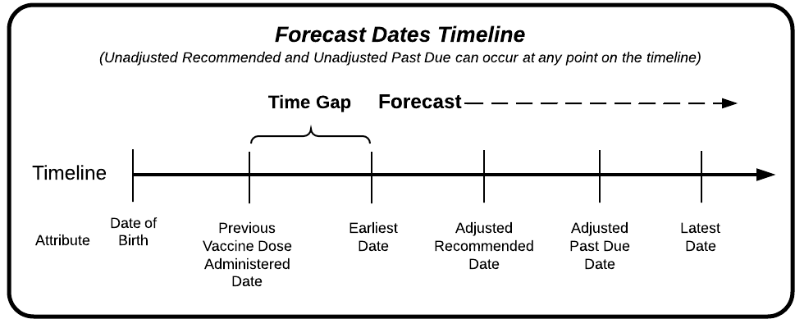

Figure 5 - 4 Forecast Dates Timeline

The following process model, attribute table, and business rule table are used to generate forecast dates. If an attribute value is empty, then the date calculations will remain empty. No assumptions will be made for the attribute.



Figure 5 - 5 Generate Forecast Dates and Recommended Vaccine Process Model

Table 5 - 6 Generate forecast Dates and Recommended Vaccine attributes

| Attribute Type | Attribute Name | Assumed Value if empty |
| --- | --- | --- |
| Calculated date (CALCDTAGE-4) | Minimum Age Date | - |
| Calculated date (CALCDTAGE-3) | Earliest Recommended Age Date | - |
| Calculated date (CALCDTAGE-2) | Latest Recommended Age Date | - |
| Calculated date (CALCDTAGE-1) | Maximum Age Date | - |
| Calculated date (CALCDTINT-4) | Minimum Interval Date(s) | - |
| Calculated date (CALCDTINT-5) | Earliest Recommended Interval Date(s) | - |
| Calculated date (CALCDTINT-6) | Latest Recommended Interval Date(s) | - |
| Calculated date (CALCDTLIVE-4) | Latest Conflict End Interval Date | - |
| Supporting data (Seasonal Recommendation) | Seasonal Recommendation Start Date | 01/01/1900 |
| Supporting data (Preferable Vaccine) | Vaccine Type (CVX) | - |
| Supporting data (Preferable Vaccine) | Forecast Vaccine Type | N |

Table 5 - 7 Generate forecast date and Recommended Vaccine Business rules

| Business Rule ID | Term | Business Rule |
| --- | --- | --- |
| FORECASTDT-1 | Earliest Date | The Earliest date must be the latest of the following dates:   1. Minimum age date 2. Latest minimum interval date 3. Latest conflict end interval date 4. Seasonal recommendation start date |
| FORECASTDT-2 | Unadjusted Recommended Date | The unadjusted recommended date must be one of the following:   1. The earliest recommended age date. 2. The latest of all earliest recommended interval dates if the earliest recommended age date is not present. 3. The forecast earliest date if the earliest recommended age date and earliest recommended interval date are not present. |
| FORECASTDT-3 | Unadjusted Past Due Date | The unadjusted past due date must be one of the following:   1. The latest recommended age date – 1 day. 2. The latest of all latest recommended interval dates – 1 day if the latest recommended age date is not present. 3. The unadjusted past due date must be empty if latest recommended age date and latest recommended interval date(s) are not present. |
| FORECASTDT-4 | Latest Date | The latest date must be the maximum age date – 1 day if present. |
| FORECASTDT-5 | Adjusted Recommended Date | The adjusted recommended date must be the later of the earliest date and unadjusted recommended date. |
| FORECASTDT-6 | Adjusted Past Due Date | The adjusted past due date must be one of the following:   * 1. The later of the earliest date and the unadjusted past due date if the unadjusted past due date is present.   2. Empty if the unadjusted past due date is not present. |
| FORECASTRECVAC-1 | Recommended Vaccine | The Recommended Vaccines must be all Supporting Data defined Preferable Vaccine Types where the Forecast Vaccine Type is “Y”. |

# Select Best Patient Series

*Select best patient series* involves reviewing all potential patient series which might satisfy the goals of an antigen and determining the one series which best fits the patient based on several important factors. The four steps of this process are listed in table 6-1.

Table 6 - 1 Select Best Patient Series Process Steps

| Section | Activity | Goal |
| --- | --- | --- |
| 6.2 | Identify Superior Patient Series | The goal of this step is to determine if one patient series is superior to the other entire patient series. |
| 6.3 | Classify Patient Series | The goal of this step is to classify where the patient is in the overall path to immunity and pass those candidate patient series on to the next step. Only those patient series with the most likely chance to be considered the best are retained for further consideration. |
| 6.4-6.6 | Scoring Patient Series | The goal of this step is to apply the proper scoring business rules based on results of the second step. The scoring business rules will determine the best patient series. Scoring business rules are specific to where the patient is in the overall path to immunity. The complete patient series scoring business rules look at factors important when candidate patient series are complete. Similarly in-process patient series scoring business rules and no valid doses scoring business rules look at factors important to their respective situation. For any given antigen, only one set of these scoring business rules will be applied to each candidate patient series. |
| 6.7 | Select Best Patient Series | The goal of this step is to evaluate the scored candidate patient series and determine which of the candidate patient series is the one and only *best patient series*. |

The process model below illustrates the major steps involved in selecting the best patient series.

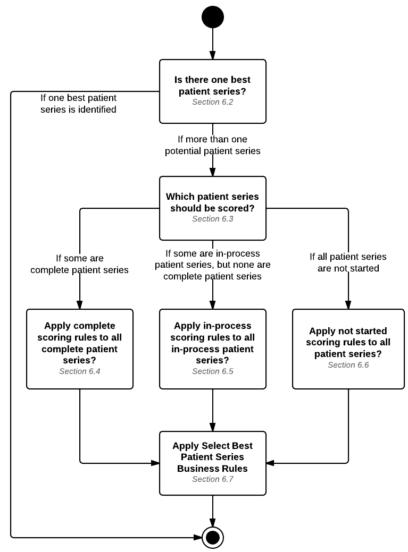

Figure 6 - 1 Select Best Patient Series Process Model

## Select best patient series vocabulary

The following table provides the vocabulary used during the process of selecting the best patient series.

Table 6 - 2 Select Best Patient Series Vocabulary

| Business Rule ID | Term | Definition or Definitional Rule |
| --- | --- | --- |
| SELECTB-1 | **Actual Finish Date** | The *actual finish date* of a complete patient series must be considered the latest date administered of a vaccine dose administered with an evaluation status “valid.” |
| SELECTB-2 | **All Valid Doses** | A patient series has *all valid doses* if all doses administered have an evaluation status “valid.” |
| SELECTB-3 | **Completable** | A patient series must be considered *completable* if the forecast finish date is less than the maximum age date of the last target dose. |
| SELECTB-4 | **Candidate Patient Series** | A *candidate patient series* is a patient series considered for scoring. |
| SELECTB-5 | **Closest to Completion** | A patient series must be considered the *closest to completion* if the number of not satisfied target doses is less than the number of not satisfied target doses in all other candidate patient series. |
| SELECTB-6 | **Complete Patient Series** | A patient series must be considered a *complete patient series* if the patient series status is “complete.” |
| SELECTB-7 | **Default Patient Series** | A patient series must be considered the default patient series if the supporting data defined default series is “Yes.” |
| SELECTB-8 | **Earliest Completing** | A complete patient series must be considered to be the *earliest completing* if the actual finish date is before the actual finish date for all other complete patient series. |
| SELECTB-9 | **Exceeded Maximum Age** | A patient series must be considered to have *exceeded maximum age* if the patient series status is “Aged Out.” |
| SELECTB-10 | **Exceeded Maximum Age to Start** | A patient series must be considered to have *exceeded maximum age to start* if the date administered of the first valid vaccine dose administered is on or after the maximum age to start date. |
| SELECTB-11 | **Finish Earliest** | A patient series can *finish earliest* if the patient series is completable and the forecast finish date is earlier than the forecast finish date in all other completable candidate patient series. |
| SELECTB-12 | **Forecast Finish Date** | The *forecast finish date* for a patient series must be calculated as the forecast earliest date plus the latest minimum interval from the remaining target dose(s). |
| SELECTB-13 | **Forecast Start Date** | The *start date* for a patient series must be the forecast earliest date if the number of valid doses for the patient series is 0. |
| SELECTB-14 | **Forecast Start Earliest** | A patient series must be considered start *earliest* if the start date is before the start date for all other candidate patient series with a start date. |
| SELECTB-15 | **Gender-Specific Patient Series** | A patient series must be considered a *gender-specific patient series* if a required gender for dose 1 of the supporting data is given. |
| SELECTB-16 | **In-Process Patient Series** | An *in-process patient series* must be a patient series with at least one target dose status “satisfied” and the patient series status “not complete.” |
| SELECTB-17 | **Maximum Age to Start Date** | The *maximum age to start date* must be calculated as the patient’s date of birth plus the Select Best Patient Series Maximum Age To Start. |
| SELECTB-18 | **Minimum Age to Start Date** | The *minimum age to start date* must be calculated as the patient’s date of birth plus the Select Best Patient Series Minimum Age To Start. |
| SELECTB-19 | **Most Valid Doses** | A patient series has the *most valid doses* if the number of valid doses is greater than the number of valid doses in all other candidate patient series. |
| SELECTB-20 | **Number of Not Satisfied Target Doses** | The *number of not satisfied target doses* must be the count of Target Doses with the status “Not Satisfied”. |
| SELECTB-21 | **Number of Valid Doses** | The *number of valid doses* must be the count of Target Doses with the status “satisfied.” |
| SELECTB-22 | **Preferred Candidate Patient Series** | A candidate patient series must be considered the preferred candidate patient series if it has the highest series preference of all candidate patient series. Note: 1 is more preferred than 2 and so on. |
| SELECTB-23 | **Product Patient Series** | A *product patient series* must have the supporting data “patient path” attribute specified as “Yes.” |

## One Best Patient Series

One best patient series examines all of the patient series for a given antigen to determine if one of the patient series is superior to all other patient series and can be considered the best patient series.

Table 6 - 3 Is there one best patient series?

|  |  |  |  |  |  |
| --- | --- | --- | --- | --- | --- |
| **CONDITIONS** | **RULES** | | | | |
| Antigen contains only 1 patient series? | Yes | No | No | No | No |
| Patient has only 1 complete patient series? | - | Yes | No | No | No |
| Patient has only 1 in-process patient series and no complete patient series? | - | - | Yes | No | No |
| Patient has all Patient Series with 0 valid doses and 1 patient series is identified as the default patient series? | - | - | - | Yes | No |
|  |  |  |  |  |  |
| **OUTCOMES** | Yes. The lone patient series is the best patient series. | Yes. The lone complete patient series is the best patient series. | Yes. The lone in-process patient series is the best patient series. | Yes. The default patient series is the best patient series. | No. More than one patient series has potential. All patient series are examined to see which should be scored and selected as the best patient series. |

## Classify Patient Series

Classify patient series is an attempt to reduce the total number of patient series to only those which have a chance to be selected as the best patient series.

Table 6 - 4 Which patient series should be scored?

|  |  |  |  |
| --- | --- | --- | --- |
| **CONDITIONS** | **RULES** | | |
| 2 or more are complete patient series? | Yes | No | No |
| 2 or more are in-process patient series and 0 are complete patient series? | - | Yes | No |
| All Patient Series have 0 valid doses? | - | No | Yes |
|  |  |  |  |
| **OUTCOMES** | Apply complete patient series scoring business rules to all complete patient series. In-process patient series and patient series with 0 valid doses are not scored and dropped from consideration. | Apply in-process patient series scoring business rules to all in-process patient series. Patient Series with 0 valid doses are not scored and dropped from consideration. | Apply no valid doses scoring business rules to all patient series. |

## Complete Patient Series

Complete patient series provides the decision table for determining the number of points to assign to a complete patient series based on a specified condition.

Table 6 - 5 How many points are awarded to a complete patient series when 2 or more candidate patient series are complete?

|  |  |  |  |
| --- | --- | --- | --- |
| **Conditions** | **If this condition is true for the candidate patient series** | **If this condition is true for two or more candidate patient series** | **If this condition is not true for the candidate patient series** |
| A candidate patient series has the most valid doses. | +1 | 0 | -1 |
| A candidate patient series is a product patient series and has all valid doses. | +1 | n/a | -1 |
| A candidate patient series is the earliest completing. | +2 | +1 | -1 |

## In-process Patient Series

In-process patient series provides the decision table for determining the number of points to assign to an in-process patient series based on a specified condition.

Table 6 - 6 How many points are awarded to an in-process patient series when 2 or more candidate patient series are in-process and no candidate patient series are complete?

|  |  |  |  |
| --- | --- | --- | --- |
| **Conditions** | **If this condition is true for the candidate patient series** | **If this condition is true for two or more candidate patient series** | **If this condition is not true for the candidate patient series** |
| A candidate patient series is a product patient series and has all valid doses. | +2 | n/a | -2 |
| A candidate patient series is completable. | +3 | n/a | -3 |
| A candidate patient series has the most valid doses. | +2 | 0 | -2 |
| A candidate patient series is closest to completion. | +2 | 0 | -2 |
| A candidate patient series can finish earliest. | +1 | 0 | -1 |
| A candidate patient series exceeded maximum age to start. | -10 | n/a | 0 |

## No valid doses

This section provides the decision table for determining the number of points to assign to a candidate patient series when there are no valid doses.

Table 6 - 7 How many points are awarded to a candidate patient series when all patient series have 0 valid doses and no default patient series is specified?

|  |  |  |  |
| --- | --- | --- | --- |
| **Conditions** | **If this condition is true for the candidate patient series** | **If this condition is true for two or more candidate patient series** | **If this condition is not true for the candidate patient series** |
| A candidate patient series can start earliest. | +1 | 0 | -1 |
| A candidate patient series is completable. | +1 | n/a | -1 |
| A candidate patient series is a gender-specific patient series and the patient’s gender matches a required gender specified on the first target dose. | +1 | n/a | 0 |
| A candidate patient series is a product patient series. | -1 | n/a | +1 |
| A candidate patient series has exceeded maximum age. | -1 | n/a | +1 |

## Select Best Candidate Patient Series

*Select best candidate patient series* provides the business rules to be applied to the scored candidate patient series which will result in the best patient series for the patient.

Table 6 - 8 Select Best Patient Series Business Rules

| Business Rule ID | Rule |
| --- | --- |
| SELECTBEST-1 | The candidate patient series score must be the sum of all points awarded to the candidate patient series. |
| SELECTBEST-2 | The best patient series must be one of the following:   * The candidate patient series with the highest candidate patient series score * The preferred candidate patient series if more than one candidate patient series are tied for the highest candidate patient series score. |

# Identify and Evaluate Vaccine Group

*Identify and evaluate vaccine group* combines patient series into a vaccine group-based forecast to provide a common and consistent view for a forecast. In the evaluation, forecasting, and select best patient series chapters, all logic was specified for antigens. At this point it is important to define how those antigen-based evaluation and forecasting results can be merged into vaccine group forecasts.

Relationship to ACIP Recommendations

* At present, MMR and DTaP/Tdap/Td vaccine groups are comprised of multiple antigens. MMR contains the antigens Measles, Mumps, and Rubella. DTaP/Tdap/Td contains the antigens Diphtheria, Tetanus, and Pertussis.

Table 7 - 1 Identify and evaluate vaccine group process steps

| Section | Activity | Goal |
| --- | --- | --- |
| 7.1 | Classify vaccine group | The goal of this activity is to classify the type of vaccine group and the patient’s current path towards immunity. This step will determine which set of vaccine group forecasting rules to apply. |
| 7.2 | Single antigen vaccine group | The goal of this activity is to apply the business rules necessary to generate a vaccine group based forecast in situations where only a single antigen is associated with a vaccine group |
| 7.3 | Multiple antigen vaccine group | The goal of this activity is to apply the decision logic and business rules necessary to generate a vaccine group based forecast in situations where more than one antigen is associated with a vaccine group. |

The following figure provides an illustration of the identifying and evaluating vaccine group process.

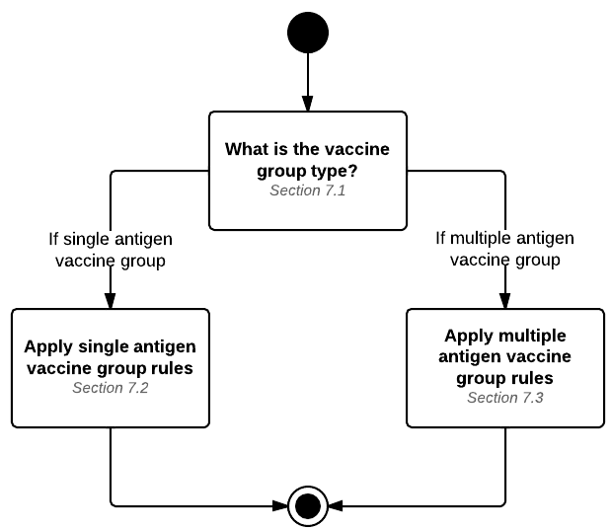

Figure 7 - 1 Identify and evaluate vaccine group process model

## Classify Vaccine Group

Classify vaccine group provides initial questioning to determine which vaccine group forecast rules to apply.

Table 7 - 2 What is the vaccine group type?

|  |  |  |
| --- | --- | --- |
| **CONDITION** | **RULES** | |
| Does the vaccine group contain exactly 1 antigen? | Yes | No |
|  |  |  |
| **OUTCOME** | Vaccine group is a single antigen vaccine group. | Vaccine group is a multiple antigen vaccine group. |

## Single Antigen Vaccine Group

The forecasting rules which need to be applied to a single antigen vaccine group are listed in the table below.

Table 7 - 3 Single antigen vaccine group rules

| Business Rule ID | Rule |
| --- | --- |
| SINGLEANTVG-1 | The vaccine group status for a single antigen vaccine group must be the patient series status of the best patient series. |
| SINGLEANTVG-2 | The vaccine group forecast earliest date for a single antigen vaccine group must be the best patient series forecast earliest date. |
| SINGLEANTVG-3 | The vaccine group forecast adjusted recommended date for a single antigen vaccine group must be the best patient series forecast adjusted recommended date. |
| SINGLEANTVG-4 | The vaccine group forecast adjusted past due date for a single antigen vaccine group must be the best patient series forecast adjusted past due date. |
| SINGLEANTVG-5 | The vaccine group forecast latest date for a single antigen vaccine group must be the best patient series forecast latest date. |
| SINGLEANTVG-6 | The vaccine group forecast unadjusted recommended date for a single antigen vaccine group must be the best patient series forecast unadjusted recommended date. |
| SINGLEANTVG-7 | The vaccine group forecast unadjusted past due date for a single antigen vaccine group must be the best patient series forecast unadjusted past due date. |
| SINGLEANTVG-8 | The vaccine group forecast reason for a single antigen vaccine group must be set the best patient series forecast reason. |
| SINGLEANTVG-9 | The vaccine group forecast antigens needed for a single antigen vaccine group must be the best patient series target disease. |
| SINGLEANTVG-10 | The vaccine group forecast recommended vaccines for a single antigen vaccine group must be the best patient series forecast recommended vaccines. |

## Multiple Antigen Vaccine Group

The forecasting decisions and rules which need to be applied to a multiple antigen vaccine group are listed below.

Table 7 - 4 What is the vaccine group status of a Multiple Antigen Vaccine Group?

|  |  |  |  |  |  |  |
| --- | --- | --- | --- | --- | --- | --- |
| **CONDITION** | **RULES** | | | | | |
| Is there at least one best patient series status of “Not Completed”? | No | No | - | Yes | Yes | - |
| Are all best patient series status “Immune”? | No | No | No | No | No | Yes |
| Is there at least one best patient series status of “Contraindicated”? | No | Yes | Yes | No | - | - |
| Is the recommendation for the vaccine group to administer full vaccine group? | - | No | Yes | Yes | No | - |
|  |  |  |  |  |  |  |
| **OUTCOME** | Complete | Contraindicated | Contraindicated | Not Complete | Not Complete | Immune |

Table 7 - 5 Multiple antigen vaccine group rules

| Business Rule ID | Rule |
| --- | --- |
| MULTIANTVG-1 | A vaccine group forecast earliest date for multiple antigen vaccine groups must be one of the following:  The latest of all best patient series forecast earliest dates if each best patient series interval priority flag is “n/a” for the target dose being forecast.  The earliest of all best patient series forecast earliest dates where the interval priority flag is “override” for the target dose being forecast. |
| MULTIANTVG-2 | A vaccine group forecast adjusted recommended date for multiple antigen vaccine groups must be the latest of the following dates:  the earliest of all best patient series forecast adjusted recommended dates  the vaccine group forecast earliest date |
| MULTIANTVG-3 | A vaccine group forecast adjusted past due date for multiple antigen vaccine groups must be the latest of the following dates:   * + the earliest of all best patient series forecast adjusted past due dates   + the vaccine group forecast earliest date |
| MULTIANTVG-4 | A vaccine group forecast latest date for multiple antigen vaccine groups must be the earliest of all best patient series forecast latest dates. |
| MULTIANTVG-5 | A vaccine group forecast unadjusted recommended date for multiple antigen vaccine groups must be the earliest of all best patient series forecast unadjusted recommended dates. |
| MULTIANTVG-6 | A vaccine group forecast unadjusted past due date for multiple antigen vaccine groups must be the earliest of all best patient series forecast unadjusted past due dates. |
| MULTIANTVG-7 | A vaccine group forecast reason for multiple antigen vaccine groups must include all the forecast reasons from each best patient series. |
| MULTIANTVG-8 | The vaccine group forecast antigens needed for multiple antigen vaccine groups must be the collection of best patient series target disease with patient series status "not complete." |
| MULTIANTVG-9 | The vaccine group forecast recommended vaccines for multiple antigen vaccine groups must be the collection of best patient series forecast recommended vaccines. |

# Processing Model

At a very simple level, the major logical steps involved in the immunization evaluation and forecasting engine can be described in two parts. The first part, illustrated by the top row in figure 8-1, is very mechanical in nature and focuses on gathering and prepping all of the required data. The second part illustrated by the bottom row in Figure 8-1 uses the data gathered in the top row to generate the evaluation and forecast via three major steps.

The following table lists the major steps of the processing model.

Table 8 - 1 Logic Specification Processing Steps

| Section | Activity | Goal |
| --- | --- | --- |
| 8.1 | Gather Necessary Data | The goal of this step is to gather all pertinent information which will be used in subsequent steps in the process. |
| 8.2 | Create All Patient Series | The goal of this step is to instantiate all antigen series defined through supporting data into patient series for this patient. |
| 8.3 | Prepare Immunization History | The goal of this step is to break apart vaccine doses administered into their antigen parts. |
| 8.4 | For Each Patient Series, Perform Evaluation and Forecast | The goal of this step is to evaluate (chapter 4) each antigen administered and create a forecast for each patient series (chapter 5). |
| 8.5 | For Each Antigen, Select the Best Patient Series | The goal of this step is to select the best patient series (chapter 6) for the patient based on their evaluated history and forecast. |
| 8.6 | For Each Vaccine Group, Identify and Evaluate the Vaccine Group | The goal of this step is to merge together antigen-based forecasts into a vaccine group forecast (chapter 7). |

Figure 8-1 provides the high-level process of the major steps.

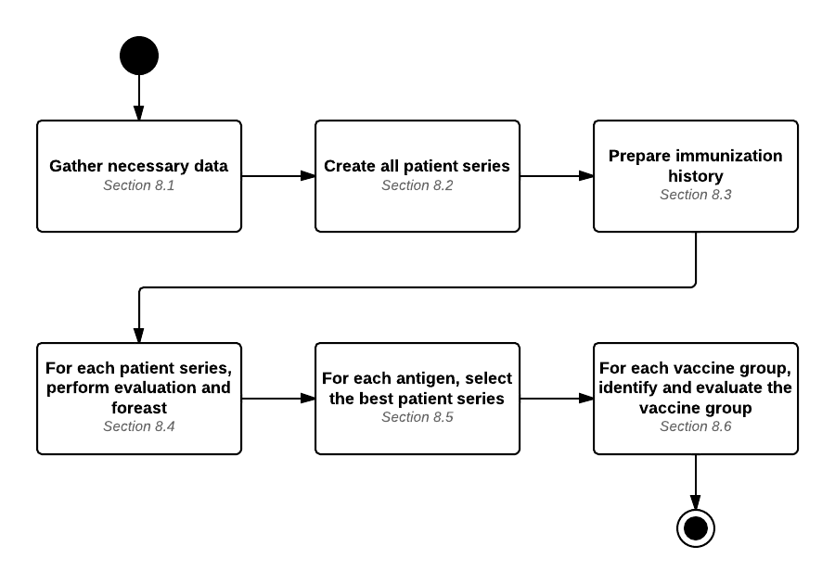

Figure 8 - 1 Logic Specification Processing Model

## Gather Necessary Data

*Gathering all of the necessary data* is a generic step which could technically be performed in several different ways. While this step is important, it is outside of the purview of this document and is only noted as a generic step in the process.

The required data fall into two categories (1) Patient-related data and (2) Evaluation and forecasting data. The lists below provide class level data needed. Further details on these classes can be found in Appendix A.

Patient-related data needed:

* Patient
* Vaccine Dose Administered
* Vaccine
* Immunization History
* Adverse Event
* Relevant Medical History

Evaluation and forecasting data needed:

* Schedule
* Antigen Series
* Series Dose
* Vaccine Group
* Antigen
* Vaccine

Finally, the term “gather” is not meant to imply a fetch, get, or retrieve operation to accumulate this data. Depending upon the implementation, some of this data may be passed by an external entity; other data may already be known; and still other data may arrive at different points in the process on an as needed basis. It is an acknowledgement of the minimal data needed in the evaluation and forecasting processes.

## Create Patient Series

An antigen series is one way to reach perceived immunity against a disease. An antigen series can be thought of as a “path to immunity” and is described in relative terms. In many cases, a single antigen may have more than one successful path to immunity and as such may have more than one antigen series. Antigen series are defined through supporting data spreadsheets defined in chapter 3.

Similar to gathering necessary data (section 8.1), *create patient series* will likely vary from system to system based on design details and technologies used. The important aspect of this step is to instantiate each antigen series as a patient series. Patient series and target dose are discussed in detail in chapter 3.

At the end of this step, each antigen series for the patient is turned into a patient series for the patient.

## Organize Immunization History

The third step in the process is to look at the patient’s immunization history and prepare those records for evaluation and forecasting by breaking them into their antigen parts. This allows the evaluation and forecasting engine to be as granular and specific as possible for both evaluation and forecasting purposes. Later in the process (section 8.6), these antigens are assembled into commonly known vaccine groups (vaccine families) for vaccine group forecasts.

To provide some immunization specifics to this step, the following tables are provided as a high-level example of the work *organize immunization history* performs.

Table 8 - 2 Prior to Organize Immunization History Example

| Product (CVX/MVX) – Description | Date |
| --- | --- |
| Engerix B-Peds (08/SKB) – HepB | 01/01/2011 |
| Pediarix (110/SKB) – DTaP-HepB-IPV | 03/01/2011 |
| Hibtiter (47/WAL) – Hib | 03/01/2011 |
| Prevnar 13 (133/WAL) – PCV13 | 03/01/2011 |
| Pediarix (110/SKB) – DTaP-HepB-IPV | 06/01/2011 |
| Hibtiter (47/WAL) – Hib | 06/01/2011 |
| Prevnar 13 (133/WAL) – PCV13 | 06/01/2011 |
| ProQuad (94/MSD) – MMRV | 01/01/2012 |

Table 8 - 3 After Organize Immunization History Example

*Sorted by antigen and then by date

| Product (CVX/MVX) – Description | Date | Antigen* |
| --- | --- | --- |
| Pediarix (110/SKB) – DTaP-HepB-IPV | 03/01/2011 | Diphtheria |
| Pediarix (110/SKB) – DTaP-HepB-IPV | 06/01/2011 | Diphtheria |
| Engerix B-Peds (08/SKB) – HepB | 01/01/2011 | HepB |
| Pediarix (110/SKB) – DTaP-HepB-IPV | 03/01/2011 | HepB |
| Pediarix (110/SKB) – DTaP-HepB-IPV | 06/01/2011 | HepB |
| Comvax (51/MSD) – Hib | 03/01/2011 | Hib |
| Comvax (51/MSD) – Hib | 06/01/2011 | Hib |
| ProQuad (94/MSD) – MMRV | 01/01/2012 | Measles |
| ProQuad (94/MSD) – MMRV | 01/01/2012 | Mumps |
| Prevnar 13 (133/Wal) – PCV13 | 03/01/2011 | PCV |
| Prevnar 13 (133/Wal) – PCV13 | 06/01/2011 | PCV |
| Pediarix (110/SKB) – DTaP-HepB-IPV | 03/01/2011 | Pertussis |
| Pediarix (110/SKB) – DTaP-HepB-IPV | 06/01/2011 | Pertussis |
| Pediarix (110/SKB) – DTaP-HepB-IPV | 03/01/2011 | Polio |
| Pediarix (110/SKB) – DTaP-HepB-IPV | 06/01/2011 | Polio |
| ProQuad (94/MSD) – MMRV | 01/01/2012 | Rubella |
| Pediarix (110/SKB) – DTaP-HepB-IPV | 03/01/2011 | Tetanus |
| Pediarix (110/SKB) – DTaP-HepB-IPV | 06/01/2011 | Tetanus |
| ProQuad (94/MSD) – MMRV | 01/01/2012 | Varicella |

The figure below illustrates how an immunization history of vaccine doses administered can be converted into antigen administered records.



Figure 8 - 2 Organize Immunization History Process Model

The process of breaking apart vaccine doses administered into their antigen parts is a fairly simple iterative process.

1. For each vaccine dose administered in the patient’s immunization history, the vaccine dose administered is interrogated for the antigens contained within.
2. For each antigen within a vaccine dose administered, an antigen administered record is created. The activity diagram above provides the basic data elements used in evaluation and forecasting. It is entirely possible different implementations may use more or less attributes from this list.
3. After all vaccine doses administered have been turned into antigen administered records, the final step in the activity diagram is to sort the antigen administered records by antigen and then by ascending date order within each antigen. Sorting these now will allow for consistent and accurate results in remainder of the steps.

A supporting data table mapping CVX codes to antigens to aid in this process can be found at the following location: [http://www.cdc.gov/vaccines/programs/iis/interop-proj/cds.html .](http://www.cdc.gov/vaccines/programs/iis/interop-proj/cds.html)

## Evaluate and Forecast all Patient Series

This step is the core of the business logic and decision points many people think of when describing evaluation and forecasting. In the Logic Specification, this step contains all of the clinical business rules and decision logic in the form of business rules and decision tables.

At the end of this step, each patient series will have an evaluated history and a forecast.

The iterative nature of this step is best described with two activity diagrams. First, figure 8-3 shows the high-level iterative process of looping through all patient series. Next, figure 8-4 specifically deals with the details of evaluation. A description of the activity diagram follows each figure.

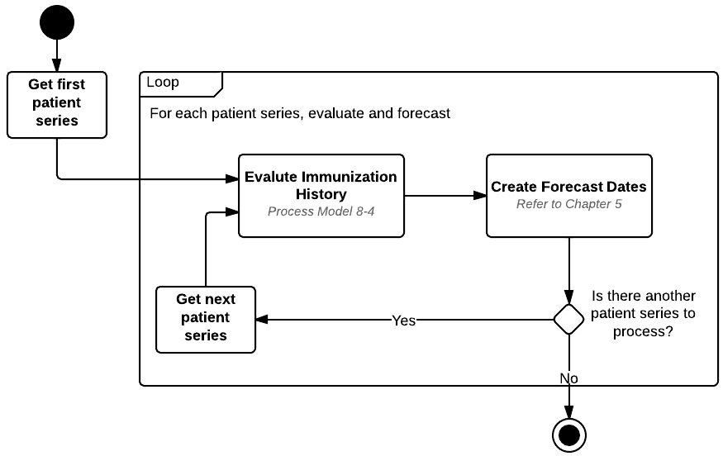

Figure 8 - 3 Evaluate and Forecast Process Model

At the highest level of this step, as illustrated in figure 8-3, a simple iterative process is used to walk through each patient series and apply the logic defined in the evaluation and forecasting chapters.

For each patient series created in the *create patient series* step (see section 8.2), the following steps are performed:

1. Evaluate the immunization history. See the *evaluate immunization history* activity diagram below for further details.
2. Create forecast dates and/or reasons for the next target dose to be administered. Process models and detailed decision logic on forecasting are located in chapter 5.

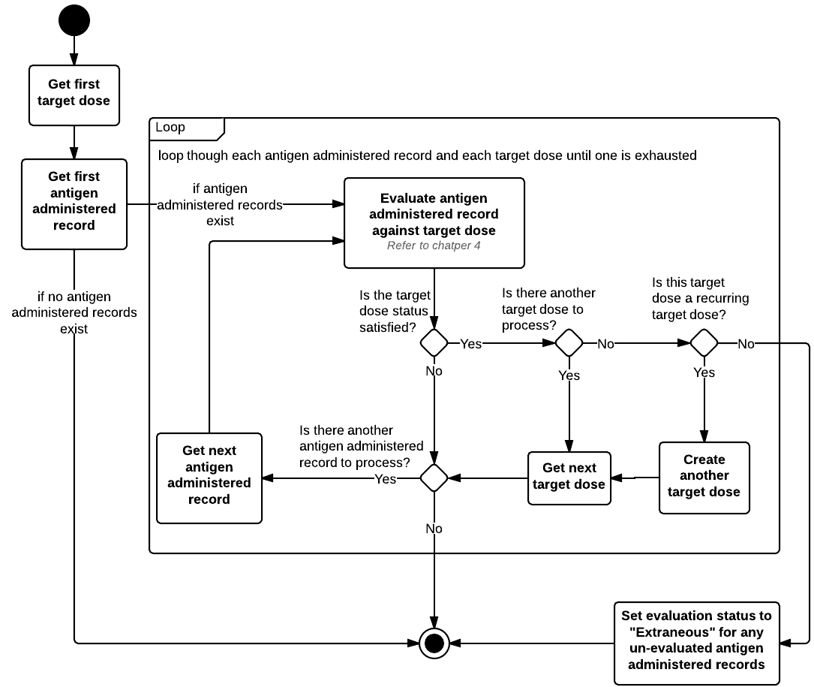

Figure 8 - 4 Evaluate Immunization History Process Model

Figure 8-4 illustrates the iterative nature of *evaluate immunization history* in greater detail. There are two collections (arrays, lists, etc.) which must be traversed. The first collection is the patient series consisting of one or more target doses. The second collection is the antigen administered records. At any point in the iterative process either collection could be the trigger to end our evaluation process. Specifically, whichever collection is exhausted first will be the trigger for ending the evaluation process.

It is important to note the contents of antigen administered records at this point in the process. Antigen administered records are only those which could potentially satisfy the goals of the patient series. For example, if the patient series is a path to immunity for HepB, then the antigen administered records will only contain HepB records in ascending date order.

The *evaluate immunization history* process is as follows:

1. The process begins by getting the first target dose from the patient series collection. The current target dose is an important concept as the process moves from evaluation into forecasting. The evaluation process will inform the forecasting process which target dose needs to be forecasted.
2. If the antigen administered collection has elements in it, the process gets the first antigen administered and continues to step 3.
   1. If the antigen administered collection is empty, the evaluation process for this patient series ends.
3. The step described as “evaluate the antigen administered record against the target dose ” is a reference to chapter 4 which contains process models and detailed decision logic that must be followed prior to moving on to step 4.
4. After the antigen administered record was evaluated against the target dose, the next step is to determine which collections to iterate based on the results of the evaluation.
   1. If the target dose status is satisfied, proceed to step 5.
      1. The antigen administered was valid. The target dose is satisfied. The evaluation process can push forward to the next target dose if one exists.
   2. If the target dose status is not satisfied, proceed to step 7.
      1. The antigen administered did not meet the goals of the target dose. The evaluation process cannot move onto the next target dose.
5. This step determines if there are more target doses in the patient series collection.
   1. If the patient series collection has been exhausted, proceed to step 6.
   2. If the patient series collection contains another target dose, get the next target dose and proceed to step 7.
6. This step determines if the current target dose (now the last target dose in the patient series) is a recurring dose. (This is a rare condition for Td and Flu.)
   1. If the target dose is defined to be a recurring dose, initialize a new target dose identical to the current target dose. The newly created target dose must now be the last element in the collection. Finally, iterate the collection to get this target dose and proceed to step 7.
   2. If the target dose is not defined to be a recurring dose, the evaluation process for this patient series ends. Any remaining antigen administered records should have their evaluation statuses set to “extraneous.”
7. This step determines if there are any more antigen administered records to evaluate.
   1. If the antigen administered collection has been exhausted, the evaluation process for this patient series ends.
   2. If the antigen administered collection contains another record, get the next antigen administered record and return back to step 3.
      1. Repeat steps 3 – 7 until the evaluation process for this patient series ends. At this point the process can end in one of two ways: (1) No more target doses (step 6.b) or (2) No more antigen administered records (step 7a).

## Select Best Patient Series

*Select Best Patient Series* determines the best path to immunity (patient series) for the patient based on the evaluated immunization history and forecast. Each antigen evaluated and forecasted may contain more than one patient series and the goal of *select best patient series* is to select one of those patient series as being superior to the others based on several factors. The factors and associated business rules are defined in chapter 6.

The process of selecting the best patient series at the highest level is a simple iterative process which loops through each antigen and applies the business rules found in chapter 6 to each antigen. A sample iterative process model is shown below to detail the looping structure.

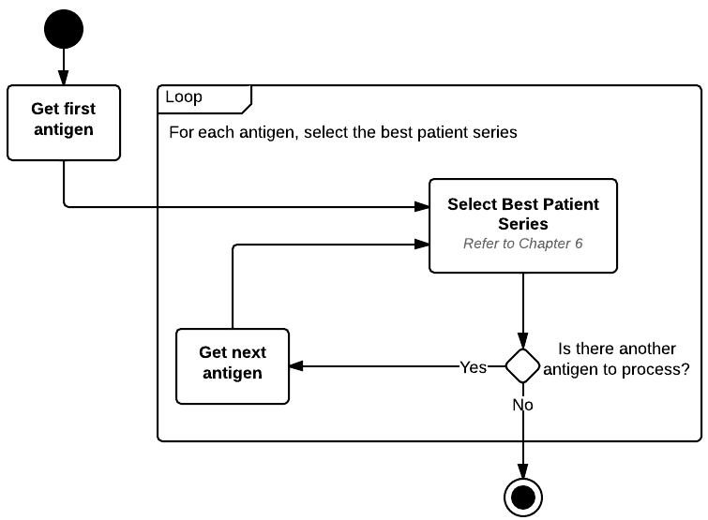

Figure 8 - 5 Select Best Series Process Model

## Identify and Evaluate Vaccine Group

The goal of *identify and evaluate vaccine group* is to merge together antigen-based forecasts into vaccine group forecasts. This is especially important in MMR and DTaP/Tdap/Td vaccine groups which each contain more than one antigen in their respective vaccine groups. In these cases, it is important to provide a forecast consistent with the vaccine group rather than the individual antigen. The business rules to create vaccine group forecasts are defined in chapter 7.

The process of identifying and evaluating a vaccine group at the highest level is a simple iterative process which loops through each vaccine group and applies the business rules defined in chapter 7 to each vaccine group. The figure on the next page is a sample iterative process model that shows the looping structure.

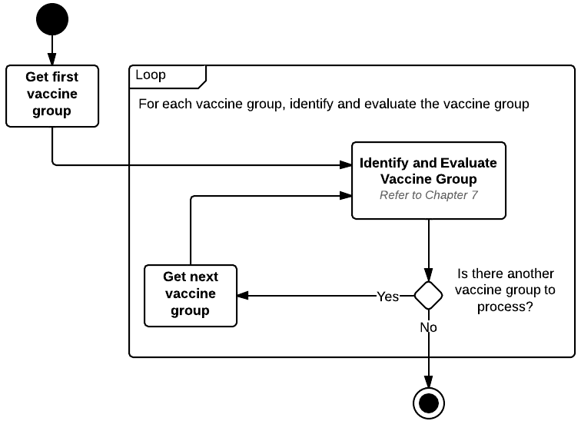

Figure 8 - 6 Identify and Evaluate Vaccine Group Process Model

# Appendix A: Domain Model and Glossary

**Domain Model (Fact Model, Vocabulary) Overview**

**Purpose**

The purpose of employing a domain model (i.e. fact model) is to:

* Document agreed-upon terms and definitions for the project
* Facilitate discussions of the terms and definitions among project participants and provide tools to capture outcomes of these discussions
* Establish a foundation and a reference source (common vocabulary) for other project materials

**About Domain Model**

A domain is an area of knowledge or activity characterized by a set of concepts and terminology understood by the practitioners in the area. A domain model captures vocabulary—terms and definitions. It ensures that all terminology and concepts that will appear in the project materials (e.g., business rules, specifications, and process descriptions) are known and understood by the domain practitioners (agreed-upon definitions and meaning).

A domain model includes:

* Domain diagram(s) that shows major business entities, their characteristics (attributes), and their relationships (Figure A-1, Figure A-2, and Figure A-3)
* A glossary that provides the definitions of vocabulary terms represented on the diagrams
* A description of the domain diagram(s) (presented below)

Unlike a data model diagram that depicts storage of information or a workflow/process diagram that depicts the sequence of steps in a process, a domain diagram is a high-level static representation of the main “things” (entities) involved in the immunization process, including a description of how these “things” (entities) are related. It is important to note that the domain diagram is not a technical specification. Instead, the domain diagram provides the foundation for other modeling diagrams and materials.

**Description of the Domain Diagrams**

The domain diagram for the CDSi project is broken into three neighborhoods for enhanced readability and ease of printing. Each neighborhood encapsulates a logical grouping of entities.

**Patient Neighborhood**

The *patient neighborhood* (Figure A-1) focuses on the patient and the patient’s medical history. The patient’s medical history is composed of two distinct items of importance. The first is the relevant medical observation which may not be directly related to a previous immunization event. The second is the immunization history which is composed of vaccine doses administered and adverse events.

**Schedule Neighborhood**

The *schedule neighborhood* (Figure A-2) focuses on what a vaccine is, how it is related to an Antigen and a Vaccine Group, and how those three entities relate to a schedule.

A vaccine has several attributes which uniquely identify it and are important during evaluation and forecasting. Each vaccine contains antigen and also belongs to a vaccine group. While not critically important at this stage, it should be noted that a vaccine can contain more than one antigen and can belong to more than one vaccine group. Combination vaccines – such as Hib-HepB – contain more than one antigen and belong to more than one vaccine group.

A schedule is the highest level entity which encompasses a collection of recommendations. Within the CDSi project, this is the routinely recommended vaccines by the ACIP for children from birth through 18 years of age. A schedule is composed of antigen series. Each antigen series defines a path to immunity for an antigen. That is to say, an antigen series focuses on a specific antigen and not a specific vaccine or a vaccine group. Each antigen series is composed of series dose(s). A series dose defines the recommendations of the ACIP through dose specific entities.

**Evaluation and Forecasting Neighborhood**

The *evaluation and forecasting neighborhood* (Figure A-3) is the result of merging the *patient neighborhood* with the *vaccine and schedule neighborhood* and applying the recommendations of ACIP. That is, it is the result of evaluating vaccine doses administered against the ACIP recommendations and creating the forecast for when the next vaccine dose should be administered according to the ACIP recommendations.

While the schedule, antigen series, and series doses from the *vaccine and schedule neighborhood* encompass the recommendations of the ACIP. When the process of evaluation and forecasting occurs, it is important to track the progress of the patient against the goals of the ACIP recommendations to know how close to series completion the patient is. This concept is depicted as the patient series and target dose. They are the measuring stick tracking the progress of the patient (and his/her history) against the recommendations of the ACIP. The target dose is the “virtual dose” according to the ACIP. The vaccine dose administered is what patient actually received.

Each vaccine dose administered is evaluated against the target dose and assigned an evaluation status and possible evaluation reason. The target dose is also used to create a forecast for the next time an immunization is due.

**Domain Diagrams**

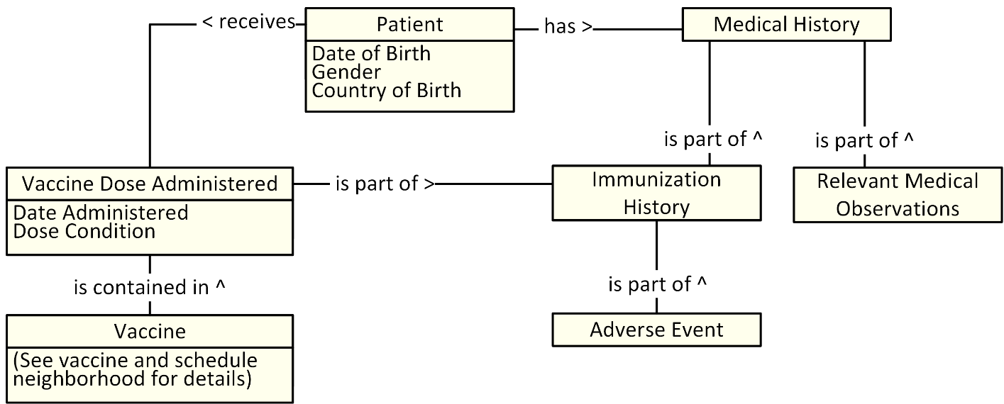

Figure A - 1 CDSi domain diagram: Patient neighborhood



Figure A - 2 CDSi domain diagram: Vaccine and schedule neighborhood

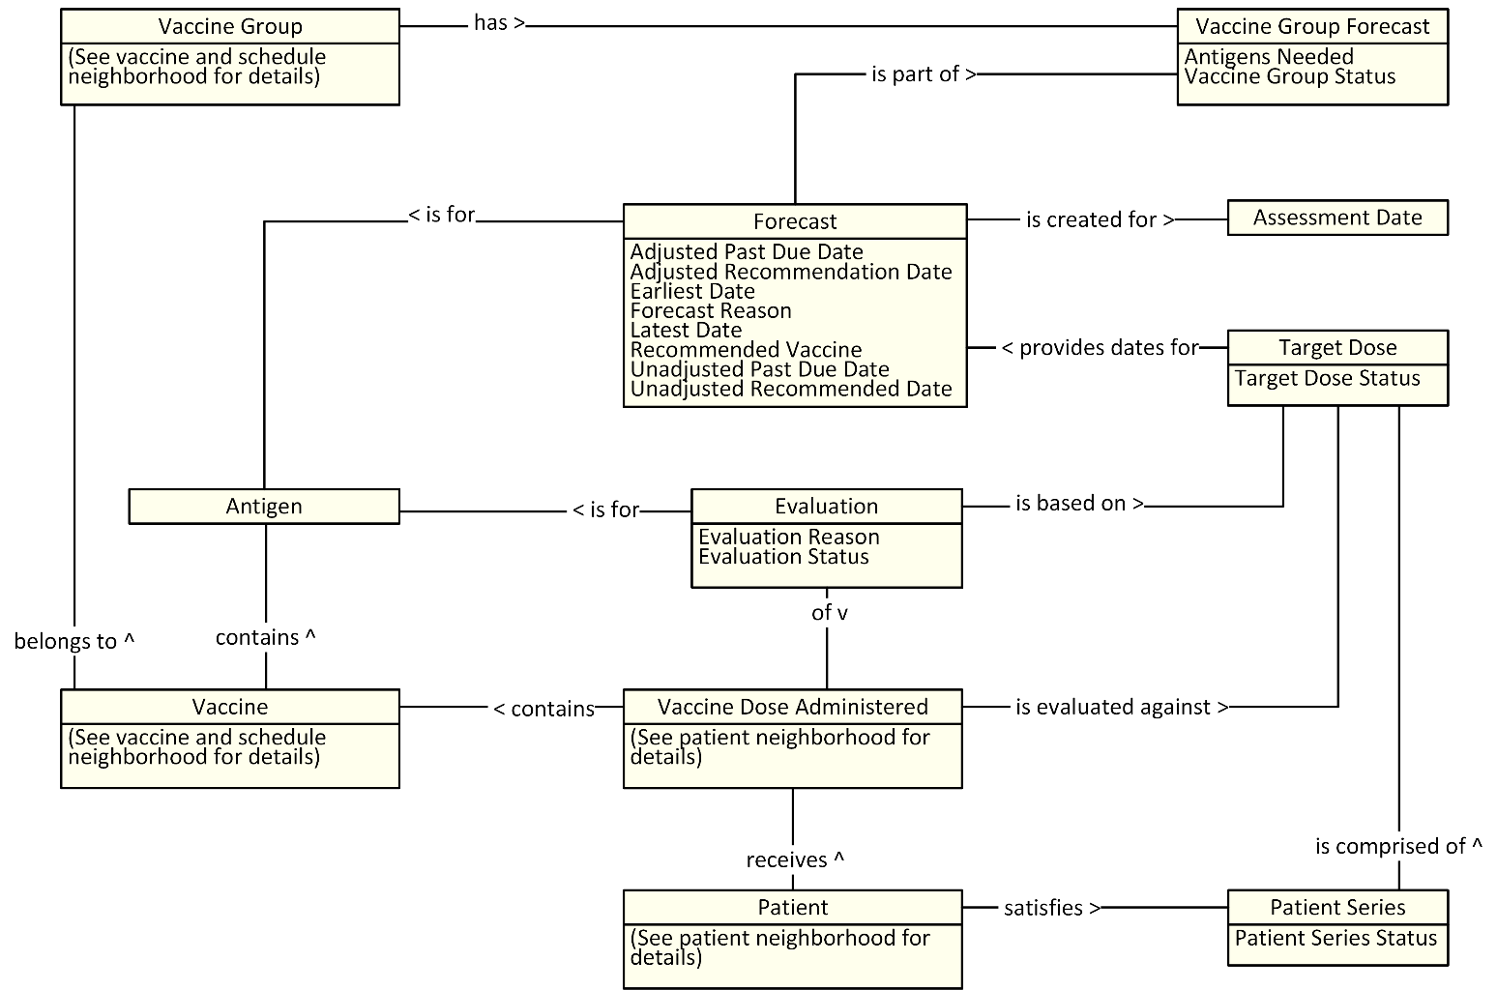

Figure A - 3 CDSi domain diagram: Evaluation and forecasting neighborhood

The glossary provides the definitions of terms identified by the domain model.

Table A - 1 Glossary

| Term | Definition |
| --- | --- |
| Absolute Minimum Age | Absolute minimum age is an age which may be earlier than the minimum age and allows for abnormally early vaccine administration (e.g. grace period). |
| Absolute Minimum Interval | Absolute minimum interval is an interval which maybe shorter than the minimum interval and allows for abnormally early vaccine administration (e.g. grace period). |
| Adjusted Past Due Date | Adjusted past due date is the date at which the next target dose for the patient is considered overdue. |
| Adjusted Recommended Date | Adjusted recommended date is the date at which the next target dose should be given. |
| Adverse Event | An adverse event is a negative health consequence experienced by the patient related in time to administration of vaccine(s). NOTE: “In time” means that it happens in some reasonable time after the immunization event. It might not be related to a specific vaccine dose administered, especially in cases when the patient receives several shots in one visit. |
| Age | Age is the length of time from birth to a specified time. |
| Allowable Interval | Allowable Interval is a space of time between vaccine doses administered outside of the base interval recommendations, but still count towards immunity. |
| Allowable Vaccine | An allowable vaccine is a vaccine which is administered outside of the recommendations of vaccine administration, but still count towards immunity. |
| Allowable Vaccine Type | Allowable vaccine type is a list of vaccines that are allowed to be administered to a patient if a preferable vaccine is not available. |
| Antigen | An antigen is a foreign (non-self) substance which can cause an immune response. |
| Antigen Series | An antigen series is one possible path to achieve presumed immunity against a disease. |
| Antigens Needed | Antigens needed are the antigens from a vaccine group which the patient is in need of receiving. |
| Assessment Date | Assessment date is the date for which the forecast is created. |
| Birth Date Immunity | Birth date immunity is a concept that implies that an individual may have protection from a specific disease if born before or after an established immunity date. |
| Clinical History Immunity | Clinical history immunity is a fact in a patient’s medical history that suggests protection from a specific disease. |
| Conditional Skip | A Conditional Skip is a situation where, based on a patient’s immunization history or age, the patient may not need a particular dose of vaccine. |
| Conditional Skip Begin Age | For Conditions of Type Vaccine Count by Age, the Begin Age defines the beginning point of the age range to be considered. |
| Conditional Skip Condition | A conditional skip condition is a fact about a patient which may impact a patient’s need for a particular dose of vaccine. |
| Conditional Skip Condition Logic | When a set consists of more than 1 condition, the Condition Logic determines if all conditions must be met or just a single one in order for the set to be met. |
| Conditional Skip Condition Logic - AND | When the Condition Logic is “AND”, all conditions in the set must be met in order for the set to be met. |
| Conditional Skip Condition Logic - OR | When the Condition Logic is “OR”, only a single condition in the set must be met for the set to be met. |
| Conditional Skip Dose Count | For Condition of Types of Vaccine Count by Age or Vaccine Count by Date, the Dose Count indicates the critical number of doses for the Condition. The Dose Count works together with Dose Type and Dose Count Logic to fully define the Condition. |
| Conditional Skip Dose Count Logic | For Condition of Types of Vaccine Count by Age or Vaccine Count by Date, the Dose Count Logic indicates for the Condition whether the patient’s dose count must be greater than, less than or equal to the Dose Count. The Dose Count Logic works together with Dose Count and Dose Type to fully define the Condition. |
| Conditional Skip Dose Type | For Condition of Types of Vaccine Count by Age or Vaccine Count by Date, the Dose Type indicates for the Condition whether or not counted doses must be valid doses for the series or not. The Dose Type works together with Dose Count and Dose Count Logic to fully define the Condition. |
| Conditional Skip End Age | For Conditions of Type Vaccine Count by Age, the End Age defines the ending point of the age range to be considered. |
| Conditional Skip End Date | For Conditions of Type Vaccine Count by Date, the End Date defines the ending point of the date range to be considered. |
| Conditional Skip Interval | For Conditions of Type of Interval, the Interval defines the minimum space of time since the last satisfied target dose. |
| Conditional Skip Set | A set is one or more conditions which need to be considered together when determining if a patient can skip a particular dose of vaccine. |
| Conditional Skip Set Logic | When The Conditional Skip section contains more than 1 set, The Set Logic determines if all sets must be met or just a single one in order for the dose to be skipped. |
| Conditional Skip Set Logic - AND | When the Set Logic is “AND”, all Sets must be met in order for the Dose to be skipped. |
| Conditional Skip Set Logic - OR | When the Set Logic is “OR”, only a single Set must be met for the Set for the Dose to be skipped. |
| Conditional Skip Start Date | For Conditions of Type Vaccine Count by Date, the Start Date defines the beginning point of the date range to be considered. |
| Conditional Skip Type | The Type specifies the nature of the condition. |
| Conditional Skip Type - Age | If the patient's age at the time of dose administration or forecast is equal to or greater than the Begin Age, then the condition is met.  Required Parameters: Begin Age |
| Conditional Skip Type - Interval | If the interval from the administered date of the last satisfied target dose equals or exceeds the Interval, then the condition is met.  Required Parameters: Interval |
| Conditional Skip Type – Vaccine Count by Age | If the patient meets the dose count requirement based on the age range then the condition is met. The Dose Count Logic determines if the patient administered dose count should be greater than, less than or equal to the Dose Count (either valid or total based on the value of Dose Type). The upper age range boundary will be either a discrete age (specified in End Age) or the age of the patient at the time of dose administration or forecast (if End Age is n/a). If the Vaccine Types (CVX List) parameter is populated, then an administered dose must be of one of the specified CVX codes in order to be counted. If the parameter is not populated, then any vaccine valid for the antigen is permitted.  Required Parameters: Begin Age, Dose Count, Dose Type, Dose Count Logic  Optional Parameters: End Age, Vaccine Types (CVX List) |
| Conditional Skip Type– Vaccine Count by Date | If the patient meets the dose count requirement based on the date range then the condition is met. The Dose Count Logic determines if the patient administered dose count should be greater than, less than or equal to the Dose Count (either valid or total based on the value of Dose Type). If the Vaccine Types (CVX List) parameter is populated, then an administered dose must be of one of the specified CVX codes in order to be counted. If the parameter is not populated, then any vaccine valid for the antigen is permitted.  Required Parameters: Start Date, Dose Count, Dose Type, Dose Count Logic  Optional Parameters: End Date, Vaccine Types (CVX List) |
| Conditional Skip Vaccine Types (CVX List) | Conditional Skip Vaccine types is the specific types of vaccine dose administered. |
| Conflict Begin Interval | Conflict begin interval is an interval which identifies the start of a live virus conflict. |
| Conflict End Interval | Conflict end interval is an interval which identifies the end of a live virus conflict. |
| Conflicting vaccine dose administered | Conflicting vaccine dose administered is a live virus vaccine dose that was administered at without appropriate spacing from another live virus administered vaccine. |
| Contraindication | A contraindication is a condition in a patient that greatly increases the chance of a serious adverse event. |
| Country of Birth | Country of birth is the birth country where an individual was born. |
| Current Vaccine Type | Current vaccine type is the vaccine type of the vaccine dose administered currently undergoing evaluation. |
| Date Administered | Date of the vaccination event. |
| Date of Birth | A patient’s date of birth either stated or reported on the patient's birth certificate. |
| Default Series | Default series is an antigen series which best describes the standard recommendations of the ACIP. |
| Dose Condition | Dose condition is an indication a vaccine dose administered should not be considered when evaluating the immunization history due to a negative external effect on the vaccine dose administered. |
| Dose Count | Dose count is the number of vaccine doses administered. |
| Dose Number | Dose number is the ordinal dose position in the antigen series. |
| Earliest Date | Earliest date is the earliest point in time at which the next target dose could be given. |
| Earliest Recommended Age | Earliest recommended age is the preferred age a vaccine should be administered. |
| Earliest Recommended Interval | Earliest recommended interval is the shortest, preferred time period between vaccine doses administered. |
| Evaluation | Evaluation is the result of the process of applying recommendations for a given series dose. It is the outcome of the evaluation process that determines whether a vaccine dose administered is valid. |
| Evaluation Reason | Evaluation reason provides reasons why a vaccine dose administered is or is not valid. |
| Evaluation Status | Evaluation status indicates validity of a vaccine dose administered in relation to a specific target dose. |
| Evidence of Immunity | Evidence of Immunity is the evidence or written documentation that indicates that an individual maybe immune or protected from a specific disease. |
| Exclusion Condition | Exclusion condition is a patient factor which precludes a patient from being considered immune without vaccination. |
| First Dose Begin Age | First dose begin age is the begin age of the first valid dose administered. |
| First Dose End Age | First dose end age is the end age of the first valid dose administered. |
| Forecast | Forecast is the result of the process of applying rules for the next series dose. The outcome of the forecasting process would be dates for the next target dose. |
| Forecast Reason | Forecast reason provides reasons why a target dose is or is not recommended to be administered. |
| Forecast Vaccine Type | Forecast vaccine type is a specific vaccine type that should be administered for a vaccine series. |
| From Immediate Previous Dose Administered | From immediate previous dose administered indicates the interval is applied from the previous vaccine dose administered within the antigen series. |
| From Most Recent | From Most Recent is the most recent specific vaccine type that was administered to a patient under ACIP recommendations. |
| From Target Dose Number in Series | From target dose number in series is the target dose from which the interval is applied. |
| Gender | Gender is the observed or reported patient's sex. |
| Immunity | Immunity is a condition of being able to resist a particular disease[5] |
| Immunity Date | Immunity date is an established date that suggests when an individual may have protection from a specific disease. |
| Immunity Guideline | Immunity guideline is a statement that is used to help determine whether or not an individual may have immunity or protection from a specific disease. |
| Immunization History | Immunization history is a collection of vaccine doses administered and any associated adverse events for a patient. |
| Interval | Interval is a space of time between vaccine doses administered. |
| Interval Priority Flag | When forecast the next target dose for a vaccine group, the Interval Priority Flag allows an override of the combined forecast dates by an antigen. |
| Latest Date | Latest date is the latest point in time at which the next target dose could be given. |
| Latest Recommended Age | Latest recommended age is the age a vaccine must be administered before the patient is considered overdue. |
| Latest Recommended Interval | Latest recommended interval is the time period from a previous vaccine dose administered before the patient is considered overdue. |
| Live Virus Conflict | A live virus conflict is a condition when two live virus vaccines are administered at too close of an interval. |
| Live Virus Vaccine | Live Virus Vaccine is a vaccine that is made with a weakened or attenuated form of a virus or bacteria. |
| Lot Expiration Date | Lot expiration date is the date at which point the lot of vaccine is no longer considered potent. |
| Manufacturer | Manufacturer is the company that develops and distributes a vaccine. |
| Maximum Age | Maximum age is the latest age a vaccine may be administered. |
| Maximum Age To Start | Maximum age to start is the latest age an antigen series may be started. |
| Medical History | Medical history is “a narrative or record of past (or current) events and circumstances that are or may be relevant to a patient's current state of health. Informally, an account of past diseases, injuries, treatments, and other strictly medical facts. More formally, a comprehensive statement of facts pertaining to past and present health gathered, ideally from the patient, by directed questioning and organized under the following heads.” http://www.medilexicon.com/medicaldictionary.php?t=41172 |
| Minimum Age | Minimum age is the earliest age a vaccine may be administered. |
| Minimum Age To Start | Minimum age to start is the earliest age an antigen series may be started. |
| Minimum Conflict End Interval | Minimum conflict end interval is an interval which identifies the absolute earliest end of a live virus conflict. |
| Minimum Interval | Minimum interval is the shortest interval between two vaccine doses administered. |
| Patient | Patient is the actual or potential recipient of a vaccine dose administered. |
| Patient Series | Patient series tracks the patient's progress towards the completion of an antigen series. |
| Patient Series Status | Patient series status indicates whether the patient has met the goals for the Patient series. |
| Preferable Vaccine | A preferable vaccine is a vaccine which follows the recommendations of vaccine administration. |
| Previous Vaccine Type | Previous vaccine type is the vaccine type of the vaccine dose administered during a previous vaccination event. |
| Product Path | Product path is an antigen series which specifically targets a product, vaccine type, and or trade name. |
| Reason | A reason is a rationale or justification for an outcome. |
| Recommended Vaccine | Recommended vaccine is the vaccine(s) that is recommended based on a patient’s immunization history and per ACIP guidelines. |
| Recurring Dose | A recurring dose indicates a target dose is to be repeated endlessly. |
| Relevant Medical Observation | A relevant medical observation is a factor (e.g., condition) that is related to a Patient that may have an impact on the forecasting of future doses. It could be a contraindication, precaution or some special indication. |
| Required Gender | Required gender is the gender the patient must be for the dose to be considered valid. |
| Schedule | A schedule is a collection of antigen series that specify various paths to achieve presumed immunity against respective diseases. |
| Schedule Name | Schedule name is a meaningful identifier for the schedule. |
| Seasonal Recommendation | A seasonal recommendation is a recommendation which is indicated by a seasonal start date and a seasonal end date in conjunction with the patient's age. |
| Seasonal Recommendation End Date | Seasonal end date is the last day a seasonal vaccine should be recommended. |
| Seasonal Recommendation Start Date | Seasonal start date is the first day a seasonal vaccine should be recommended. |
| Select Best Patient Series | Select best patient series is the process of reviewing all potential patient series which might satisfy the goals of an antigen and determining which patient series is best path to immunity for the patient. |
| Series Dose | Series dose is an individually defined dose within an antigen series. |
| Series Name | Series name is a meaningful identifier for an antigen series. |
| Series Preference | Series preference is a ranking given to antigen series within an antigen. |
| Target Disease | A target disease is a specific vaccine preventable disease where a particular vaccine is administered to an individual to reduce the risk of infection by working with the body’s natural defenses to help it develop an immunity to the disease. |
| Target Dose | Target dose is a patient-specific dose required to satisfy a recommendation of the ACIP. |
| Target Dose Status | Dose status indicates whether or not a vaccine dose administered has met the goals of the target dose. |
| Total Count of Valid Doses | Total count of valid doses is the total number of valid doses regardless of age. |
| Trade Name | Trade name is the manufacturer's proprietary name and in some cases its intended use (e.g. adults, pediatrics). |
| Unadjusted Past Due Date | Unadjusted past due date is the static past due date a patient should be considered overdue for the next target dose regardless of patient's current age and previous vaccine doses administered. |
| Unadjusted Recommended Date | Unadjusted recommended date is the static recommended date a patient should receive the next target dose regardless of patient's current age and previous vaccine doses administered. |
| Vaccine | Vaccine is a specific instance of the medicine (containing antigen(s)) given during a vaccination. |
| Vaccine Dose Administered | A vaccine dose administered is the record of the event where a vaccine was administered. |
| Vaccine Group | Vaccine group is a classification category. Vaccine group describes broad categories of diseases. In many cases this reflects individual diseases. In some cases, the group characterizes multiple diseases. |
| Vaccine Group Forecast | Vaccine group forecast is the forecast for a vaccine group. |
| Vaccine Group Status | Vaccine group status indicates whether the patient has met the goals for the Vaccine group. |
| Vaccine Type | Vaccine type is the specific type of vaccine dose administered. |
| Vaccine Type Begin Age | Vaccine type begin age is the earliest age the vaccine type can be administered. |
| Vaccine Type End Age | Vaccine type end age is the latest age the vaccine type can be administered. Vaccine type end age date is derived from vaccine type end age. |
| Volume | Volume is a measurement of the size of the vaccine. |

# Appendix B: Acronyms and Abbreviations

The table below provides the meanings of acronyms and abbreviations stated within the document.

Table B - 1 Acronyms and abbreviations

| Term | Meaning |
| --- | --- |
| ACIP | Advisory Committee on Immunization Practices |
| CDC | Centers for Disease Control and Prevention |
| CDS | Clinical Decision Support |
| CDSi | Clinical Decision Support for Immunization |
| DHHS | U.S. Department of Health and Human Services |
| DT | Diphtheria and tetanus toxoids adsorbed (children) |
| DTaP | Diphtheria and tetanus toxoids and acellular pertussis vaccine adsorbed |
| EHR | Electronic Health Record |
| EIPB | Education, Information and Partnership Branch |
| FDA | Federal Drug Administration |
| Flu | Influenza |
| HepA | Hepatitis A vaccine |
| HepB | Hepatitis B vaccine |
| Hib | Haemophilus influenza type b conjugate vaccine |
| HIE | Health Information Exchange |
| HIS | Health Information System |
| HIV | Human Immunodeficiency Virus |
| HPV | Human papillomavirus vaccine |
| IIS | Immunization Information System |
| IISSB | Immunization Information Systems Support Branch |
| MCV | Meningococcal conjugate vaccine |
| MMR | Measles, Mumps, and Rubella vaccine |
| MMRV | Measles, Mumps, Rubella, and Varicella vaccine |
| MMWR | Morbidity and Mortality Weekly Report |
| NCIRD | National Center for Infectious Diseases |
| PCV | Pneumococcal conjugate vaccine |
| Polio | Poliomyelitis vaccine |
| PPSV | Pneumococcal polysaccharide vaccine |
| Rota | Rotavirus vaccine |
| SME | Subject Matter Expert |
| Td | Tetanus and diphtheria toxoids adsorbed (adult) |
| Tdap | Tetanus toxoid, reduced diphtheria toxoid and acellular pertussis vaccine, adsorbed |
| VZ | Varicella vaccine |

# Appendix C: Acknowledgements

**Logic Specification Panel Members**

* **Bill Adams, MD,** Boston University School of Medicine, Logic Specification Expert Panelist

Dr. William Adams is an epidemiologist, medical informatician, and practicing pediatrician at Boston Medical Center (BMC). He is Director of BU-CTSI Clinical Research Informatics, Director of Child Health Informatics, and Professor of Pediatrics at Boston University School of Medicine. His research focuses on developing and evaluating information technology (IT)-based solutions for improving the quality of health and healthcare for children. His focuses include immunization registries, the child health EHR, patient-centered IT and clinical data warehousing for quality improvement and research. He is a member of the Massachusetts Immunization Information System (MIIS) technical and programmatic teams. He is a founding member of the American Academy of Pediatrics (AAP) Partnership for Policy Implementation (PPI), a group of child health informaticians committed to improving AAP guideline quality including computability. He also serves as advisor to the AAP Center for Child Health Informatics and is a member of the AAP Steering Committee for the Quality Innovation Network.

* **Judy Anderson**, Hewlett Packard (HP), Validation and Testing Expert Panelist

Judy Anderson has nearly 8 years of hands-on immunization registry experience that includes direct interaction with the Georgia registry users, in-depth knowledge of the immunization schedules, requirement analysis, and test case development.  Past projects have included data exchange and inventory management/reporting enhancements, in addition to a supporting role on the current VTrckS implementation for the Georgia registry.  One of her strengths, as a member of the HP Immunization Evaluator Workgroup, is to interpret CDC/ACIP recommendations into logical solutions that can be implemented across the WIR-based registries.  She is a graduate of Loyola University of Chicago with a Bachelor of Arts degree in Communication Arts/Mass Media.

* **Jennifer Austin, PMP,** Northrop Grumman Corporation, CDSi Project Manager

Jennifer Austin has over 20 years of business and government consulting experience and has supported the CDC for over six years in various project management capacities including large Oracle Financials and PeopleSoft HR implementations and a data quality and management engagement for the Division of HIV/AIDS Prevention. Jennifer was the Project Manager for Phase I of the Clinical Decision Support for Immunizations (CDSi) Project and also managed three other CDC expert panel initiatives related to the interoperability of immunization information systems (IIS) with EHRs. She is currently also the Project Manager for the Trends in Immunization Practices (TIPS) system.

* **Regina Austin**, HLN Consulting, Validation and Testing Expert Panelist

Regina Austin has over 20 years of healthcare-related experience and expertise in analysis, requirement elicitation, writing, testing, and training in her current position as Senior Analyst and Project Specialist with HLN Consulting. Her focus in recent years has been assisting public health clients with the development and deployment of customized, cutting-edge software meeting the latest standards in healthcare IT. She is current the lead business analyst on several major HLN immunization-related projects. Regina attends and participates in key industry conferences, most recently as a facilitator of HL7 2.5.1 and clinical decision support round-table discussions at the 2012 and 2013 AIRA conferences. Regina is also a member of American Immunization Registry Association’s (AIRA) Standards and Interoperability Steering Committee (SISC). Among her recent publications is a white paper in the HIMSS Journal of Healthcare Information Management on open source clinical decision support for immunizations.

* **Gerry Bragg, MBA,** Altarum Institute / Michigan Care Improvement Registry (MCIR), Logic Specification Expert Panelist

Gerry Bragg has over 20 years of experience in systems analysis and programming and for the past 15 years, has supported the Michigan Care Improvement Registry (MCIR) as a Senior Systems Developer. He has supported the MCIR system in a variety of capacities, including the development of patient de-duplication/match-merge processes and clinical decision support/immunization forecasting algorithms. Mr. Bragg also specializes in database/SQL performance, scalability, tuning, refactoring, design, technical planning, and configuration management. The system currently supports more than 25,000 users. Mr. Bragg holds an MBA in Management Information Systems from the University of Minnesota in Minneapolis, Minnesota, and a BA in Accounting from Hillsdale College in Hillsdale, Michigan.

* **Kahil Branton,** Advanced Strategies, In-Person Session Facilitator

Kahil Branton has had a 18+ year career in the Information Technology industry, with experience in business requirements analysis, JDA facilitation, systems architecture, software development, and user interface design. Kahil has facilitated groups through the development of business object models (aka. conceptual data models), architectural designs and business process models. Kahil also has extensive experience in event, location and socio-political modeling. As a Senior Consultant with Advanced Strategies, Inc., Kahil teaches courses on business analysis and consults with government and private sector organizations. He has facilitated numerous sessions for public health and healthcare organizations, including: The CDC, AIRA, and Hospital Corporation of America. Kahil has both a Master’s and Bachelor’s degree in Computer Science and Engineering from Massachusetts Institute of Technology.

* **Nathan Bunker,** Dandelion Software & Research, LLC, CDSi Project Informatics Specialist

Nathan Bunker is a software developer and public health consultant for public and private agencies; focusing specifically on immunization software and data exchange. His work has given him experience with key immunization registry functions, including: immunization recommendation/forecast, HL7 interfacing, data quality analysis, vaccination matching, patient matching, and vaccine barcoding.

* **Daryl Chertcoff, BSE,** HLN Consulting, LLC

Mr. Chertcoff has been providing information technology consulting services and delivering electronic healthcare systems to public health agencies and their partners for the past 12 years. He has worked with a wide range of technologies throughout his career, is an ongoing student of Health Information Technology standards, and believes strongly in participating in volunteer efforts to further the adoption of Health IT nationwide. Mr. Chertcoff offers each new business process analysis or development effort a combination of project management and technical leadership skills to get the job done. He enjoys collaborating with partners and considers each new challenge an opportunity to make sense of the problem in a practical manner, by drawing on experience from past projects as well as from involvement in standards groups and technology forums.

* **Joan Christison-Lagay,** Connecticut Immunization Registry and Tracking System (CIRTS), Validation and Testing Expert Panelist

Joan Christison-Lagay, a former Peace Corps volunteer, is a graduate of Smith College and holds master’s degrees from both Brown University and the UNC. She began her public health career for the City of Hartford, CT in 1980 working on projects to reduce the incidence of low birth weight infants. In 1993 she was named the director of the first immunization registry in New England, now known as the CT Immunization Registry and Tracking System (CIRTS). She currently contracts with CT DPH, MA DPH and Community Health Centers, CT on issues relating to immunization assessment and training.

* **Rachel Cunningham, MPH,** Texas Children’s Hospital, Logic Specification Expert Panelist

Rachel M. Cunningham, MPH, is the immunization registry and educational specialist at Texas Children’s Hospital in the Immunization Project. Rachel is the primary author of *Vaccine-Preventable Disease: The Forgotten Story* of which more than 130,000 copies have been distributed. Rachel also worked with Nathan Bunker and other Immunization Project staff to develop the TCH Immunization Forecaster and TCH Forecast Tester. The TCH Immunization Forecaster is used through Texas Children’s Hospital as well as its private pediatric network, Texas Children’s Pediatrics (TCP), which has 48 practices throughout the greater Houston area. The TCH Immunization Forecaster is also currently being utilized by Indian Health Services and the Virginia Department of Health while the TCH Forecast Tester is being utilized by multiple organizations across the U.S. Rachel has been at Texas Children’s since 2007. She earned her Bachelor of Science degree from Oral Roberts University and has a master’s in public health from The University of Texas Health Science Center at Houston.

* **Gail Decosta,** Advanced Strategies, In-Person Meeting Facilitator

Gail DeCosta has had a 30+ year career in the Information Technology industry, with experience in business requirements analysis, JDA facilitation, software development, and project management. She has facilitated groups through the documentation of current business processes and the transformation to a desired future state of “To-Be” business process models. Additionally, Gail also has extensive experience in event, location, socio-political, and business object/data modeling and project management. Gail is employed by Advanced Strategies, Inc. and both teaches courses on business analysis and consults with government and private sector organizations. She has facilitated numerous sessions for public health and health care organizations, including: The CDC, AIRA, MN Department of Health, Hospital Corporation of America and the National Cancer Institute. Gail holds a Bachelor of Arts degree in Psychology from Brown Universityand a Master’s degree in Education from Georgia State University.

* **Kristen Forney, MPH,** New York Citywide Immunization Registry (CIR), Validation and Testing Expert Panelist

Kristen Forney is a public health professional who has led a variety of health IT projects for the Citywide Immunization Registry at the New York City Department of Health and Mental Hygiene.  She has participated in the Immunization Calculation Engine (ICE) project as the lead analyst for New York City.  As lead analyst for NYC, Kristen co-facilitated the subject matter expert workgroup responsible for developing and documenting the rules and test cases used to implement the ICE algorithm.

* **Anita Geevarughese, MD,** New York Citywide Immunization Registry (CIR), Logic Specification Expert Panelist

Dr. Anita Geevarughese serves as the Adult Immunization Medical Specialist for the Bureau of Immunization at the New York City (NYC) Department of Health and Mental Hygiene.  In this role, Dr. Geevarughese works on a variety of programmatic and policy initiatives to support immunizations in NYC, including improvement of healthcare personnel influenza vaccination coverage, development of school-located influenza vaccination programs and utilization of electronic health record data to create feedback reports for adult providers on practice-level influenza and pneumococcal vaccination coverage. Dr. Geevarughese assists in the development of both public and provider communications and offers provider education on a number of topics related to adult immunization.  She current serves on the executive committee for the National Adult Immunization Coordinators Partnership and has previously served as the principal NYC contact for a CDC-sponsored pilot to field test the National Quality Forum measure on standardized reporting of healthcare personnel influenza vaccination.

* **Shaun Grannis, MD, MS, FAAFP,** Regenstrief Institute / Indiana University

Dr. Shaun Grannis is a Research Scientist at Regenstrief Institute, Inc. and Assistant Professor of Family Medicine at the Indiana University School of Medicine. He received an Aerospace Engineering degree from the Massachusetts Institute of Technology, and underwent post-doctoral training in Medical Informatics and Clinical Research at Regenstrief Institute. He joined Indiana University in 2001 and collaborates closely with national and international public health stakeholders to advance the technical infrastructure and data-sharing capabilities. He is a member of World Health Organization (WHO) Collaborating Center for the Design, Application, and Research of Medical Information Systems, where he provides consultancy on issues related to health information system identity management and implementing automated patient record matching strategies.

Dr. Grannis completed an analysis of an automated regional electronic laboratory reporting system that revealed substantial increases in the capture rates for diseases of public health significance when compared to manual, paper-based procedures. He is project director for an initiative integrating data flows from over 120 hospitals across the state of Indiana for use in public health disease surveillance. For the last 5 years this system has received real-time data from hospitals amounting to more than 2 million transactions per year, and has detected public health outbreaks of gastrointestinal illness, carbon monoxide poisoning, and other events of interest to public health. Most recently this system was leveraged to monitor H1N1 influenza disease burden across the state of Indiana. As co-chair of the U.S. Health Information Technology Standards Panel (HITSP) Population Health technical work group, Dr. Grannis helped lead development of technical Interoperability Specifications for nationally recognized public health IT use cases.

Dr. Grannis also serves as the Director of the Indiana Center of Excellence in Public Health Informatics, which recognizes that public health practice is driven by a wide variety of data types, data sources, and data management techniques.

* **Amy Groom, MPH,** Indian Health Service (IHS), Logic Specification Expert Panelist

Amy Groom is a Public Health Advisor with the Centers for Disease Control and Prevention, assigned to work with the Indian Health Service’s Division of Epidemiology and Disease Prevention. She has served as the National IHS Immunization Program manager since 2001. In this capacity,she works with IHS and tribal immunization programs across the country to develop immunization policy, implement immunization programs, and monitor immunization coverage. In addition, she is the lead for the development of the IHS clinical decision support software for immunizations, and provides training to end-users on the use of the sofwtare. She is the ex-officio representative for IHS on both the Advisory Committee on Immunization Practices and the National Vaccine Advisory Committee. She holds a Masters in Public Health from Boston University.

* **Chip Hart,** Physician’s Computer Company (PCC), Logic Specification Expert Panelist

Chip Hart is the Director of PCC's Pediatric Solutions and author of the blog "Confessions of a Pediatric Practice Consultant" (chipsblog.pcc.com). Chip's two decades of pediatric practice management expertise have been focused on the support and development of independent pediatric practices. Chip spends nearly all of his time working in and with private practices around the country. He has worked as a consultant for the American Academy of Pediatrics (AAP) and the AAP Section on Administration and Practice Management (SOAPM). Chip leads educational seminars and consults for pediatric professionals nationwide for organizations like the AAP, state chapter AAP programs, the MGMA, and various physician and hospital organizations around the country. Chip was a member of the CCHIT Child Health Work Group and the CDC Clinical Decision Support working group. Chip contributes articles on practice management and health care information technology for Pediatric Coding Alert, the AAP's SOAPM Newsletter, and Medical Group Management Association.

* **Mari Hilleman,** Hewlett Packard (HP), Validation and Testing Expert Panelist

Mari Hilleman is a business analyst with Hewlett Packard and has been focused on statewide immunization information systems for 11 years. Mari has worked with five different State immunization programs to define requirements and test plans for the development of enhancements to their Immunization Information Systems.  Currently Mari is supporting the Idaho Immunization Reminder Information System in the implementation and testing of the Wisconsin Immunization Evaluator module used for forecasting and evaluation of Idaho’s ACIP schedule as well as school and childcare eligibility.

* **Robert Hopkins, Jr., MD, FACP, FAAP,** American College of Physicians (ACP), Logic Specification Expert Panelist

Dr. Hopkins is Professor of Internal Medicine and Pediatrics and director of the division of the Division of General Internal Medicine at the University of Arkansas for Medical Sciences. He has active teaching and faculty practices in Internal Medicine and Pediatrics at UAMS and also directs the Combined Internal Medicine-Pediatrics residency at UAMS. He is recognized nationally as an expert in adult immunization, clinical practice guidelines review and development, medical education and quality improvement and has published well over 100 articles on these topics. He is the immediate past governor of the Arkansas Chapter of the American College of Physicians and has served on numerous national ACP committees in addition to his roles at the University of Arkansas for Medical Sciences. Currently, he serves on the Adult Immunization Technical Advisory Committee and the ACP Performance Measurement Committee and the Arkansas Department of Health Vaccine Medical Advisory Committee.

* **Paul Hunter, MD,** American Academy of Family Physicians (AAFP), Logic Specification Expert Panelist

As Associate Medical Director of the City of Milwaukee Health Department (MHD), Dr. Paul Hunter focuses on clinical aspects of local public health, especially immunizations, sexually transmitted diseases, tuberculosis, and obesity. He writes the medical orders that MHD nurses use to vaccinate Milwaukeeans. He represents MHD on the Wisconsin Council on Immunization Practices and on the Immunization Work Group of the National Association of County and City Health Officials. He helped develop Immunize Milwaukee! (IM!), a coalition of stakeholders from health systems, health departments, schools, neighborhood centers, health insurers, and others, which focuses on raising vaccination rates of all residents of Metro-Milwaukee. As an Assistant Professor of Family Medicine at the University of Wisconsin School of Medicine and Public Health, he teaches medical and public health students about practical aspects of implementing community health interventions. Dr. Hunter practiced family medicine for 19 years in underserved neighborhoods in Milwaukee and Rockford.

* **Janel Jorgenson,** Utah Statewide Immunization Information System (USIIS)

Janel Jorgenson is a graduate of the University of Utah with a degree in Health Education & Promotion. She has an interest in children’s health issues and has been with the Utah Department of Health Immunization Program since 2000. Janel is currently the Provider Relations Coordinator where she provides supervision, support, training, and education for both the Utah VFC Program and the Utah Statewide Immunization Information System (USIIS).

* **Erin Kennedy, DVM, MPH,** Centers for Disease Control and Prevention (CDC), Logic Specification Expert Panelist

Dr. Erin Kennedy is a Medical Officer in the Immunization Services Division, National Center for Immunization and Respiratory Diseases at the Centers for Disease Control. Dr. Kennedy has a DVM and Masters in Anatomy and Neurobiology from Colorado State University and an MPH in Epidemiology from Emory University. Dr. Kennedy first joined the CDC as a fellow on the Rabies Team and then became an Epidemic Intelligence Service Officer in 2008 where she worked primarily on 2009 H1N1 pandemic influenza surveillance. Her career in public health has included research and policy on vaccine preventable diseases, pandemic preparedness, and improving coverage for recommended adult vaccines.

* **Brady Kerr, RN,** Texas Children’s Hospital, Validation and Testing Expert Panelist

Brady Kerr is a graduate of the University of Utah with a bachelor’s degree in Nursing.  He is currently working as the Health Education Nurse for the Immunization Project at Texas Children’s Hospital.  An important part of his role in the Immunization Project is working to maintain, improve and promote the immunization forecaster for Texas Children’s Hospital.  Previous roles have included caring for geriatric patients as a Home Health RN Case Manager and working as an Immunization Nurse for the Salt Lake County Health Department.

* **Pinar Keskinocak, PhD,** Georgia Institute of Technology School of Industrial and Systems Engineering

Pinar Keskinocak is the Joseph C. Mello Professor in the School of Industrial and Systems Engineering and the co-founder and co-director of the Center for Humanitarian Logistics at the Georgia Institute of Technology. She also serves as the Associate Director for Research at the Health Systems Institute at Georgia Tech.

Her research focuses on applications of operations research and management science with societal impact (particularly health and humanitarian applications), supply chain management, pricing and revenue management, and logistics/transportation. She has worked on projects in several industries including automotive, semiconductor, paper manufacturing, printing, healthcare, hotels, and airlines. Her research has been published in journals such as Operations Research, Management Science, Manufacturing & Service Operations Management, Production and Operations Management, IIE Transactions, Naval Research Logistics, and Interfaces.

* **Chandra Klein,** Envision Technology, Validation and Testing Expert Panelist

Chandra Klein works with Envision Technology Partners, Inc. as a Subject Matter Expert.  She has developed test cases for the forecast feature of the WebIZ immunization registry.  Chandra has been a public health nurse for over 10 years.  She has worked in many areas of public health including Tuberculosis Case Management, Perinatal Hep B Case Management, and Immunizations.  Most recently she was the Immunization Program Supervisor for the Larimer County Health Department in Fort Collins, Colorado.

* **Eric Larson,** Northrop Grumman Corporation, CDSi Project Lead Informatics Specialist

Eric Larson is a Senior Information Architect for Northrop Grumman Corporation and is under contract to the CDC Immunization Information System Support Branch. He is the lead technical consultant on the Clinical Decision Support project. Previous to Eric’s current assignment, he spent about 10 years in the private sector helping several statewide immunization programs implement, maintain and improve their IIS. Eric also participates in initiatives at AIRA, HL7, IHE, ONC’s S&I Framework and is currently serving on the AIRA Board of Directors.

* **Carl Lauter, MD, FACP,** American College of Physicians (ACP), Logic Specification Expert Panelist

Dr. Carl Lauter, currently the Governor of the Michigan Chapter, American College of Physicians, graduated from Wayne State University and Wayne State University School of Medicine. He completed his residency in internal medicine followed by a NIH fellowship in infectious diseases and subsequently a fellowship in allergy and immunology. He is board certified in all three specialties. He was on the full time faculty of Wayne State University School of Medicine from 1973 – 1980 and has been at William Beaumont Hospital, Royal Oak, Michigan, since that time. In the past, Dr. Lauter was an internal medicine residency director in two different programs and Chief, Department of Medicine at William Beaumont Hospital for ten years. He is Professor of Medicine at Oakland University School of Medicine and Section Head of Allergy and Immunology, as well as Clinical Professor of Medicine at Wayne State University. Dr. Lauter is an editorial reviewer for several peer reviewed journals. He is a contributor to the medical literature. At the national level he sits on the Immunization Technical Advisory Committee of the American College of Physicians and the Primary Immunodeficiency Committee and the Altered Immune Response Committee of the American Academy of Allergy, Asthma and Immunology. His clinical and teaching interests involve immunology, immunodeficiency and adverse and allergic reactions to vaccinations.

* **Susan Lett, MD, MPH,** Massachusetts Department of Health, Logic Specification Expert Panelist

Dr. Susan Lett has been the medical director of the Massachusetts Immunization Program for over 25 years and has played a key role in the development of the Massachusetts Immunization Information System (MIIS).  For the past 5 years, she has co-lead with Dr. Bill Adams, the MIIS immunization decision support team. The MIIS uses a web-service based immunization forecasting module (IFM) which is supported by Drs. Lett and Adams, and their technical team.  The IFM includes forecasting rules for children and adults and also supports advanced decision support related to clinical features such as contraindications, immunities, and special indications.  All MIIS IFM rules are based on ACIP recommendations. The team has also developed an extensive set of test cases designed to provide comprehensive, automated testing of rules.  Dr. Lett is also an internist who has served as a voting member on the Advisory Committee for Immunization Practices (ACIP).  She is currently active on 4 ACIP working groups: Adult Schedule, Harmonized (Childhood) Schedule, General Recommendations on Immunization and Influenza.  Susan also helped to review phase1 of the Logic Specification for ACIP Recommendations.

* **Tom Maerz,** Wisconsin immunization Registry (WIR)

Tom Maerz is an Applications Developer, Computer Electronics Builder and Network Specialist by trade. He’s worked with Health Care records and integration with Electronic Medical Record (EMR) systems since 1979 and Vital Records de-duplication of information since 1990. In addition, his experience includes working with Health Care providers, HMO’s, Schools and EMR vendors regarding an Immunization Registry for the State of Wisconsin since 1995.

* **Judy Merritt,** Scientific Technologies Corporation (STC), Logic Specification Expert Panelist

Judy Merritt is the Clinical Decision Support Specialist and Senior Developer for Scientific Technologies Corporation focusing on interfaces between immunization forecasting services and health applications. She has over 17 years’ experience with design, development, implementation and support of immunization systems in public health. She also served as the Immunization Registry Coordinator for one of the first state immunization registry systems in the nation implemented as an early CDC immunization registry pilot project.

* **Ninad Mishra, MD, MS,** CDC Public Health Informatics and Technology Program Office (PHITPO)
* **Stuart Myerburg, JD,** Centers for Disease Control and Prevention (CDC), CDSi Project Lead

Stuart Myerburg is a Health Scientist, Informatics in the Immunization Information Systems Support Branch (IISSB) at the Centers for Disease Control and Prevention (CDC).  He serves as the technical lead on initiatives to create clinical decision support (CDS) for immunizations, as well as on efforts to improve the interoperability of Electronic Health Records (EHR) with Immunization Information Systems (IIS).  Mr. Myerburg has 17 years of experience working in public health, including serving as the Associate Director for Project Management in the Office of Information Technology at the Rollins School of Public Health.  He holds a B.A. from Emory College and a J.D. from Emory University School of Law.

* **Craig Newman,** Northrop Grumman Corporation, CDSi Project Informatics Specialist

Before joining Northrop Grumman, Craig Newman worked for over nine years for Epic. While at Epic, Craig developed, implemented, and supported a wide variety of HL7 interfaces. He has extensive experience in developing interoperability specifications for Meaningful Use as well as coding and implementing interfaces to meet those specifications. Laboratory orders and results and immunizations are areas of particular experience and interest. Craig holds a Bachelor of Science from the University of Calgary and a PhD in the Biological Sciences from the University of Texas at Austin.

* **Rob Savage,** Northrop Grumman Corporation, CDSi Project Subject Matter Expert

Rob Savage has been involved in the Immunization Information Systems arena since 1989, playing a number of roles including system architect, developer, business analyst and technical writer. While working on the development of the Wisconsin Immunization Registry (WIR), he was the architect of the CDS engine evaluating immunization history and forecasting next doses due. He has been involved in HL7 standards development since 2005. He represented the American Immunization Registry Association for a number of years. He continues to be involved as a Northrup Grumman contractor to the Immunization Information Systems Support Branch at CDC. He is the author of the Version 2.5.1 Implementation Guide for Immunization Messaging. In this role he provided consultation to NIST for their development of Meaningful Use Certification. Rob is a co-chair of the Public Health and Emergency Response workgroup and participates in a number of other work groups. Based on his experience in public health and immunization messaging, he has presented tutorials and seminars on the role of HL7 in supporting public health and on implementing Version 2.5.1 immunization messaging.

* **Mark Sawyer, MD,** American Immunization Registry Association (AIRA)

Dr. Sawyer is a Professor of Clinical Pediatrics and a Pediatric Infectious Disease specialist at the UCSD School of Medicine and Rady Children’s Hospital San Diego. He is the medical director of the UCSD San Diego Immunization Partnership, a contract with the San Diego County Agency for Health and Human Services to improve immunization delivery in San Diego. He is also the Past-President of the California Immunization Coalition and a member of the CDC Advisory Committee on Immunization Practices (ACIP).

* **Jay Schindler, PhD, MPH,** Northrop Grumman Corporation, Senior Public Health Informatician

Jay Schindler’s training includes public health (PhD, University of Illinois), epidemiology (MPH, University of Minnesota), and physiology (BS, Pennsylvania State University). He has been in academics for over 20 years, with specialization areas including: statistics and data visualization, survey construction and analysis, informatics and information services-public health integration, modeling and simulation, behavioral self-regulation, and gamification/experiential learning. Dr. Schindler has conducted research and generated publications in biofeedback, evaluation of school and community based health promotion programs, public health informatics interventions, agent-based modeling of health activities, and more. He is currently supporting analytics and data visualization research/development projects to advance the effective synergy of clinical and public health data.

* **Eric Schuh,** Hewlett Packard(HP) / Oregon Immunization Program (OIP), Logic Specification Expert Panelist

Eric Schuh is a business analyst with Hewlett Packard and has been focused on statewide immunization information systems for 11 years.  During this time Eric has provided support for the Georgia Registry of Immunization Transactions and Services (GRITS) and is currently working with the Oregon ALERT Immunization Information System.  While working on the Georgia and Oregon projects, Eric played a key role in the design, testing, and implementation of multiple upgrades to the immunization evaluation and forecasting tool utilized by the states.  Eric is an active member of the WIR-based Immunization Evaluator Workgroup and the WIR Consortium.  Eric was also a member of the Phase I Clinical Decision Support for Immunizations Expert Panel for childhood vaccinations.

* **Lauren Shrader, MA,** Northrop Grumman Corporation, CDSi Project Evaluation Specialist

Lauren Shrader has over 14 years of experience in both quantitative and qualitative research and has worked on multiple contracts for multiple agencies including, the Centers for Disease Control and Prevention (CDC), Substance Abuse and Mental Health Services Administration (SAMHSA), Agency for Healthcare Research and Quality (AHRQ), Centers for Medicare & Medicaid Services (CMS), and Department of Defense (DoD). Lauren has extensive experience in evaluation, data analysis, programming in both SAS and SPSS, writing technical reports, and presenting findings in PowerPoint or poster format.

* **Rosalyn Singleton, MD, MPH,** Alaska Native Tribal Health Consortium (ANTHC), Validation and Testing Expert Panelist

Dr. Rosalyn Singleton received her medical degree from Northwestern University Medical School, Chicago in 1982, and completed a Pediatric residency at Children’s Memorial Hospital, Chicago, and a MPH from Loma Linda University. During 1984-88 Dr. Singleton worked in a small Navajo hospital in Chinle, Arizona as a pediatrician. Since 1988 Dr. Singleton has worked as a part-time pediatrician at Alaska Native Medical Center, an Immunization Consultant for Alaska Native Tribal Health Consortium and a visiting research associate with Arctic Investigations Program – Centers for Disease Control and Prevention (CDC). Her research grants and publications have been in the areas of RSV, Hib, and Pneumococcal disease and chronic respiratory disease.

* **Shane Speciale,** Avanza Systems, Inc., Logic Specification Expert Panelist

Shane Speciale is the President of Avanza Systems, Inc., an immunization registry product manufacturer. Shane has been personally involved in the planning, design, development, implementation, and/or support of more than 20 immunization registries at the local, state, and federal (DOD) levels over the past 19 years and has intimate knowledge of and experience with immunization-related recommendations and clinical decision support. Shane was also a member of the Clinical Decision Support for Immunizations Expert Panel for childhood vaccinations in 2011 and 2012.

* **Patricia Speights**, **MPH,** Northrop Grumman Corporation, CDSi Project Business Analyst

Patricia Speights has over 10 years of experience as a Business Analyst and has worked on many state or government healthcare implementations and maintenance projects for Xerox, Inc.  Her most previous position involved helping to develop the new ND Medicaid claims processing system: ND Health Enterprise MMIS.  Patricia has extensive experience in providing analytical support, requirements gathering and translation, design, testing, and end user training.

* **Amanda Timmons,** Oregon Immunization Program (OIP) / ALERT Immunization Information System, Logic Specification Expert Panelist

Amanda Timmons has worked with computerized forecasting algorithms for the past twelve years; first in Oregon’s home grown immunization registry, Oregon Immunization ALERT and more recently, with Oregon’s new implementation of WIR. Amanda’s other professional interests include providing technical support to immunization providers, conducting ongoing training and learning whatever new skills will be required in the ever-changing world of immunization.

* **Bryan Volpp, MD,** Veterans Health Administration, Logic Specification Expert Panelist

Dr. Bryan Volpp is an Infectious Diseases Physician at the VA Northern California Healthcare System and the Chief Health Informatics Officer for the regional office.  Dr. Volpp attended Duke University Medical School and did his residency and fellowship training at the University of Iowa.  Dr. Volpp has been involved with the implementation of the VA EHR and the decision support tools in the VA EHR since 1994.  Dr. Volpp has served on the VA/DOD National Clinical Practice Guideline Council and has built, tested and supported most of the existing National VA clinical reminders and all of the regional reminders which include reminders for many immunizations.

* **Stuart Weinberg, MD, FAAP,** Vanderbilt University School of Medicine

Stuart Weinberg’s involvement with immunization registries began in 1992 with his participation as an informatics consultant in an "All Kids Count" Planning Grant. Dr. Weinberg also served as Co-Chair of the Pennsylvania Statewide Immunization Information System (SIIS) Task Force from 1994-1997. His recent activities at Vanderbilt have included developing two-way functionalities between Vanderbilt's electronic medical record and Tennessee's immunization registry, and piloting immunization assessment and forecasting through web services. In 2012, Dr. Weinberg was the recipient of Tennessee's first Childhood Immunization Champion Award from the Centers for Disease Control and Prevention (CDC).

**Process, Communication and Sustainability Panel**

* **Rebecca Coyle, MS Ed,** American Immunization Registry Association (AIRA)
* **Amy Groom, MPH,** Indian Health Service (IHS)
* **Chip Hart,** Physicians Computer Company (PCC)

Chip Hart has worked among and for private primary care practices for over 20 years as part of the Physician's Computer Company, a pediatric-focused EHR and PM software developer. Chip's clients have tracked immunizations and printed school forms for nearly 30 years. He has hands-on experience working with more than two dozen state IIS organizations: the AAP, CDC, CCHIT, various state HIEs, and MGMA.

* **Priya Rajamani, MBBS, PhD, MPH,** Minnesota Immunization Information Connection (MIIC)

Sripriya Rajamani is a physician with medical training from India. She holds a public health and doctoral degree in Health Informatics from the University of Minnesota. She is actively involved with the Minnesota e-Health Initiative and staffing its Standards and Interoperability workgroup for the last five years. She is currently with the Minnesota Immunization Registry (MIIC) program as part of the EHR-IIS Interoperability grant. One of the deliverables of the MN grant is the upgrade of vaccine forecasting. She got interested in clinical decision support and volunteered for the Process, Communications and Sustainability panel of CDC Clinical Decision Support (CDS) team.

* **Bobby Sanchez,** New Mexico Statewide Immunization Information System (NMSIIS)
* **Rosemary Spence, RN,** Colorado Immunization Information System (CIIS)

Rosemary Spence is a public health nurse consultant with the Colorado Immunization Section. She has been a nurse consultant in the Section for 14 years. Previous roles have included managing Colorado’s Vaccines for Children Program. She currently serves as the nurse consultant for the Colorado Immunization Information System (CIIS) and provides clinical guidance for updating the registry’s vaccine forecasting algorithm. Rosemary was the immunization coordinator and child health nursing manager at the Weld County Department of Public Health and Environment in Greeley, CO prior to working at the Colorado Department of Public Health and Environment.

**Validation and Testing Panel**

* **Greg Anderson,** Connexin Software
* **Janis Betten,** Oregon Immunization System (OIS)

Janis has worked in Oregon with the development of immunization forecasting logic and testing for use with clinical evaluation programs and school student information system immunization modules since the early 1990’s. Her other professional interests include all activities involved with Oregon school immunization law—a passion for over 30 years.

* **Joan Christison-Lagay,** Connecticut Immunization Registry and Tracking System (CIRTS)

Joan Christison-Lagay, a former Peace Corps volunteer, is a graduate of Smith College and holds master’s degrees from both Brown University and the UNC. She began her public health career for the City of Hartford, CT in 1980 working on projects to reduce the incidence of low birth weight infants. In 1993 she was named the director of the first immunization registry in New England, now known as the CT Immunization Registry and Tracking System (CIRTS). She currently contracts with CT DPH, MA DPH and Community Health Centers, CT on issues relating to immunization assessment and training.

* **Christine Marr Gray, MPH, CHES,** Virginia Immunization Information System (VIIS)

Christine Gray has been working with the Virginia Immunization Information System (VIIS) since March 2009. Currently as the VIIS Business Plan and Data Quality Manager, Ms. Gray develops and evaluates data quality standards for registry data; coordinating and executing VIIS application testing, proposed changes and system enhancements, immunization scheduling. Prior to this position, Ms. Gray was the VIIS Consultant for the South Central region of Virginia. Primarily she trained interested providers and other health care workers to use the registry, and acted as a liaison to the rest of the VIIS staff. Ms. Gray received her Master in Public Health from The George Washington University in 2009 and is a Certified Health Education Specialist. She graduated from Virginia Tech in 2004 with a Bachelor’s of Science in Economics. Before her tenure at the Virginia Department of Health, Ms. Gray worked for five years with the National Turkey Federation (NTF) improving worker safety and decreasing food borne illness.

* **Nichole Lambrecht,** Envision Technology Partners, Inc.

Nichole Lambrecht is a Senior Project Manager with Envision Technology Partners, Inc. and has been with the company for two years. Envision Technology Partners, Inc. has developed the immunization information system (IIS) called WebIZ in which several state and city governments utilize. In Nichole’s current role, she works with state and city governments to develop and manage their WebIZ application, as well as provides training and system quality assurance. Nichole previously worked with the Kansas Immunization Registry where she served a total of five years in all aspects of the project, including user support and Project Manager. Nichole has participated in several national workgroups with the Centers of Disease Control (CDC) and American Immunization Registry (AIRA) and she has served as a subject matter expert regarding aspects of IIS functionality and best practices. During this project she helped test and develop the test case toolkit.

* **Vikki Papadouka, PhD, MPH,** New York Citywide Immunization Registry (CIR)

Vikki Papadouka worked for the New York City Immunization Registry in NYC’s Department of Health and Mental Hygiene since 1997, and has been the director of research and evaluation since 2003. Her work includes designing systems and protocols to ensure data quality for the IIS, working with internal and external agencies in collaborative research projects that use CIR data, working with clinical experts to translate immunization schedule rules into algorithms, and working with vendors to improve registry operations and data capture.

* **Narasimha Velagaleti,** EPIC Systems Corporation
* **Kent Ware,** Ohio Statewide Immunization Information System (SIIS)

Kent Ware was privileged to lead a great team in Ohio for 26 years through many program areas including VFC, outbreak management, Strategic National Stockpile, Pandemic Influenza and the IIS program. Managing and directing these programs have been simultaneously humbling and rewarding, for the tasks were often daunting. Mr. Ware is now VP of Health Integration at Esah Health Integration Services. Working with the CDS team continues to strengthen his perspective that there are many talented individuals applying their skills for the betterment of public health.

**External Reviewers**

* **Freddie Barber, RN, BA, MSHCA,** Scientific Technology Company (STC)

Freddie Barber became a Registered Nurse in 1983. She started her nursing career as a critical care nurse spending 20 years at various levels in the acute care setting in monitored units. In 1997 she received her BA in Sociology and Anthropology and her MS in Health Care Administration in 2003. In 2011 Freddie completed a Certificate in Informatics in Public Health from Johns Hopkins Bloomberg School of Public Health. Freddie began working in Public Health as a Vaccines for Children Representative in Arkansas and then as the Vaccines for Children Coordinator. She is currently a Data Transfer Coordinator/Public Health Advisor for Scientific Technologies Corporation working with State IIS on interfacing with EHRs.

* **John Canning,** Physicians Computer Company (PCC)
* **Mark Dente, MD,** General Electric (GE) Healthcare

Dr. Dente’s informatics career spans over 19 years, focusing on new approaches to increase patient safety and creating new methods to implement evidence-based medicine.

As Chief Medical Officer for GE Healthcare IT, his responsibilities include: Leading the organization’s clinical and Informatics strategy; representing GE on government, health ministries, and advocacy committees; evaluating and executing on strategic corporate, industry and research objectives as well as supporting GE Healthcare IT’s regulatory needs.

* **Ruth Gubernick, MPH,** HLN Consulting, LLC

Ruth Gubernick is an independent consultant. For over 15 years, she has been part of a consulting team with HLN, LLC which has performed needs assessments regarding immunization registries in WA, UT, KY, NH and VT. She was a subject matter expert (SME) for registry planning in MN and LA and registry evaluation and enhanced development in CA, RI, OH, New York City and Philadelphia. Ruth has been a participant, as a SME, on the American Immunization Registry Association (AIRA)’s Modeling Immunization Registry Operations Workgroup (MIROW).

Ruth works with the Pediatric Council on Research and Education (PCORE), the Foundation of the American Academy of Pediatrics, NJ Chapter (AAPNJ), as a Program Specialist facilitating quality improvement efforts with pediatric medical home teams and practice-based systems change. She is also working with the National AAP’s Quality Improvement Innovation Network (QuIIN) as a Quality Improvement Advisor.

* **Alean Kirnak,** Software Partners (SWP), LLC
* **Susan Lett, MD, MPH,** Massachusetts Immunization Information Systems (MIIS)
* **Shadkashara “Shad” Rajashekarappa,** General Electric (GE) Healthcare
* **Saad Omer, MBBS, MPH, PhD,** Emory University Schools of Public Health & Medicine & Emory Vaccine Center

Dr. Saad Omer is an Assistant Professor of Global Health, Epidemiology, and Pediatrics at Emory University, Schools of Public Health & Medicine and an affiliate faculty of the Emory Vaccine Center. He has worked on studies in the United States, Guatemala, Ethiopia, India, Pakistan, Uganda and South Africa. Dr. Omer has conducted several studies to evaluate the roles of schools, parents, health care providers, and state-level legislation in relation to immunization coverage and disease incidence. Dr. Omer’s research portfolio includes clinical trials to estimate efficacy and/or immunogenicity of influenza, polio, measles and pneumococcal vaccines; studies on the impact of spatial clustering of vaccine refusers; and clinical trials to evaluate drug regimens to reduce mother-to-child transmission of HIV in Africa. Dr. Omer is the principal investigator for the Georgia site of the Vaccine Safety Datalink -based at Kaiser Permanente, Georgia. He is also the principal investigator of a cohort study in Georgia (United States) for evaluating the impact of influenza vaccine receipt in pregnancy and fetal/birth outcomes. He was awarded the Maurice Hilleman Early-stage Investigator award in vaccinology by the National Foundation of Infectious Diseases.

* **Kim Salisbury-Keith, MBA, KIDSNET,** Rhode Island Department of Health

Kim Salisbury-Keith has worked in Public Health for over 25 years. She has an undergraduate degree from the University of North Carolina at Chapel Hill and an MBA from the University of Rhode Island. Kim has worked in a variety of public health programs including WIC, Lead poisoning prevention, and Newborn screening. She has served as Rhode Island’s Immunization Program Manager and is currently the Development Manager for KIDSNET, RI’s integrated childhood information system. Kim was a founding member of the American Immunization Registry Association (AIRA) and has served as an officer and board member for that organization. She has also served on a variety of CDC and AIRA work groups and panels including two MIROW initiatives.

* **Richard Shiffman, MD, MCIS,** Yale University School of Medicine
* **Gary Wheeler,** Hewlett Packard (HP)

**Education, Information and Partnership Branch (EIPB) Liaison**

* **Andrew Kroger,** Center for Disease Control and Prevention (CDC)

# Appendix D: References

1. CDC. A Comprehensive Immunization Strategy to Eliminate Transmission of Hepatitis B Virus Infection in the United States. MMWR 2005;54(No. RR-16). Available at <http://www.cdc.gov/mmwr/PDF/rr/rr5416.pdf>
2. CDC. Addition of Severe Combined Immunodeficiency as a Contraindication for Administration of Rotavirus Vaccine. MMWR 2010; 59(No. 22). Available at <http://www.cdc.gov/mmwr/preview/mmwrhtml/mm5922a3.htm?s_cid=mm5922a3_e%0d%0a>
3. CDC. FDA Approval of Expanded Age Indication for a Tetanus Toxoid, Reduced Diphtheria Toxoid and Acellular Pertussis Vaccine. MMWR 2011; 60(No. 37). Available at <http://www.cdc.gov/mmwr/preview/mmwrhtml/mm6037a3.htm?s_cid=mm6037a3_e%0d%0a>
4. CDC. FDA Approval of Expanded Age Indication for a Tetanus Toxoid, Reduced Diphtheria Toxoid and Acellular Pertussis Vaccine. MMWR 2009; 58(No. 14). Available at <http://www.cdc.gov/mmwr/preview/mmwrhtml/mm5814a5.htm>
5. CDC. FDA Licensure of Bivalent Human Papillomavirus Vaccine (HPV2, Cervarix) for Use in Females and Updated HPV Vaccination Recommendations from the Advisory Committee on Immunization Practices (ACIP). MMWR 2010; 59(No. 20). Available at <http://www.cdc.gov/mmwr/PDF/wk/mm5920.pdf>
6. CDC. FDA Licensure of Quadrivalent Human Papillomavirus Vaccine (HPV4, Gardasil) for Use in Males and Guidance from the Advisory Committee on Immunization Practices (ACIP). MMWR 2010; 59(No. 20). Available at <http://www.cdc.gov/mmwr/PDF/wk/mm5920.pdf>
7. CDC. General Recommendations on Immunizations. MMWR 2011;60(No. RR-2). Available at <http://www.cdc.gov/mmwr/pdf/rr/rr6002.pdf>
8. CDC. Haemophilus b Conjugate Vaccines for Prevention of Haemophilus influenzae Type b Disease Among Infants and Children Two Months of Age and Older. MMWR 1991;40(No. RR-01). Available at <http://www.cdc.gov/mmwr/preview/mmwrhtml/00041736.htm>
9. CDC. Interim Recommendations for the Use of Haemophilus influenzae Type b (hib) Conjugate Vaccines Related to the Recall of Certain Lots of Hib-Containing Vaccines (PedvaxHIB® and Comvax®). MMWR 2007; 56(No. 50). Available at <http://www.cdc.gov/mmwr/preview/mmwrhtml/mm5650a4.htm>
10. CDC. Licensure of 13-Valent Pneumococcal Conjugate Vaccine for Adults Aged 50 Years and Older. MMWR 2012; 61(No. 21). Available at <http://www.cdc.gov/mmwr/preview/mmwrhtml/mm6121a3.htm>
11. CDC. Licensure of a 13-Valent Pneumococcal Conjugate Vaccine (PCV13) and Recommendations for Use Among Children --- Advisory Committee on Immunization Practices (ACIP), 2010. MMWR 2010; 59(No. 09). Available at <http://www.cdc.gov/mmwr/preview/mmwrhtml/mm5909a2.htm>
12. CDC. Licensure of a Haemophilus influenzae Type b (Hib) Vaccine (Hiberix) and Updated Recommendations for Use fo Hib Vaccine. MMWR 2009;58(No. 36). Available at <http://www.cdc.gov/mmwr/preview/mmwrhtml/mm5836a5.htm?s_cid=mm5836a5_e>
13. CDC. Licensure of a Meningococcal Conjugate Vaccine (Menveo) and Guidance for Use --- Advisory Committee on Immunization Practices (ACIP), 2010. MMWR 2010; 59(No. 09). Available at <http://www.cdc.gov/mmwr/preview/mmwrhtml/mm5909a5.htm>
14. CDC. Licensure of a Meningococcal Conjugate Vaccine for Children Aged 2 Through 10 Years and Updated Booster Dose Guidance for Adolescents and Other Persons at Increased Risk for Meningococcal Disease --- Advisory Committee on Immunization Practices (ACIP), 2011. MMWR 2011; 60(No. 30). Available at <http://www.cdc.gov/mmwr/preview/mmwrhtml/mm6030a3.htm?s_cid=mm6030a3_e%0d%0a>
15. CDC. Measles, Mumps, and Rubella - Vaccine Use and Strategies for Elimination of Measles, Rubella, and Congenital Rubella Syndrome and Control of Mumps: Recommendations of the Advisory Committee on Immunization Practices (ACIP). MMWR 1998; 47(No. RR-8). Available at <http://www.cdc.gov/mmwr/PDF/rr/rr4708.pdf>
16. CDC. Notice to Readers: Alternate Two-Dose Hepatitis B Vaccination Schedule for Adolescents Aged 11-15 Years. MMWR 2000;49(No. 12). Available at <http://www.cdc.gov/mmwr/preview/mmwrhtml/mm4912a5.htm>
17. CDC. Notice to Readers: FDA Approval for a Combined Hepatitis A and B Vaccine. MMWR 2001;50(No. 37). Available at <http://www.cdc.gov/mmwr/preview/mmwrhtml/mm5037a4.htm>
18. CDC. Notice to Readers: FDA Approval of an Alternate Dosing Schedule for a Combined Hepatitis A and B Vaccine (Twinrix®). MMWR 2007;56(No. 40). Available at <http://www.cdc.gov/mmwr/preview/mmwrhtml/mm5640a5.htm?s_cid=mm5640a5_e>
19. CDC. Notice to Readers: FDA Approval of Havrix® (Hepatitis A Vaccine, Inactivated) for Persons Aged 1 - 18 Years. MMWR 2005;54(No. 48). Available at <http://www.cdc.gov/mmwr/preview/mmwrhtml/mm5448a4.htm?s_cid=mm5448a4_e>
20. CDC. Notice to Readers: FDA Approval of VAQTA® (Hepatitis A Vaccine, Inactivated) for Children Aged >1 Year. MMWR 2005;54(No. 40). Available at <http://www.cdc.gov/mmwr/preview/mmwrhtml/mm5440a7.htm>
21. CDC. Notice to Readers: FDA Licensure of Diphtheria and Tetanus Toxoids and Acellular Pertussis Adsorbed, Hepatitis B (Recombinant), and Poliovirus Vaccine Combined, (PEDIARIX™) for Use in Infants. MMWR 2003;52(No. 10). Available at <http://www.cdc.gov/mmwr/preview/mmwrhtml/mm5210a8.htm>
22. CDC. Notice to Readers: Licensure of a Combined Live Attenuated Measles, Mumps, Rubella, and Varicella Vaccine. MMWR 2005; 54(No. 47). Available at <http://www.cdc.gov/mmwr/preview/mmwrhtml/mm5447a4.htm?s_cid=mm5447a4_e>
23. CDC. Notice to Readers: Updated Recommendations of the Advisory Committee on Immunization Practices (ACIP) for the Control and Elimination of Mumps. MMWR 2006; 55(No. 22). Available at <http://www.cdc.gov/mmwr/preview/mmwrhtml/mm5522a4.htm?s_cid=mm5522a4_e>
24. CDC. Notice to Readers: Revised Recommendations of the Advisory Committee on Immunization Practices to Vaccinate All Persons Aged 11--18 Years with Meningococcal Conjugate Vaccine. MMWR 2007; 56(No. 31). Available at <http://www.cdc.gov/mmwr/preview/mmwrhtml/mm5631a3.htm?s_cid=mm5631a3_e>
25. CDC. Pertussis Vaccination: Use of Acellular Pertussis Vaccines Among Infants and Young Children. MMWR 1997;46(No. RR-7). Available at <http://www.cdc.gov/mmwr/PDF/rr/rr4607.pdf>
26. CDC. Poliomyelitis Prevention in the United States. MMWR 2000; 49(No. RR-5). Available at <http://www.cdc.gov/mmwr/PDF/rr/rr4905.pdf>
27. CDC. Preventing Tetanus, Diphtheria, and Pertussis Among Adolescents: Use of Tetanus Toxoid, Reduced Diphtheria Toxoid and Acellular Pertussis Vaccines. MMWR 2006; 55(No. RR-3). Available at <http://www.cdc.gov/mmwr/PDF/rr/rr5503.pdf>
28. CDC. Prevention and Control of Influenza with Vaccines Recommendations of the Advisory Committee on Immunization Practices (ACIP), 2010. MMWR 2010; 59(No. RR-08). Available at <http://www.cdc.gov/mmwr/preview/mmwrhtml/rr5908a1.htm>
29. CDC. Prevention and Control of Influenza with Vaccines: Recommendations of the Advisory Committee on Immunization Practices (ACIP) - United States, 2012-13 Influenza Season. MMWR 2012; 61(No. 32). Available at <http://www.cdc.gov/mmwr/pdf/wk/mm6132.pdf>
30. CDC. Prevention and Control of Influenza with Vaccines: Recommendations of the Advisory Committee on Immunization Practices (ACIP), 2011. MMWR 2011; 60(No. 33). Available at <http://www.cdc.gov/mmwr/preview/mmwrhtml/mm6033a3.htm>
31. CDC. Prevention and Control of Meningococcal Disease. MMWR 2005; 54(No. RR-7). Available at <http://www.cdc.gov/mmwr/PDF/rr/rr5407.pdf>
32. CDC. Prevention and Control of Seasonal Influenza with Vaccines Recommendations of the Advisory Committee on Immunization Practices (ACIP), 2009. MMWR 2009; 58(No. RR-8). Available at <http://www.cdc.gov/mmwr/pdf/rr/rr5808.pdf>
33. CDC. Prevention of Hepatitis A Through Active or Passive Immunization. MMWR 2006;55(No. RR-7). Available at <http://www.cdc.gov/mmwr/PDF/rr/rr5507.pdf>
34. CDC. Prevention of Pneumococcal Disease Among Infants and Children — Use of 13-Valent Pneumococcal Conjugate Vaccine and 23-Valent Pneumococcal Polysaccharide Vaccine. MMWR 2010; 59(No. RR-11). Available at <http://www.cdc.gov/mmwr/pdf/rr/rr5911.pdf>
35. CDC. Prevention of Pneumococcal Disease: Recommendations of the Advisory Committee on Immunization Practices (ACIP). MMWR 1997; 46(No. RR-08). Available at <http://www.cdc.gov/mmwr/preview/mmwrhtml/00047135.htm>
36. CDC. Prevention of Rotavirus Gastroenteritis Among Infants and Children. MMWR 2009; 58(No. RR-2). Available at <http://www.cdc.gov/mmwr/PDF/rr/rr5802.pdf>
37. CDC. Prevention of Varicella. MMWR 2007; 56(No. RR-4). Available at <http://www.cdc.gov/mmwr/pdf/rr/rr5604.pdf>
38. CDC. Quadrivalent Human Papillomavirus Vaccine. MMWR 2007; 56(No. RR-2). Available at <http://www.cdc.gov/mmwr/PDF/rr/rr5602.pdf>
39. CDC. Recommendation of the ACIP for Use of Quadrivalent Meningococcal Conjugate Vaccine (MenACWY-D) Among Children Aged 9 Through 23 Months at Increased Risk for Invasive Meningococcal Disease. MMWR 2011; 60(No. 40). Available at <http://www.cdc.gov/mmwr/preview/mmwrhtml/mm6040a4.htm?s_cid=mm6040a4_e%0d%0a>
40. CDC. Recommendations for Use of Haemophilus b Conjugate Vaccines and a Combined Diphtheria, Tetanus, Pertussis, and Haemophilus b Vaccine. MMWR 1993;42(No. RR-13). Available at <http://www.cdc.gov/mmwr/PDF/rr/rr4213.pdf>
41. CDC. Recommendations on the Use of Quadrivalent Human Papillomavirus Vaccine in Males - Advisory Committee on Immunization Practices (ACIP), 2011. MMWR 2011; 60(No. 50). Available at <http://www.cdc.gov/mmwr/pdf/wk/mm6050.pdf>
42. CDC. Recommended Immunization Schedules for Persons Aged 0 through 18 years - United States, 2011. MMWR 2011;60(No. 5). Available at <http://www.cdc.gov/mmwr/pdf/wk/mm6005.pdf>
43. CDC. Recommended Immunization Schedules for Persons Aged 0 through 18 years - United States, 2012. MMWR 2012;61(No. 5). Available at <http://www.cdc.gov/mmwr/pdf/wk/mm6105.pdf>
44. CDC. Report from the Advisory Committee on Immunization Practices (ACIP): Decision Not to Recommend Routine Vaccination of All Children Aged 2--10 Years with Quadrivalent Meningococcal Conjugate Vaccine (MCV4). MMWR 2008; 57(No. 17). Available at <http://www.cdc.gov/mmwr/preview/mmwrhtml/mm5717a4.htm>
45. CDC. Update: Recommendations from the Advisory Committee on Immunization Practices (ACIP) Regarding Administration of Combination MMRV Vaccine. MMWR 2008; 57(No. 10). Available at <http://www.cdc.gov/mmwr/preview/mmwrhtml/mm5710a3.htm?s_cid=mm5710a3_e>
46. CDC. Updated Recommendation from the Advisory Committee on Immunization Practices (ACIP) for Use of 7-Valent Pneumococcal Conjugate Vaccine (PCV7) in Children Aged 24--59 Months Who Are Not Completely Vaccinated. MMWR 2008; 57(No. 13). Available at <http://www.cdc.gov/mmwr/preview/mmwrhtml/mm5713a4.htm?s_cid=mm5713a4_e>
47. CDC. Updated Recommendations for Use of Haemophilus influenzae Type b (Hib) Vaccine: Reinstatement of the Booster Dose at Ages 12-15 Months. MMWR 2009; 58(No. 24). Available at <http://www.cdc.gov/mmwr/preview/mmwrhtml/mm5824a5.htm?s_cid=mm5824a15e>
48. CDC. Updated Recommendations for Use of Meningococcal Conjugate Vaccines --- Advisory Committee on Immunization Practices (ACIP), 2010. MMWR 2011; 60(No. 03). Available at <http://www.cdc.gov/mmwr/preview/mmwrhtml/mm6003a3.htm>
49. CDC. Updated Recommendations for Use of Tetanus Toxoid, Reduced Diphtheria Toxoid and Acellular Pertussis (Tdap) Vaccine from the Advisory Committee on Immunization Practices, 2010. MMWR 2011; 60(No. 01). Available at <http://www.cdc.gov/mmwr/preview/mmwrhtml/mm6001a4.htm>
50. CDC. Updated Recommendations of the Advisory Committee on Immunization Practices (ACIP) Regarding Routine Poliovirus Vaccination. MMWR 2009; 58(No. 30). Available at <http://www.cdc.gov/mmwr/PDF/wk/mm5830.pdf>
51. CDC. Use of Combination Measles, Mumps, Rubella and Varicella Vaccine. MMWR 2010; 59(No. RR-3). Available at <http://www.cdc.gov/mmwr/pdf/rr/rr5903.pdf>
52. CDC. Use of Diphtheria Toxoid-Tetanus Toxoid-Acellular Pertussis Vaccine as a Five-Dose Series. MMWR 2000;49(No. RR-13). Available at <http://www.cdc.gov/mmwr/preview/mmwrhtml/rr4913a1.htm>
53. CDC. U.S. Vaccine Abbreviations---Advisory Committee on Immunization Practices (ACIP), 2012. Available at <http://www.cdc.gov/vaccines/acip/committee/guidance/vac-abbrev.pdf>

# Appendix E: Supplemental Material

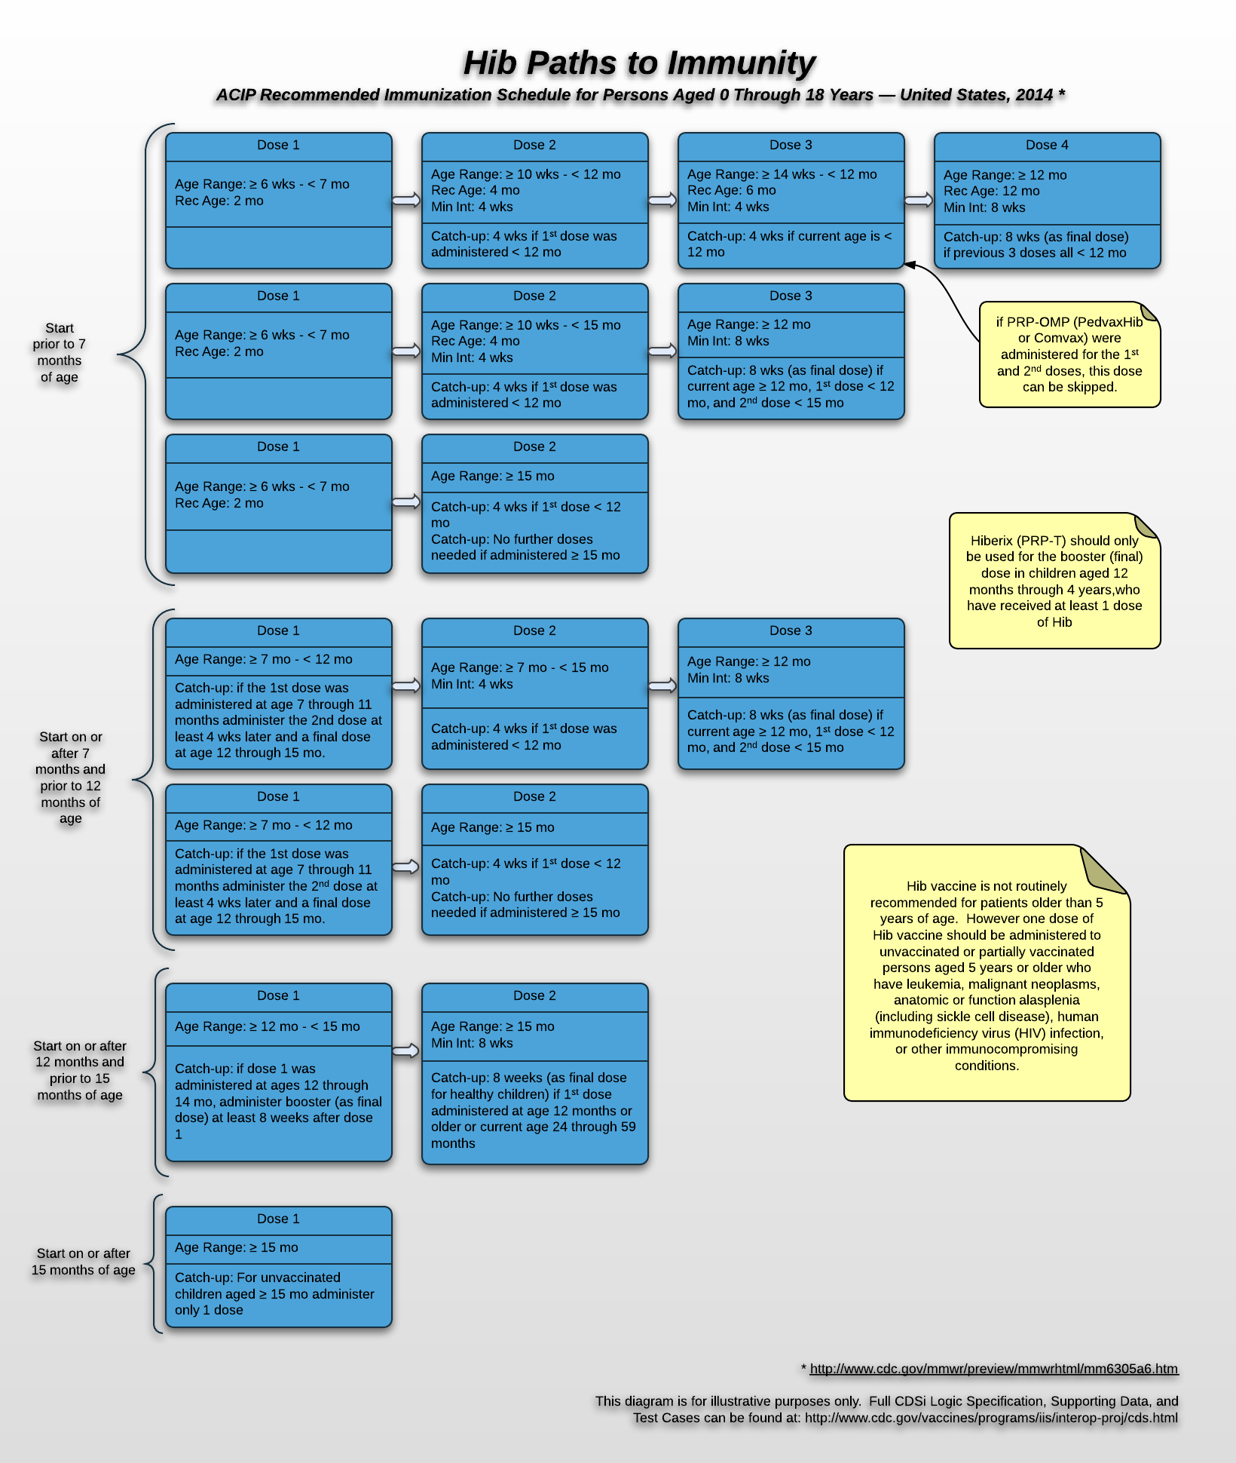

# Appendix F: Document Management

| Date | Changed By | Comments | Version # |
| --- | --- | --- | --- |
| 8/31/12 | L. McKenzie/E. Larson | Draft distributed to Expert Panel and Reviewers | 0.1 |
| 10/05/12 | L. McKenzie/E. Larson | Final Draft distributed to CDC leadership | 0.2 |
| 10/29/12 | L. McKenzie/E. Larson | Initial publication | 1.0 |
| 11/14/12 | L. McKenzie/J. Wain | Updated Executive Summary (1.3 and 1.4)  Updated to meet section 508 requirements | 1.1 |
| 01/09/13 | J. Wain | Fixed minor errors in Acknowledgements Appendix | 1.2 |
| 09/19/13 | E. Larson | * Select Best Patient Series language clarifications   + Sections 6.1, 6.2, 6.3, 6.5, and 6.6 * Select Best Patient Series Decision Table correction   + Section 6.3 * Updated Date Calculation Intervals to define intervals to only be from Valid or Not Valid doses. Substandard doses do not need an interval.   + Section 3.4 * Assessment date was added to the domain model and a typo was corrected in the definition of the term assessment date   + Appendix A * Evaluation and Forecasting for Skipping Doses were updated to incorporate a Trigger Interval in addition to the existing Trigger Age to address issues found while testing polio, guidance from EIPB, and the harmonized schedule.   + Sections 3.4, 4.2, 5.1, Appendix A * Updated business rule numbers to an improved identification scheme for referencing business rules and improved ability to insert newly needed business rules in the future.   + Sections 3.4, 5.4, 6.7, 7.3, 7.4, 7.6 * Minor wording updates in various business rules to improve clarity and ability to implement   + Section 3.4 | 1.3 |
| 11/07/13 | E. Larson | * Updates to properly select the catch-up schedule when children start late by age. A new concept (Maximum Age To Start) was defined in the appendix and added to the select best patient series logic.   + Sections 6.1, 6.5, Appendix A * Added new appendix to address multiple paths to immunity concept as supplemental material and references to the new appendix in various sections.   + Sections 2.1, 2.8, Appendix E * Updates to Forecast sections regarding Conditional Need. The logic remained the same as previously, but moved Conditional Need into its own section (New section 5.3) and added a specific target dose status for improved clarity on the use of conditional need.   + Changes to Sections 3.2, 5, 5.3 (New), 5.4 (previously 5.3) * Document editorial consistency improvements   + Entire document | 1.4 |
| 01/09/14 | E. Larson | * Evaluation and Forecasting for Skipping Doses were updated to incorporate a Trigger Target Dose to address issues found while testing Tdap/Td, guidance from EIPB, and the harmonized schedule.   + Sections 4.2, 5.1, Appendix A * Identify and Evaluate Vaccine Group (Chapter 7) was refactored to apply a cleaner process model, decision tree, and business rules based on Tdap/Td and MMR testing and research.   + Chapter 7 | 1.5 |
| 03/20/14 | E. Larson | * Updated inconsistencies found in Supplemental Material graphics.   + Appendix E * Added Business Rule to Calculate Dates to ensure consistent application of date calculations   + Section 3.4 – See CALCDT-6 Business Rule | 1.6 |
| 08/14/2014 | E. Larson | * Updated definition of Maximum Age to Start   + Section 6.1 * Added/improved diagrams and process models   + chapters 4, 5, 6, 7, 8 and appendices * Updated attribute tables to cross-reference with date calculation business rules   + chapters 4 and 5 * Added a new Patient Series Status and associated usage of new “Aged Out” status.   + Section 3.2 and chapters 5 and 6 * Improved decision table and business rule language to fully utilize vocabulary.   + Chapters 5 and 6 * Assigned Patient Series Status to outcomes section of decision table.   + Section 5.4 * New Evaluation section was added to accommodate clarifications from EIPB on Hep A intervals after a not valid dose.   + Section 4.6 was created (Allowable Interval).   + Other updates due to this were in the chapter 4 process model, section 4.11, and Appendix A. | 1.7 |
| 12/16/2014 | E. Larson | * Added support for maximum doses by age (i.e.: 6 doses by 7 years in DTaP   + Section 5.1 and Appendix A | 1.8 |
| 05/11/2015 | P.Speights/E.Larson | * Added Zoster to the Vaccine Groups in Table 1-1 * Added Age base Adult Recommendations to the Additional Items in scope include. * Added Not Recommended status and definition in Table 3-3 * Updated Table 3.5 to include business rule CALCDTINT-8, CALCDTCOND-1, and CALCDTCOND-2 * Added From Most Recent explanation under the Relationship to ACIP Recommendation in Section 4.5 * Added Figure 4-10 From Most Recent timeline in section 4.5 * Added Supporting data “From Most Recent” to table 4-11 * Updated the Activity and Goal in Table 5-1 to incorporate sections 5.4 * Updated the processing model in Figure 5-1 to add section 5.4 * Added the new Immunity section in section 5.4 * Updated Table 5-7 to add supporting data for Begin and End Age Date. * Updated Table 5-14 to add Not recommended status info. * Added the term Minimum Age to Start Date and Definition in table 6.2 * Updated Table 7-3 to add business rule SINGLEANTVG-10 * Updated Table 7-4 to add business rule MULTIANTVG-9 * Updated the Figure 8-2 * Updated the Domain models Figure A-1, Figure A-2, and Figure A-3 * Added new terms and definitions to the Table A-1 Glossary section. Included are Conditional begin age, Birth Date Immunity, Clinical History Immunity, Country of Birth, Conditional End Age, Exclusion Condition, Forecast Vaccine Type, From Most Recent, Immunity Date, Immunity Guideline, Minimum Age to Start, and Recommended Vaccine, | 2.0 |
| 12/22/2015 | C.Newman/P.Speights/E.Larson | * Updated the fourth paragraph in Background and Goals 1.1. * Updated text in section 2.4. * Updated text in the first paragraph of section 3.1. * Removed Substituted from Target Dose Statuses Table 3.2 * Updated Supporting Data text in 3.3 * Updated Logical Component Date Rules in Table 3-5 * Added Table 3-8 What Exercises Should I do today in section 3.5. * Updated Evaluation Process Steps in Table 4-1 * Updated Evaluation Process Model in Figure 4-1 * Removed Skip Target Dose section and replaced with Evaluate Conditional Skip in section 4.2. * Removed Substitute Target dose section * Updated Evaluate Interval in Section 4.4. * Updated Live Virus Conflict Business Rules in Table 4-23 of section 4.6 * Updated Forecast Dates and Reasons Process steps in Table 5-1. * Updated Forecast Dates and Reason Process Model in Figure 5-1. * Replaced Skip Target dose with Evaluate Conditional Skip in section 5.1. * Removed Substitute Target Dose section. * Updated text in Determine Evidence of Immunity section 5.2. * Updated decision table 5-3: “Does the patient have evidence of immunity?” * Updated Generate Forecast Date and Recommended Vaccine Business rules in Table 5-7. * Updated Select Best Patient Series Vocabulary/Definition in Table 6-2. * Updated Select Best Patient Series Business Rules in Table 6-8. * Updated Organize Immunization History Process Model in Figure 8-2. * Updated the CDSI Domain Diagram: Patient Neighborhood in Figure A-1. * Updated the CDSI Domain Diagram: Vaccine and Schedule Neighborhood in Figure A-2. * Updated the CDSI Domain Diagram: Evaluation and Forecasting Neighborhood in Figure A-3. * Updated the Glossary in Table A-1. * Added PPSV to the Acronym’s and Abbreviations in Appendix B. | 2.1 |

1. Participation was defined as having at least two recorded vaccinations in an Immunization Information System (IIS).
2. Participation was defined as having submitted data to the IIS in their state or city in the previous six months (i.e. from July 1 through December 31, 2010), indicating recent submissions.
3. All data derived from the 2010 Immunization Information Systems Annual Report (IISAR). 54 of 56 Centers for Disease Control and Prevention (CDC) Immunization Program grantees/IIS reported. For further information, see: [2010 Immunization Information Systems Annual Report (IISAR)](http://www.cdc.gov/vaccines/programs/iis/annual-report-IISAR/index.html).
4. Aids refer to manual support mechanisms and in no way imply that an automated system is being developed or provided. These aids can, however, be used to refine existing or develop new automated systems.
5. Immunity. (n.d.). Merriam-Webster.com. Retrieved December 26, 2013, from http://www.merriam-webster.com/dictionary/immunity